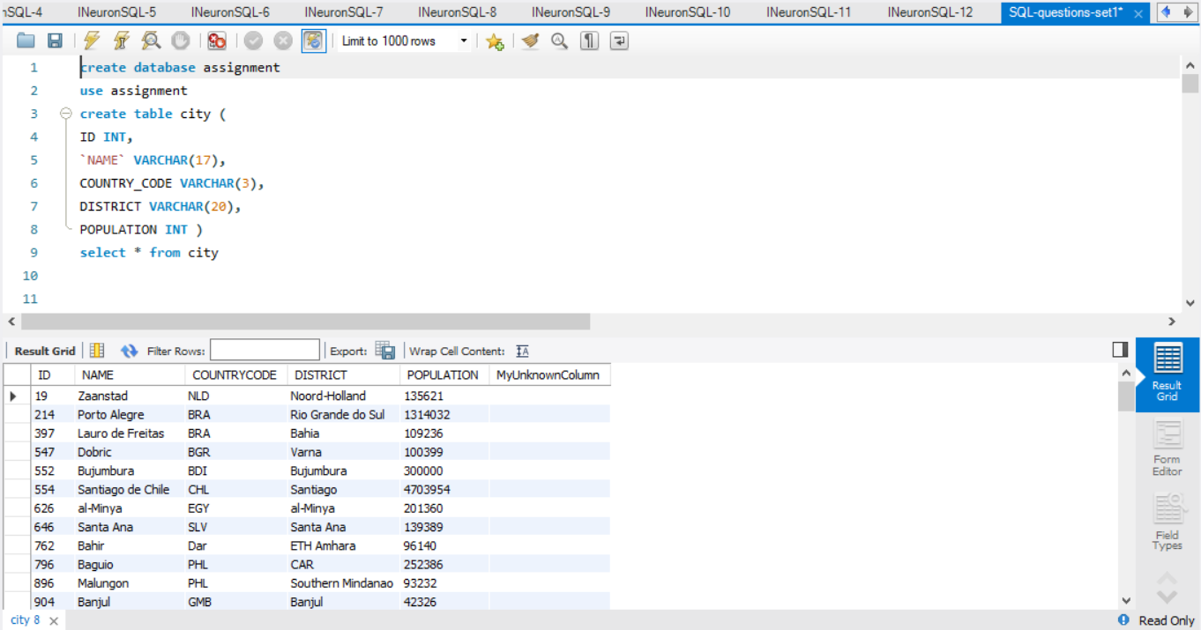

**Q1**. Query all columns for all American cities in the CITY table with populations larger than 100000. The CountryCode for America is USA.The CITY table is described as follows:

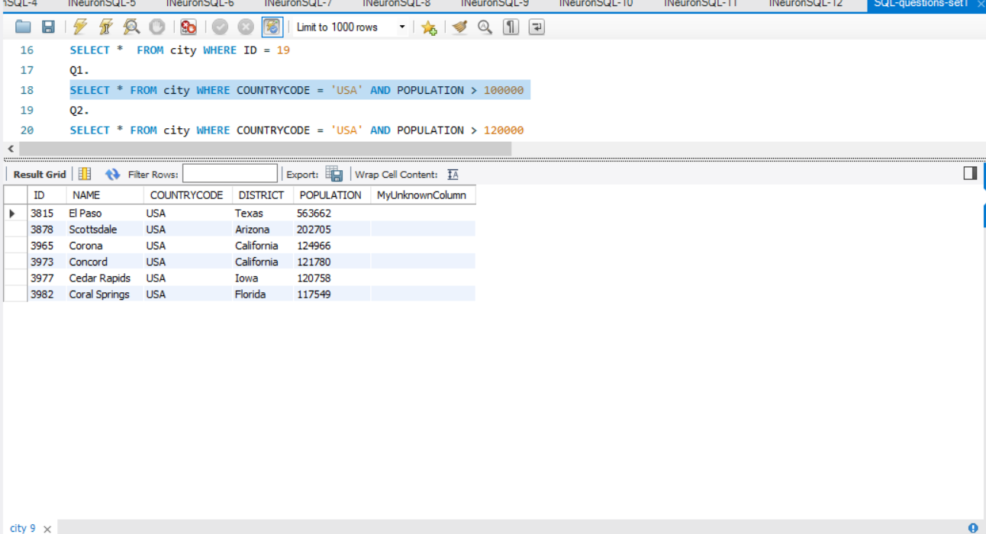

**Q2**. Query the NAME field for all American cities in the CITY table with populations larger than 120000.The CountryCode for America is USA. The CITY table is described as follows

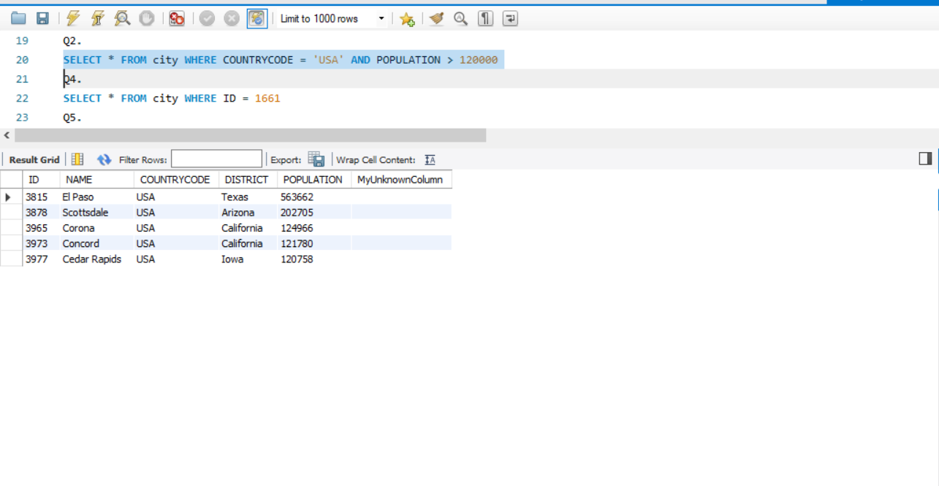

**Q3.** Query all columns (attributes) for every row in the CITY table. The CITY table is described as follows:

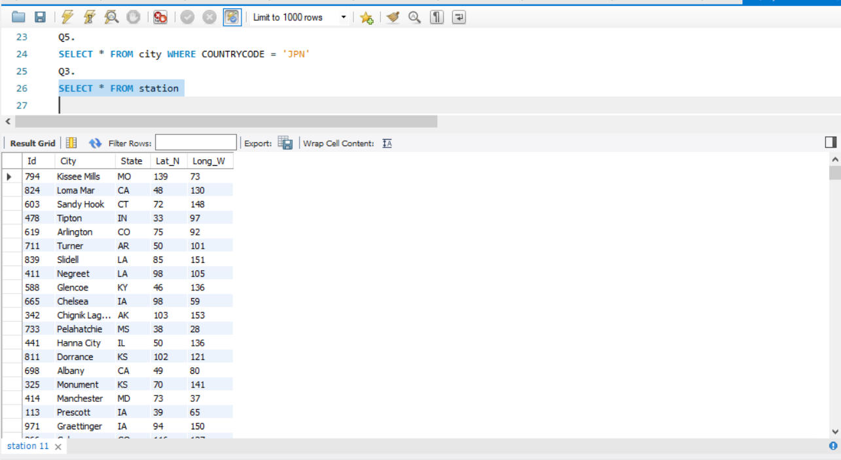

**Q4**. Query all columns for a city in CITY with the ID 1661.The CITY table is described as follows:

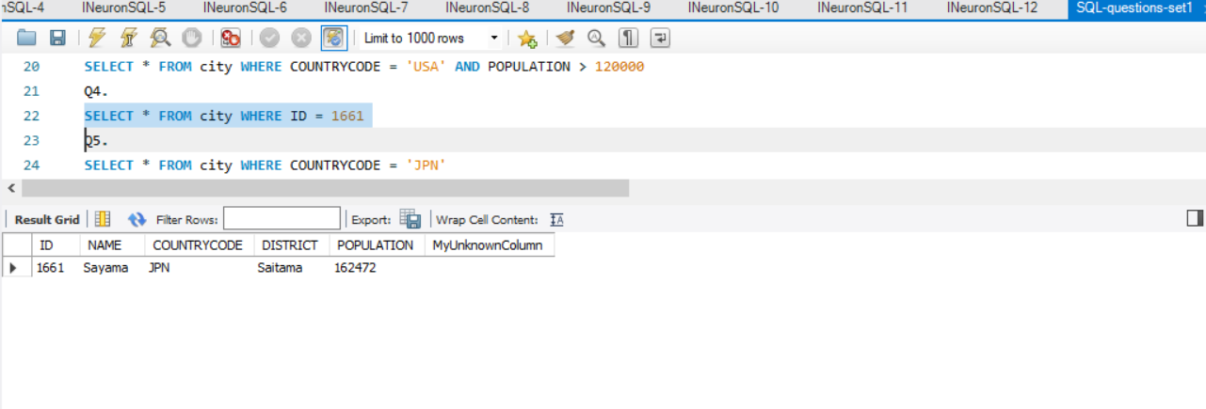

**Q5**. Query all attributes of every Japanese city in the CITY table. The COUNTRYCODE for Japan is JPN.

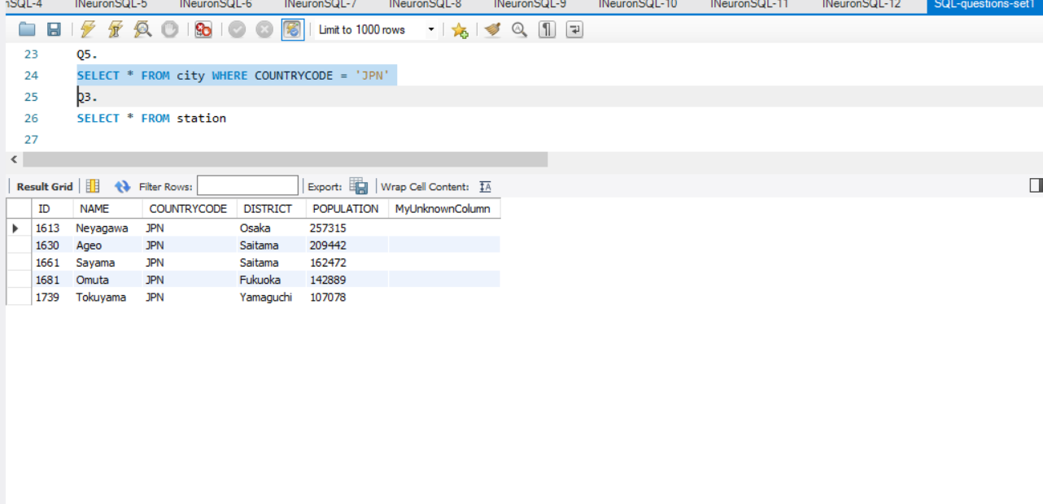

**Q7.** Query a list of CITY and STATE from the STATION table.

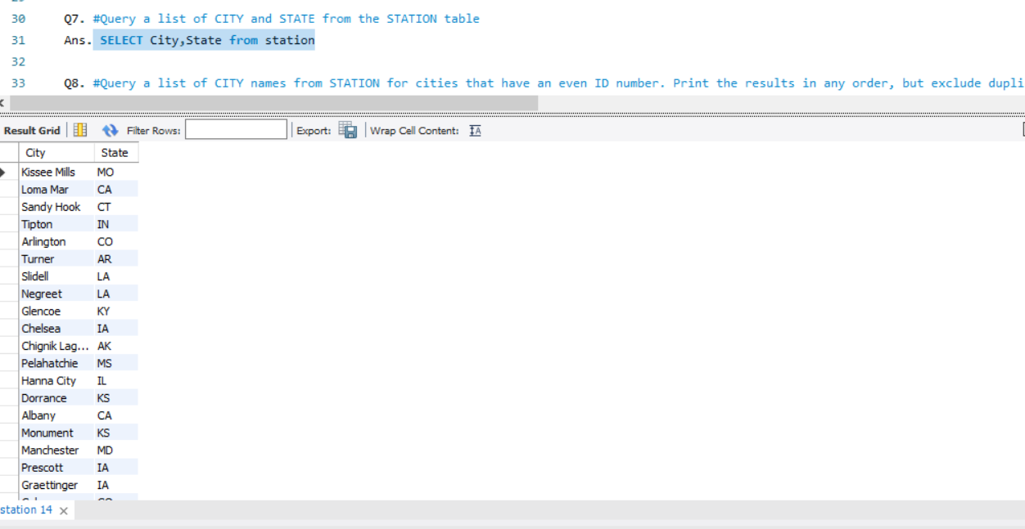

**Q8.** Query a list of CITY names from STATION for cities that have an even ID number. Print the results in any order, but exclude duplicates from the answer.

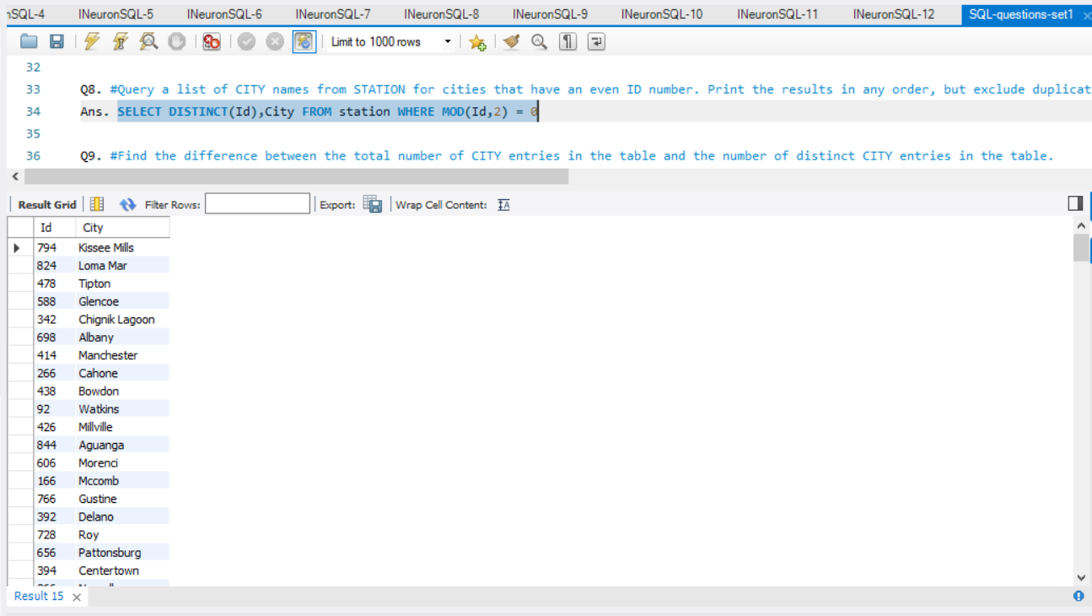

**Q9**. Find the difference between the total number of CITY entries in the table and the number of distinct CITY entries in the table.

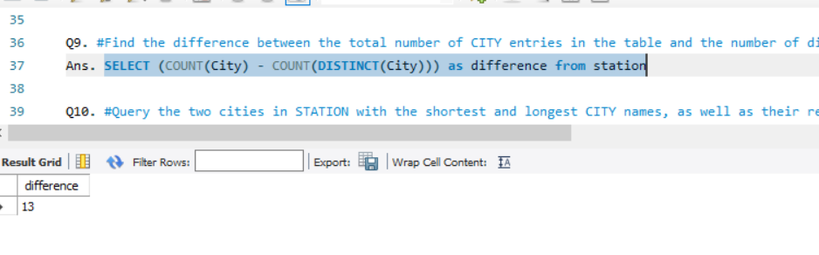

**Q10.** Query the two cities in STATION with the shortest and longest CITY names, as well as their respective lengths (i.e.: number of characters in the name). If there is more than one smallest or largest city, choose the one that comes first when ordered alphabetically.

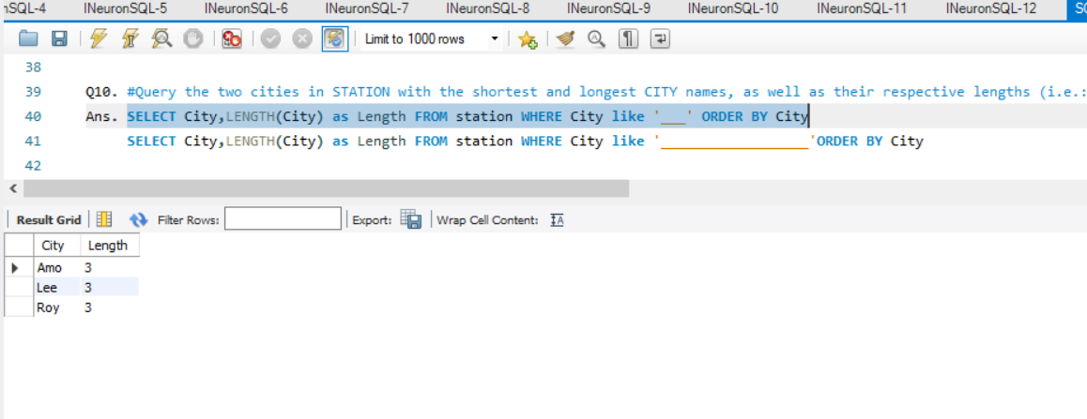

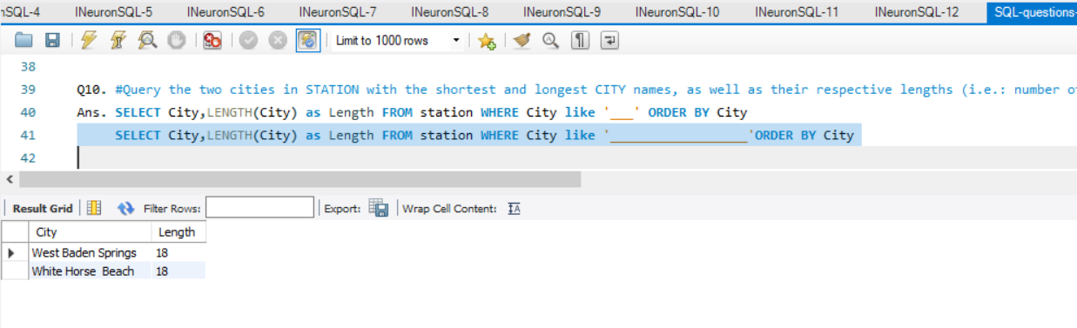

**Q11**. Query the list of CITY names starting with vowels (i.e., a, e, i, o, or u) from STATION. Your result cannot contain duplicates.

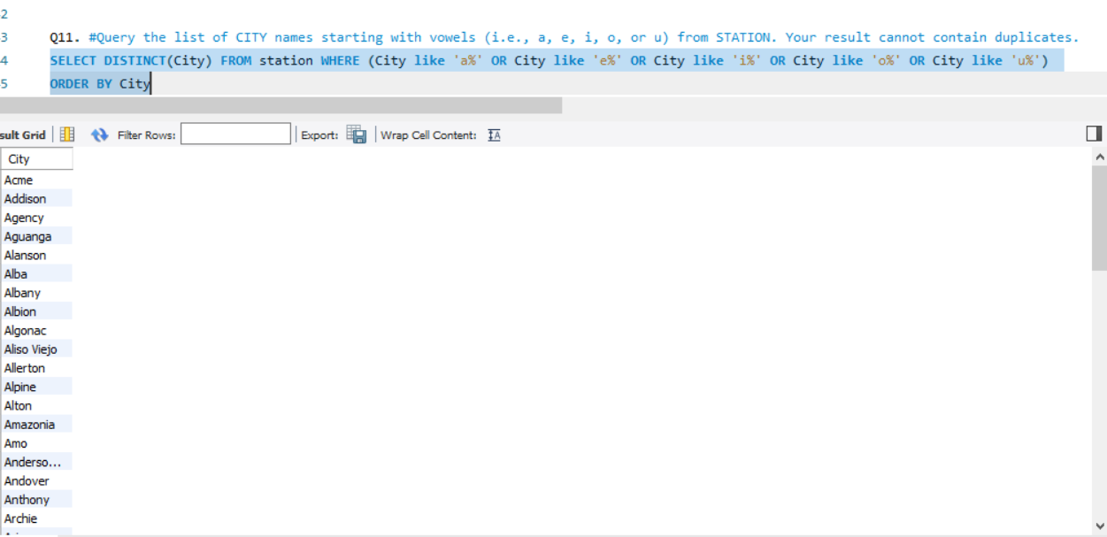

**Q12.** Query the list of CITY names ending with vowels (a, e, i, o, u) from STATION. Your result cannot contain duplicates.

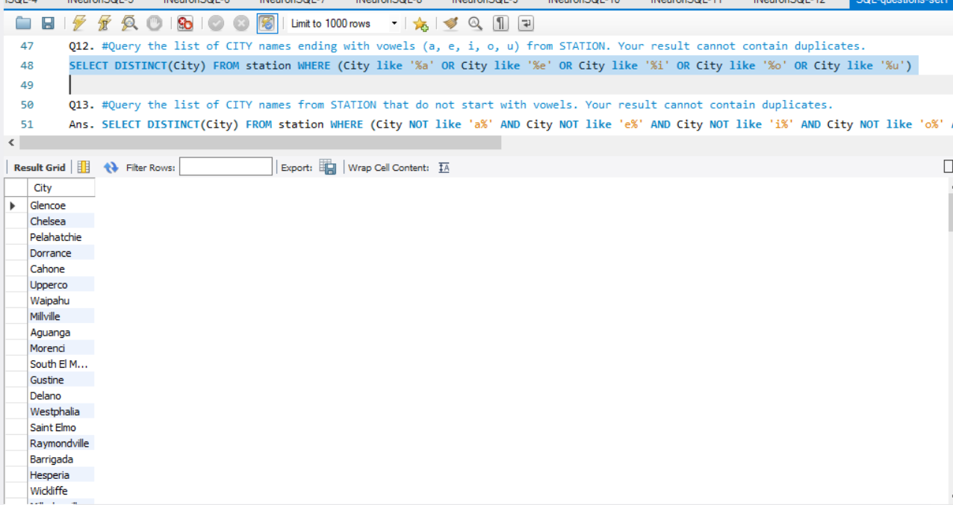

**Q13.** Query the list of CITY names from STATION that do not start with vowels. Your result cannot contain duplicates.

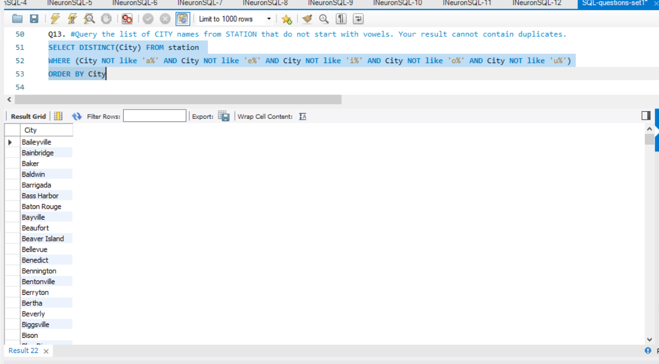

**Q14.** Query the list of CITY names from STATION that do not end with vowels. Your result cannot contain duplicates.

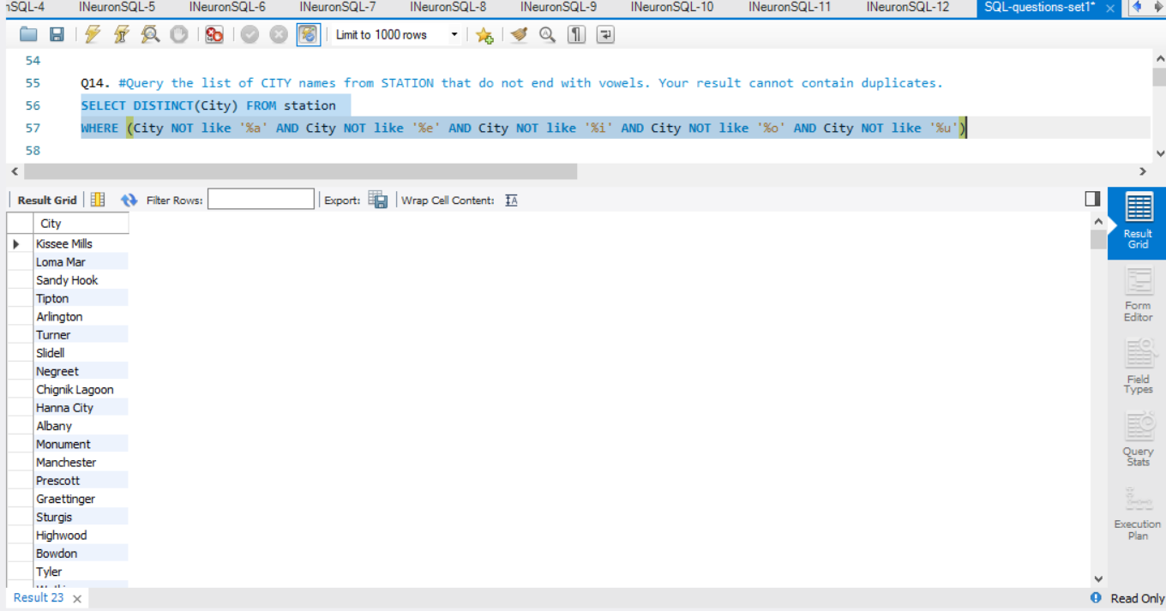

**Q15.** Query the list of CITY names from STATION that either do not start with vowels or do not end with vowels. Your result cannot contain duplicates.

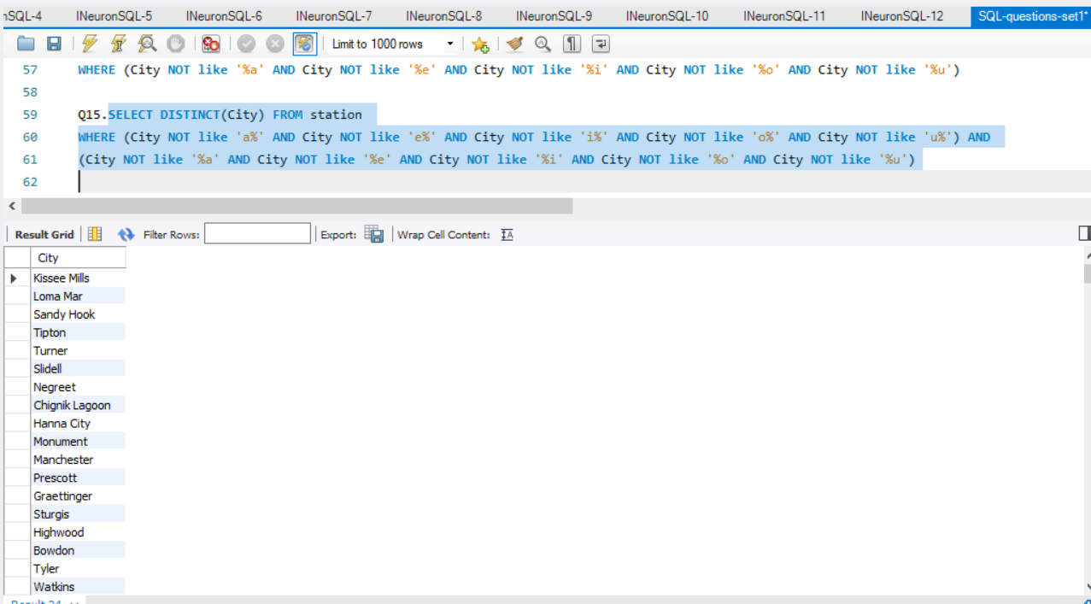

**Q17.** Write an SQL query that reports the products that were only sold in the first quarter of 2019. That is,between 2019-01-01 and 2019-03-31 inclusive.

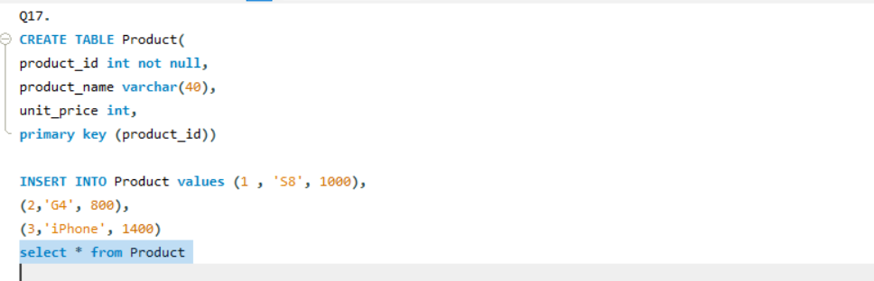

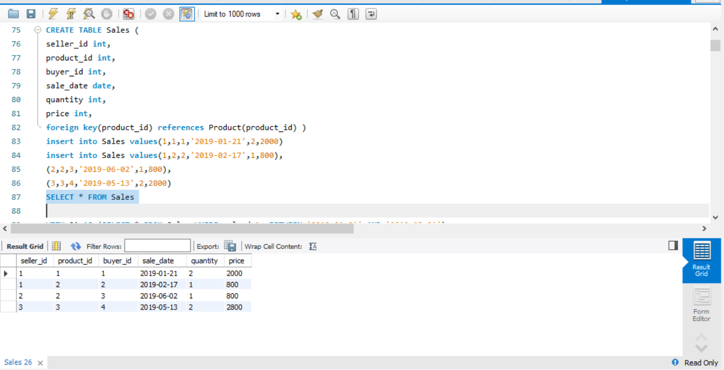

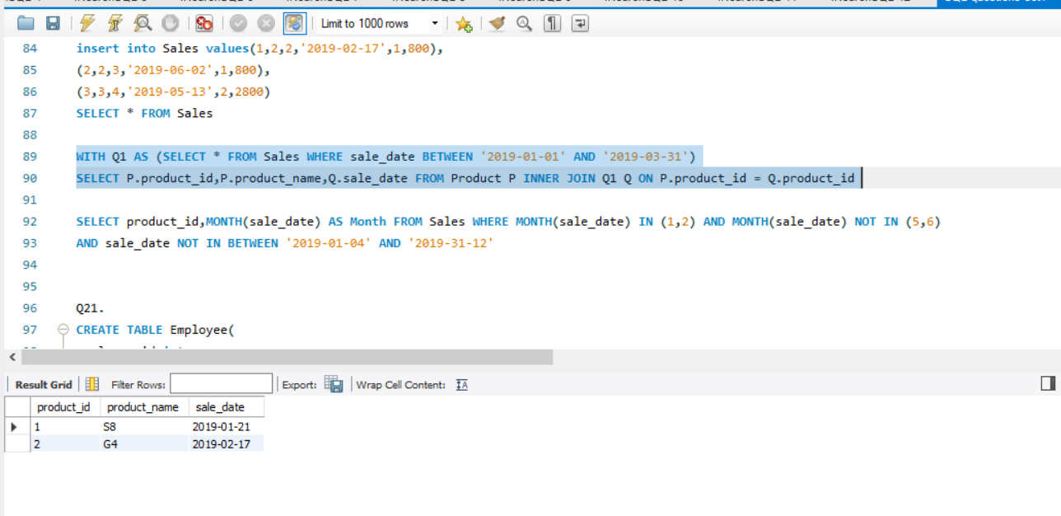

**Q21.** Write an SQL query to find the team size of each of the employees.

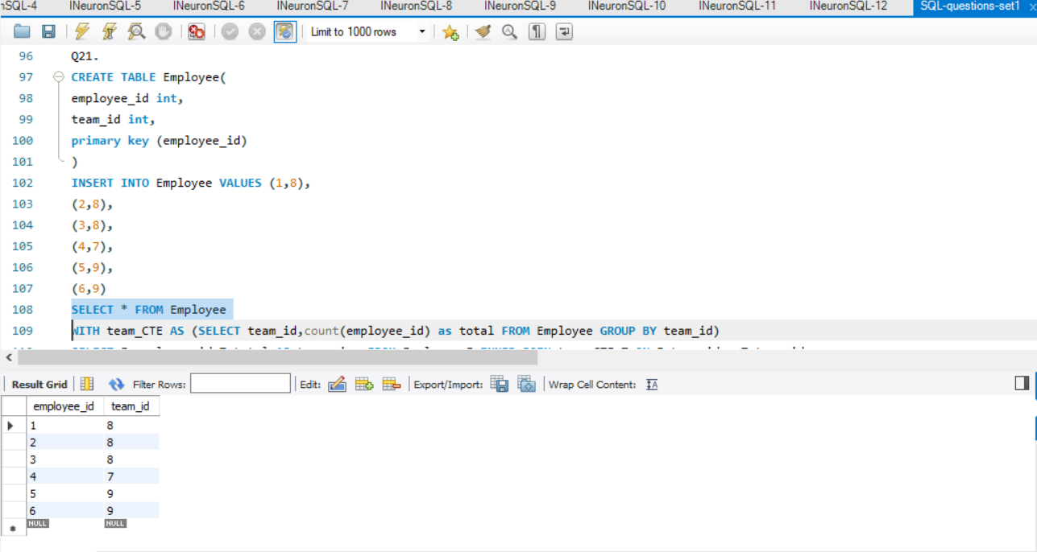

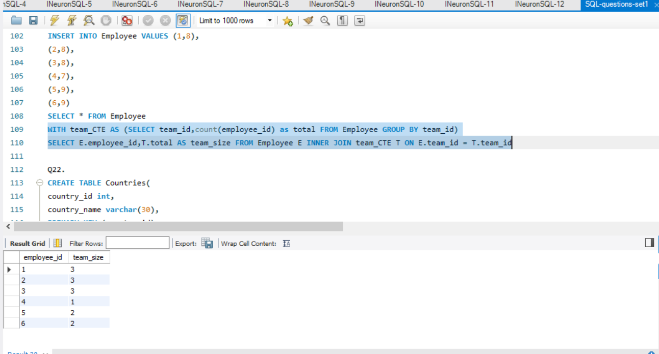

**Q22.** Write an SQL query to find the type of weather in each country for November 2019. The type of weather is:

● Cold if the average weather_state is less than or equal 15,

● Hot if the average weather_state is greater than or equal to 25, and

● Warm otherwise.

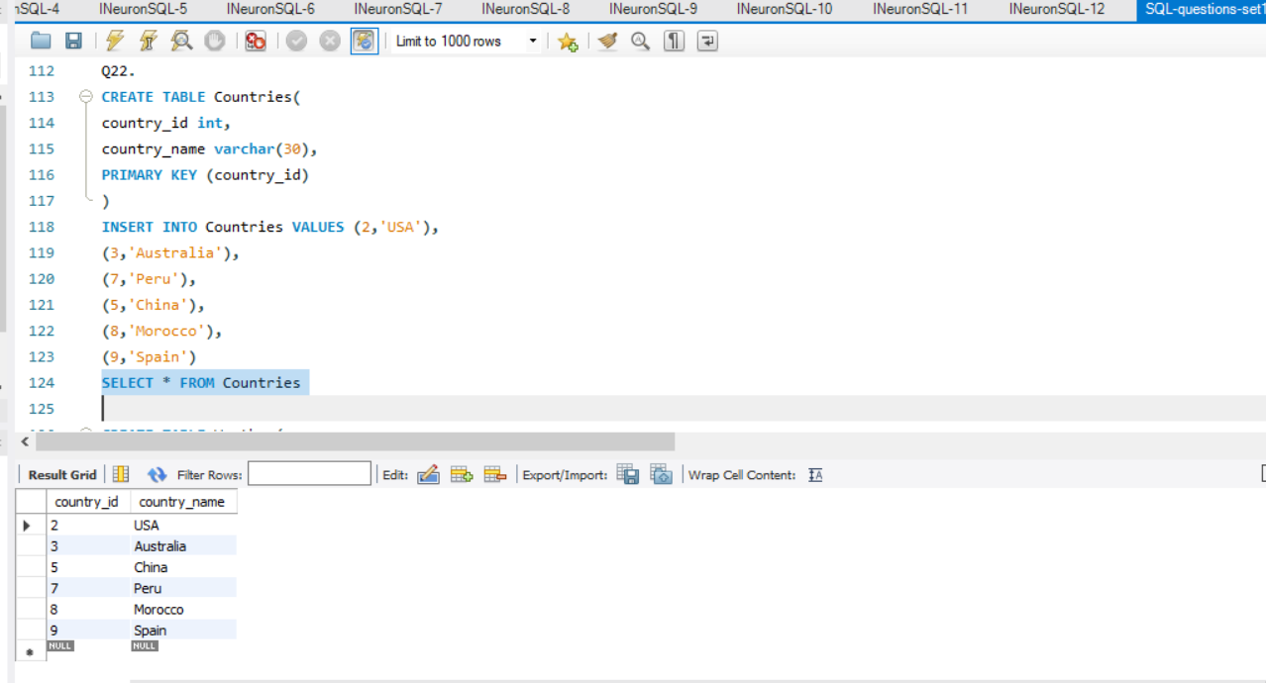

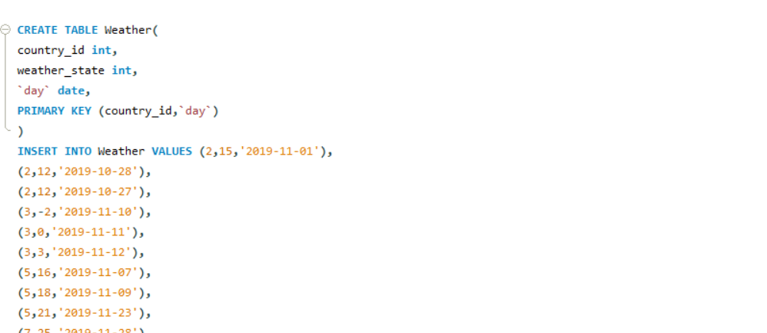

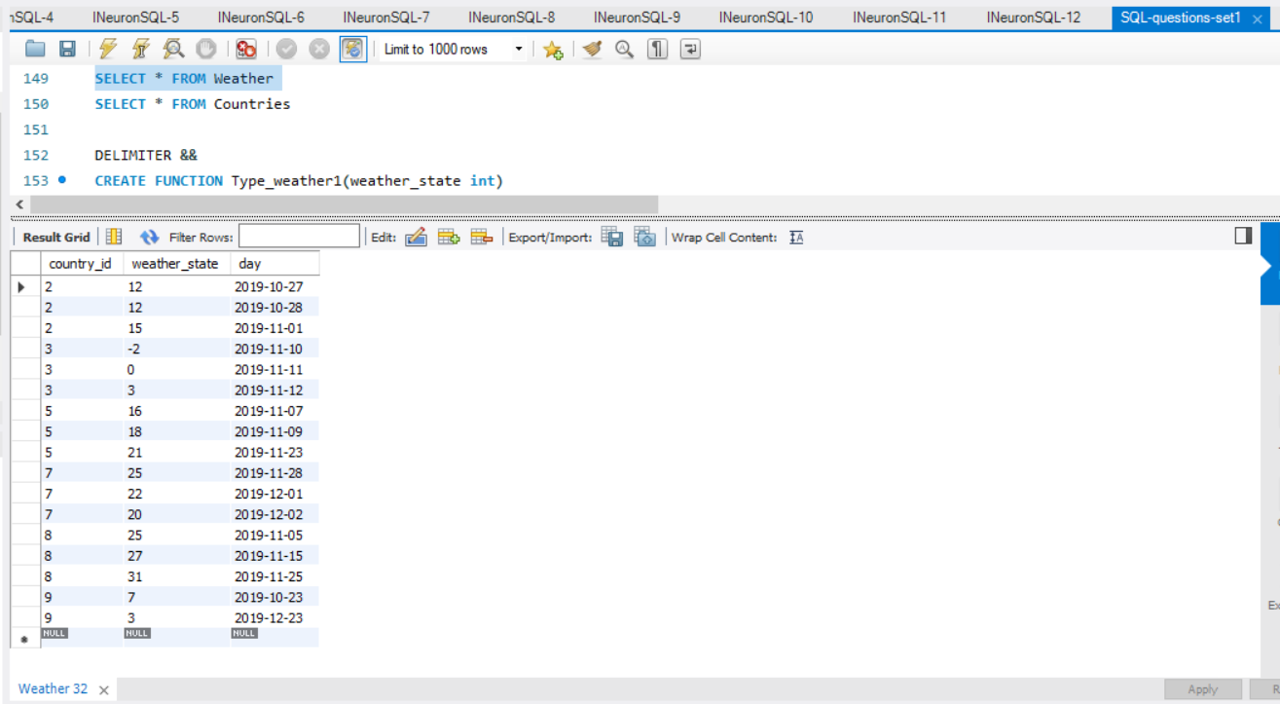

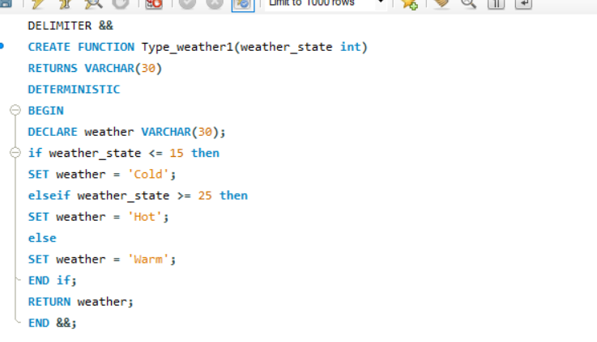

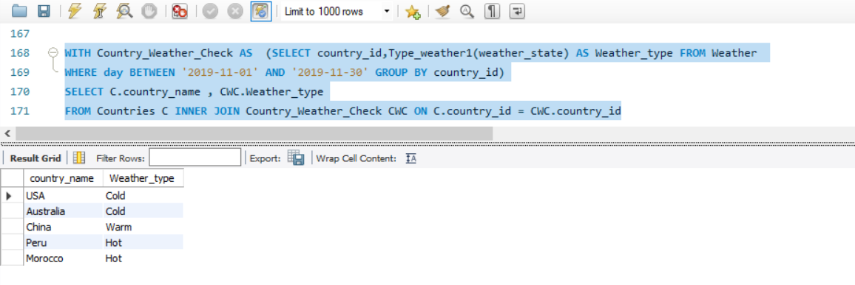

**Q23.** Write an SQL query to find the average selling price for each product. average_price should be rounded to 2 decimal places.

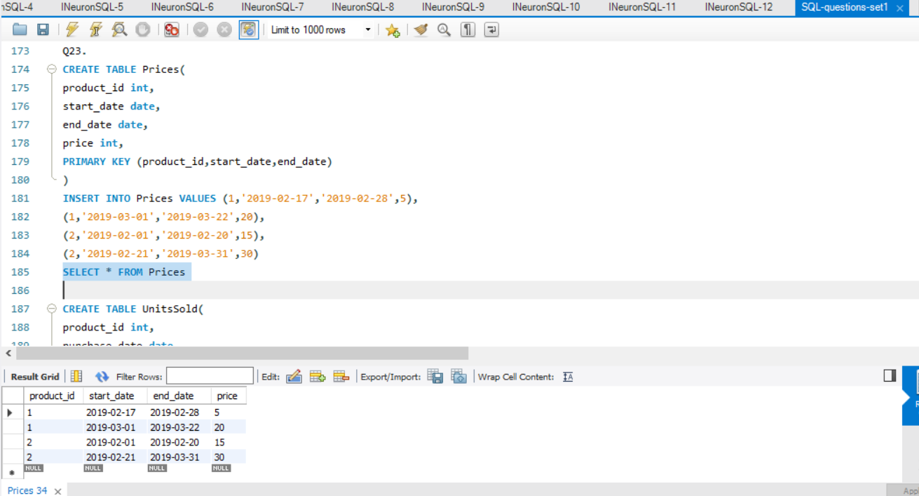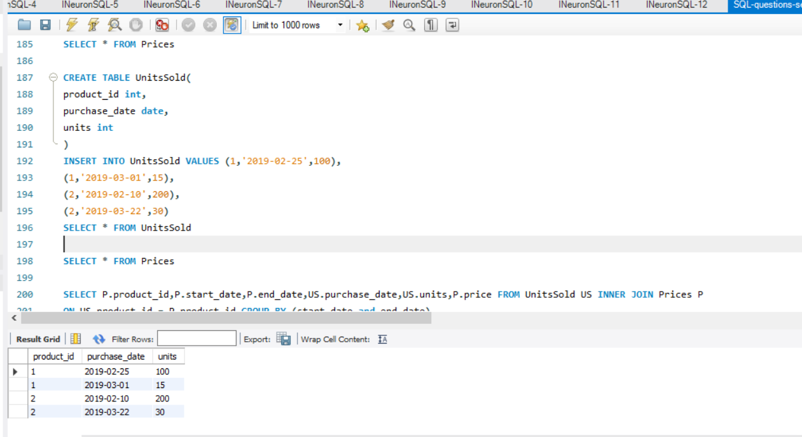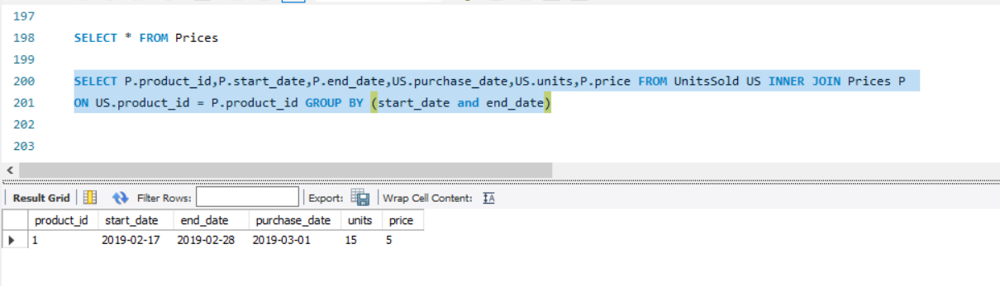

**Q24.** Write an SQL query to report the first login date for each player.

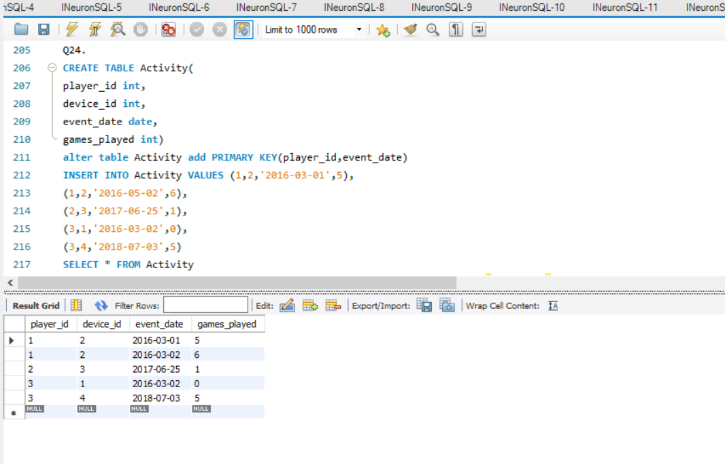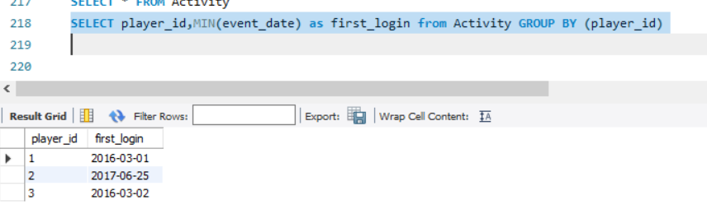

**Q25.** Write an SQL query to report the device that is first logged in for each player.

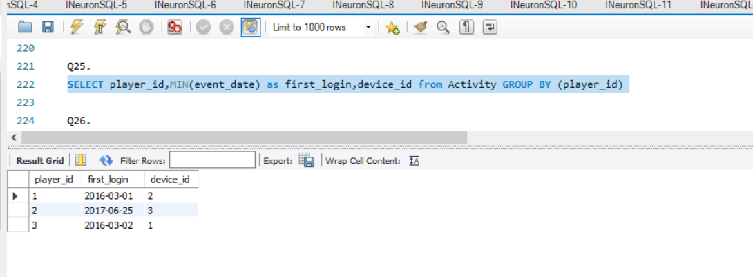

**Q26.** Write an SQL query to get the names of products that have at least 100 units ordered in February 2020 and their amount.

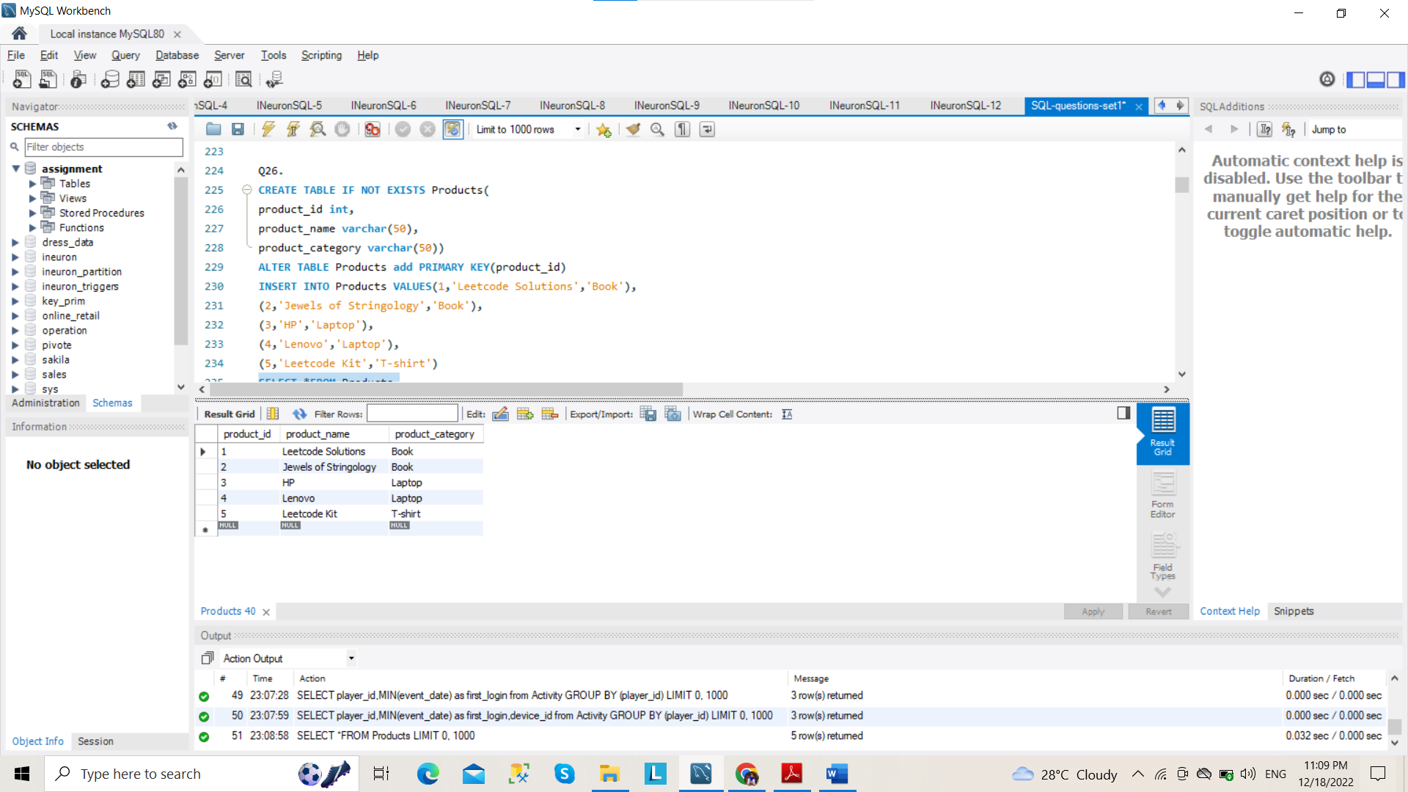

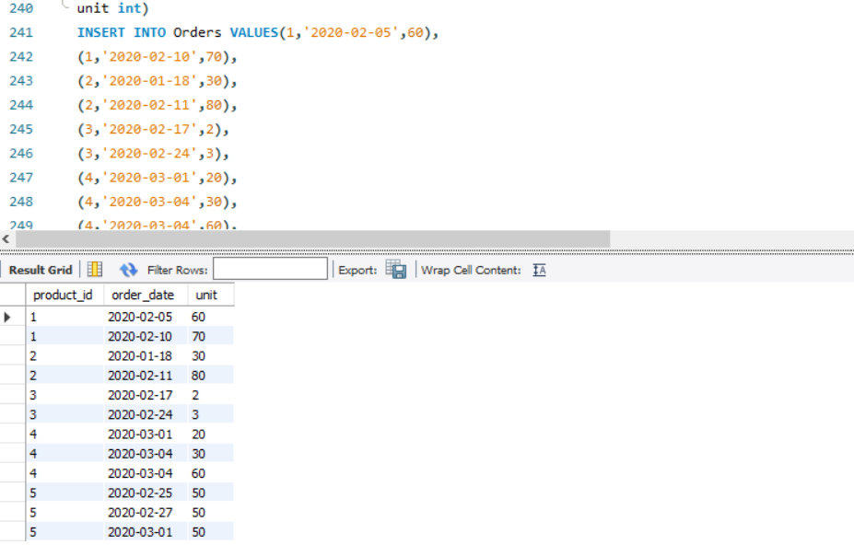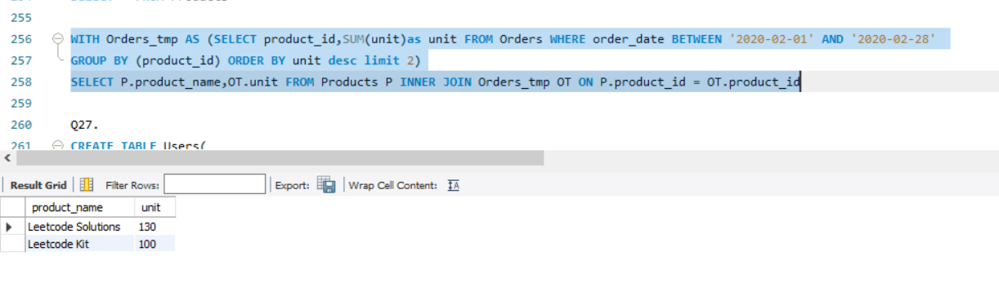

**Q27.** Write an SQL query to find the users who have valid emails.

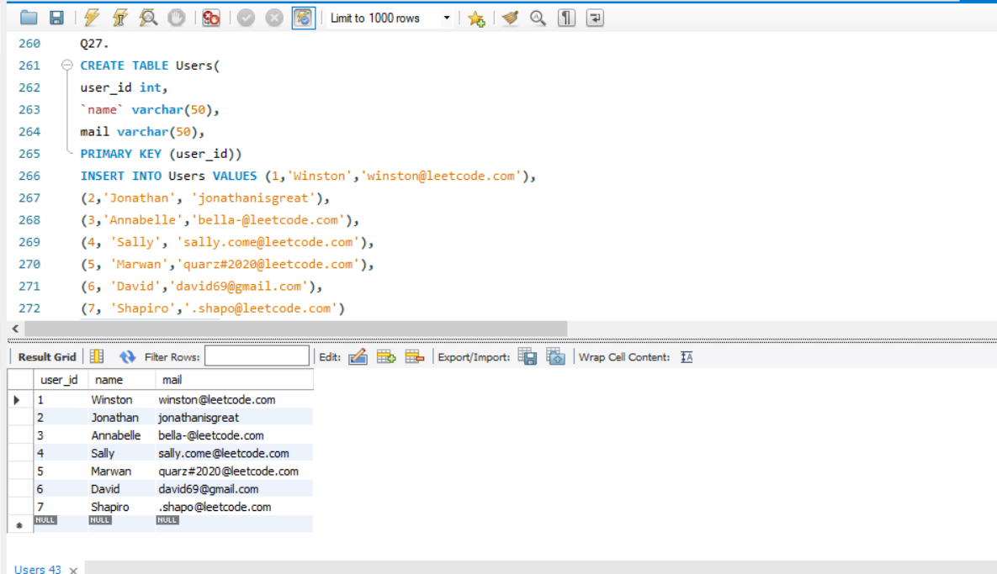

**Q28**. Write an SQL query to report the customer_id and customer_name of customers who have spent at least $100 in each month of June and July 2020.

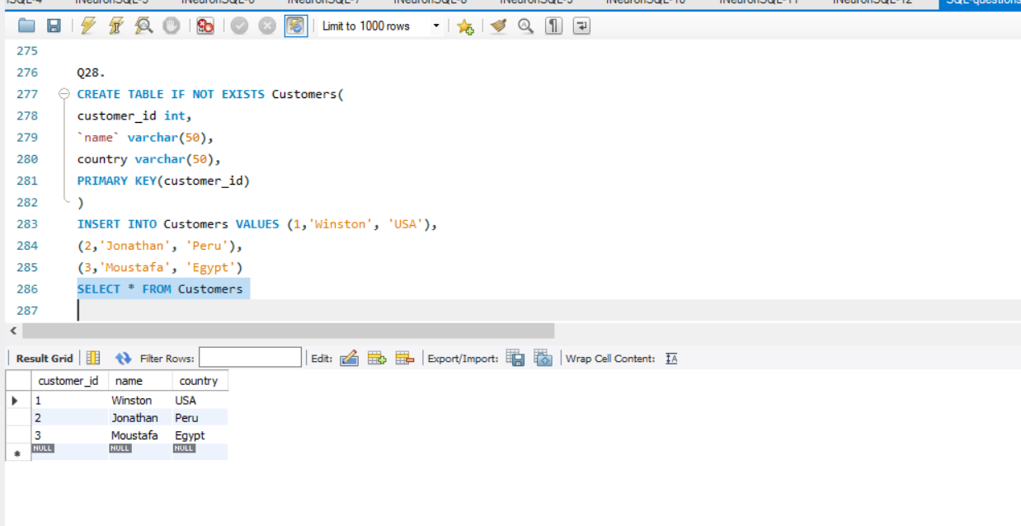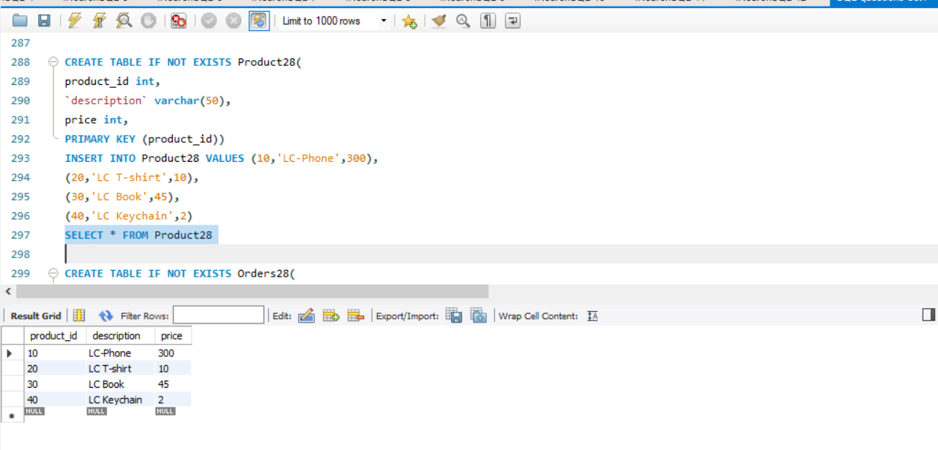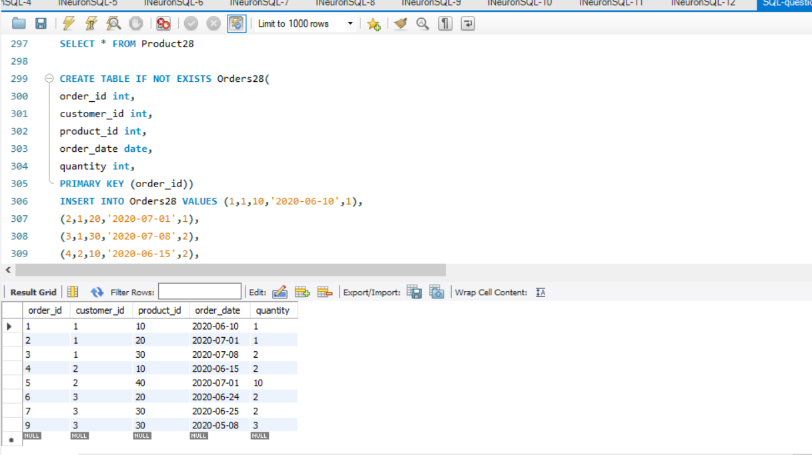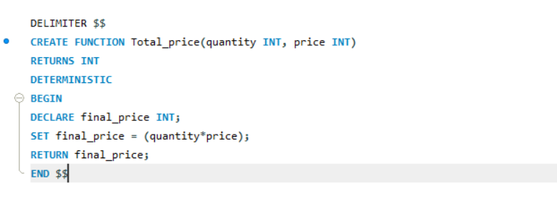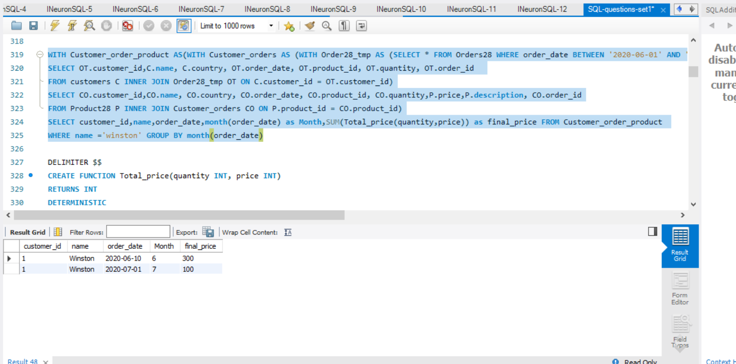

**Q29**. Write an SQL query to report the distinct titles of the kid-friendly movies streamed in June 2020. Return the result table in any order.

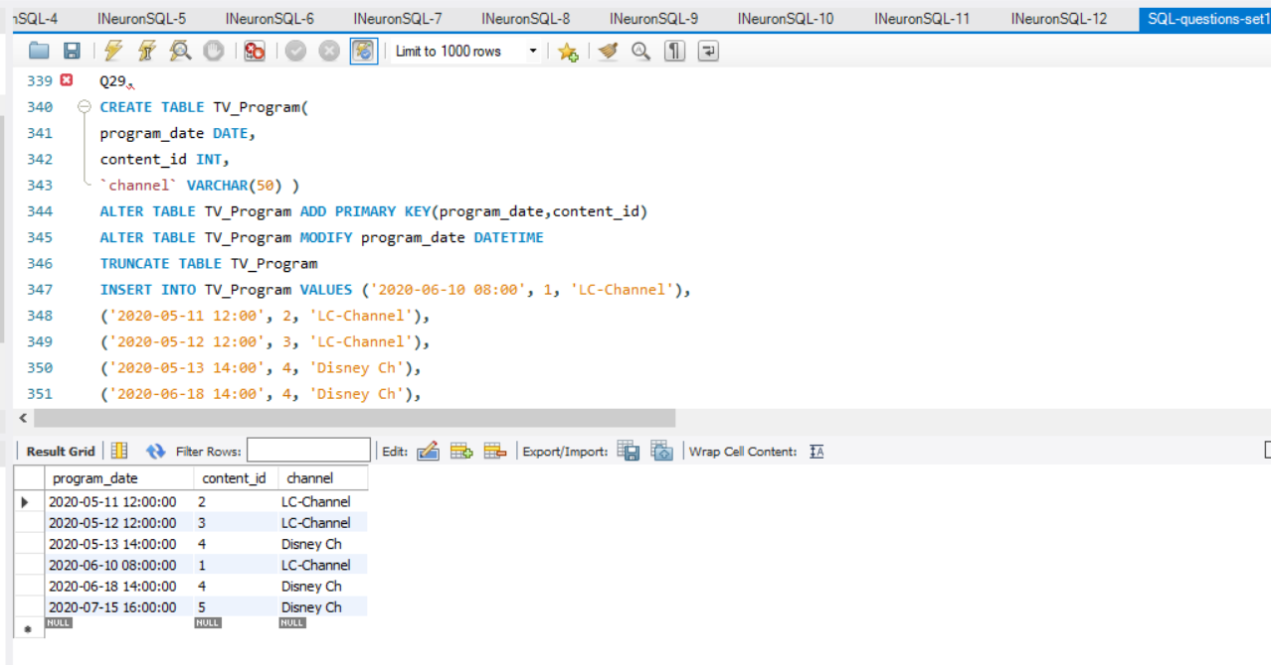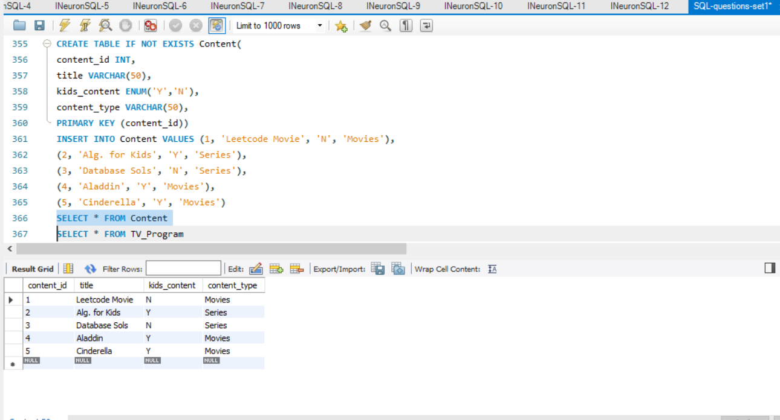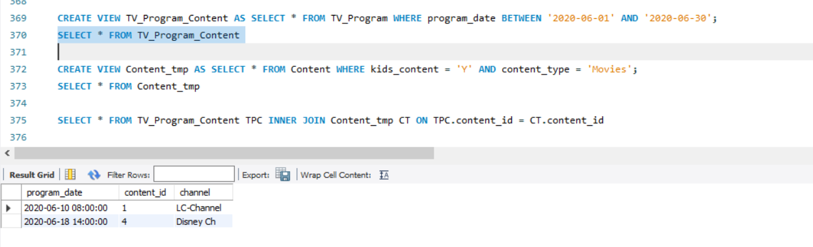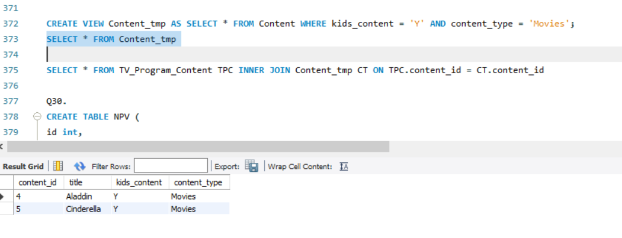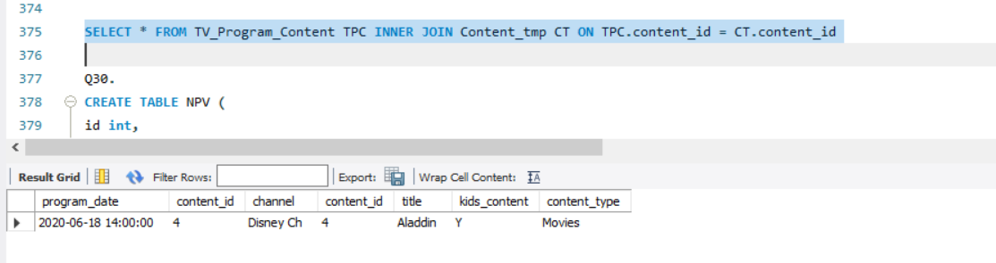

**Q30.** Write an SQL query to find the npv of each query of the Queries table

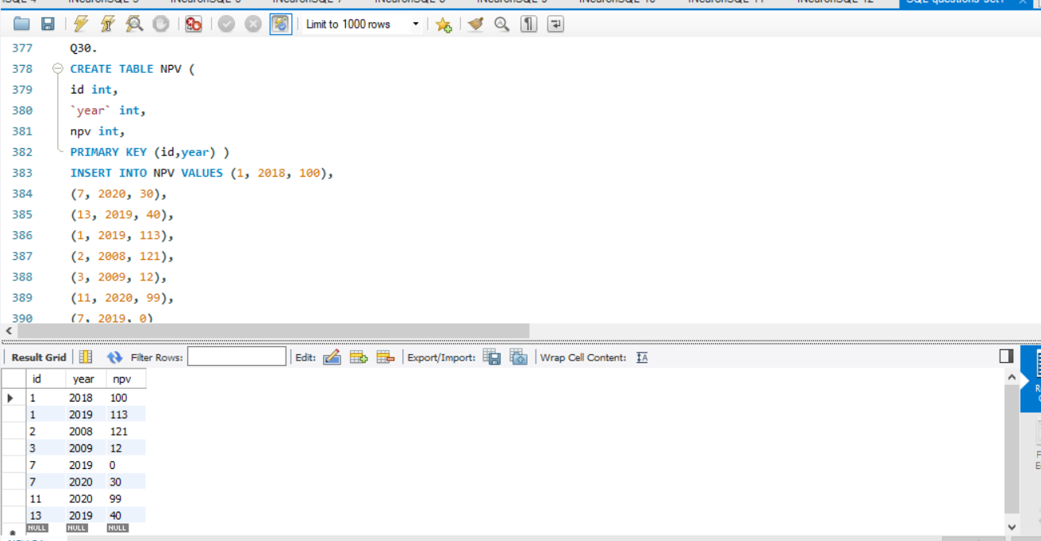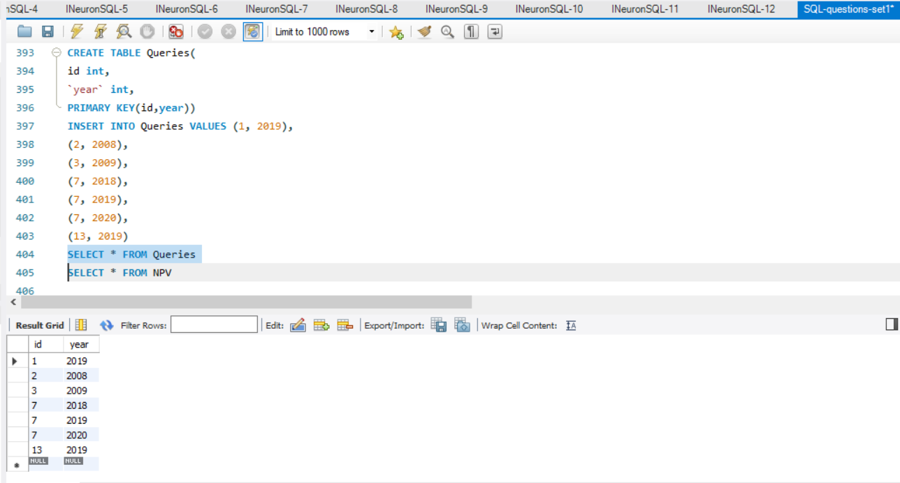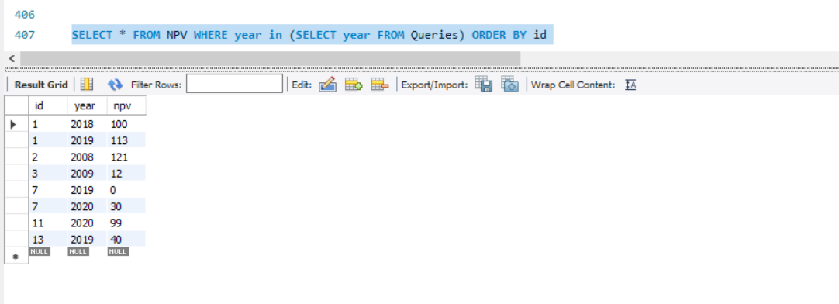

**Q32.** Write an SQL query to show the unique ID of each user, If a user does not have a unique ID replace just show null.

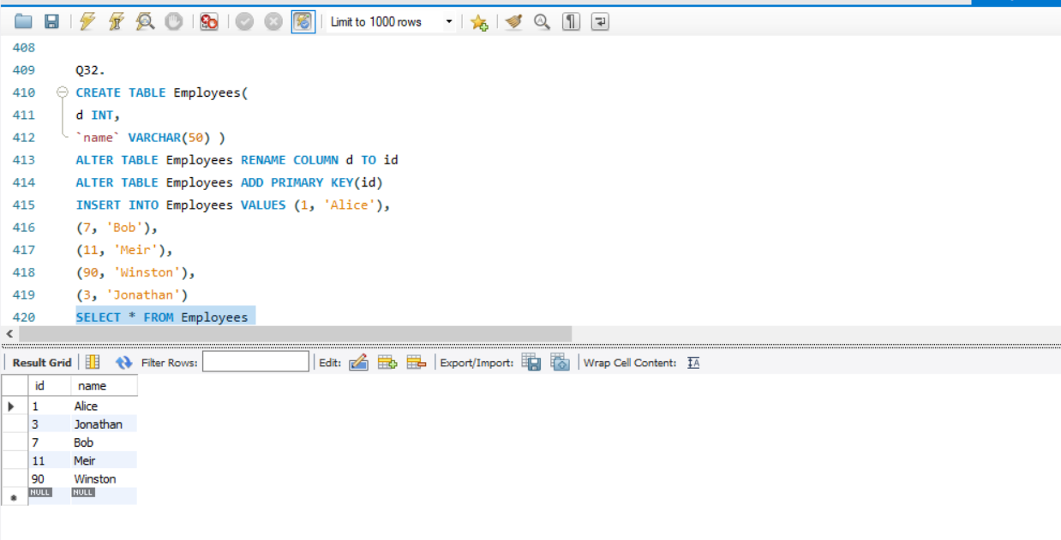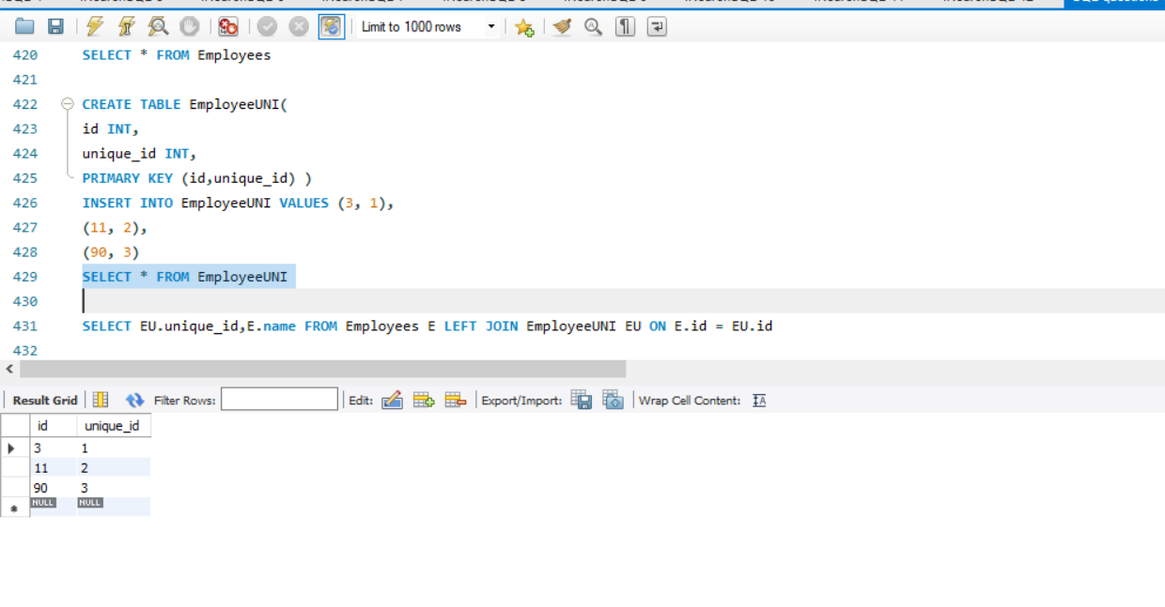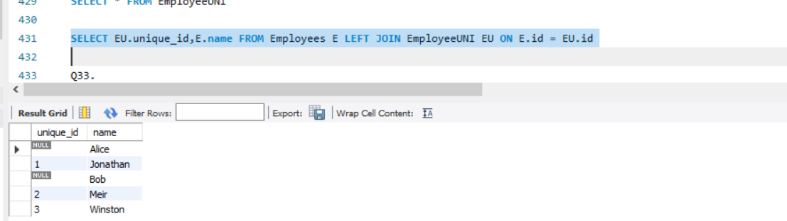

**Q33.**Write an SQL query to report the distance travelled by each user.Return the result table ordered by travelled_distance in descending order, if two or more users

travelled the same distance, order them by their name in ascending order.

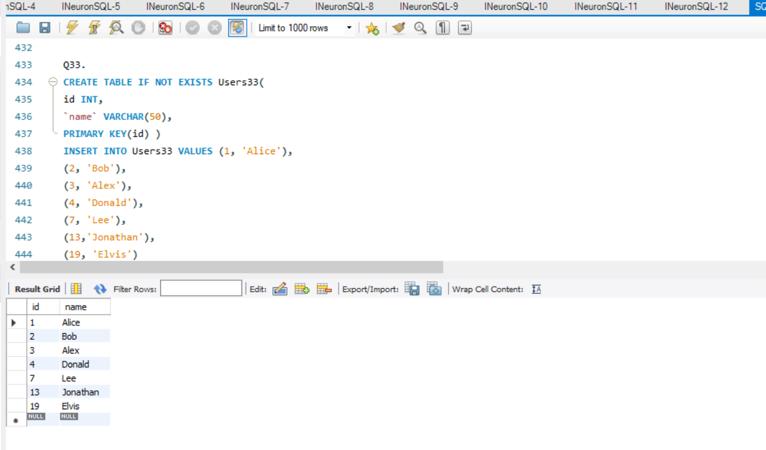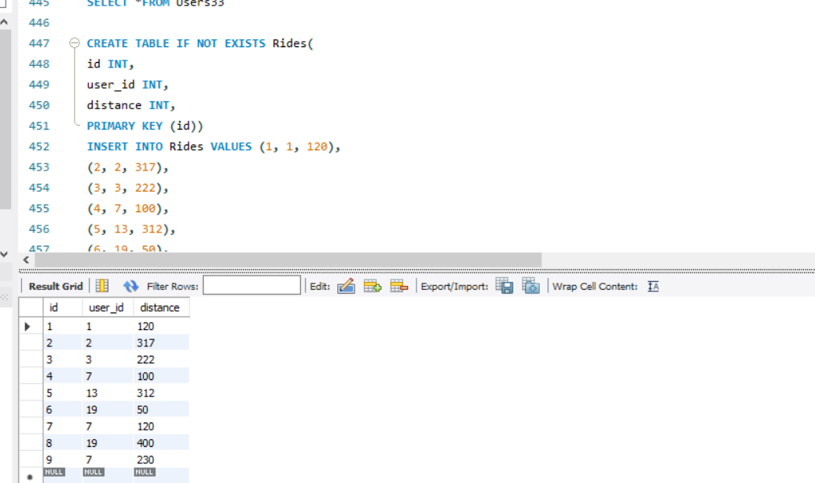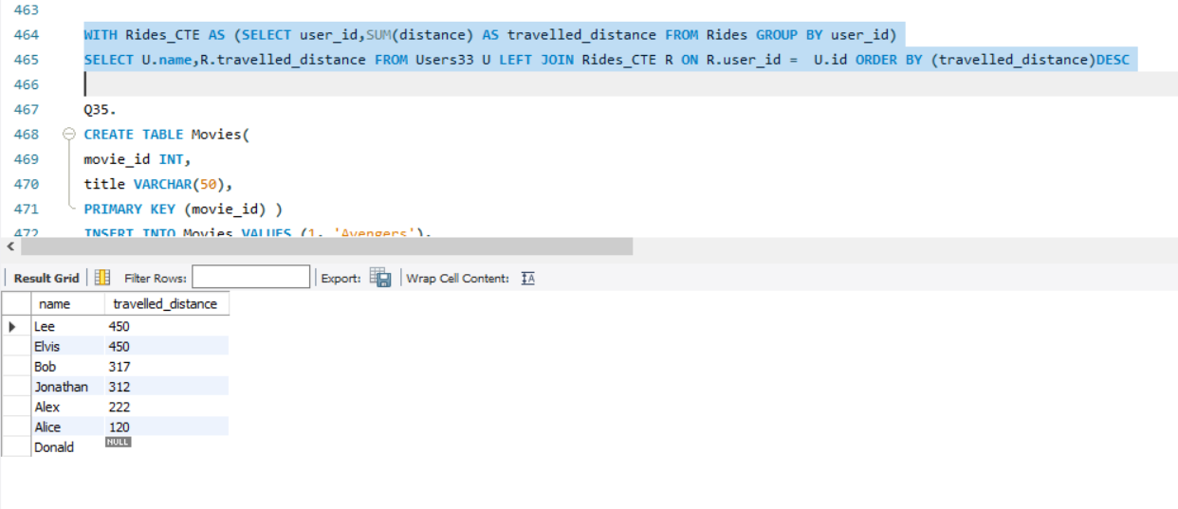

**Q35.** Write an SQL query to:

● Find the name of the user who has rated the greatest number of movies. In case of a tie,

return the lexicographically smaller user name.

● Find the movie name with the highest average rating in February 2020. In case of a tie, return

the lexicographically smaller movie name.

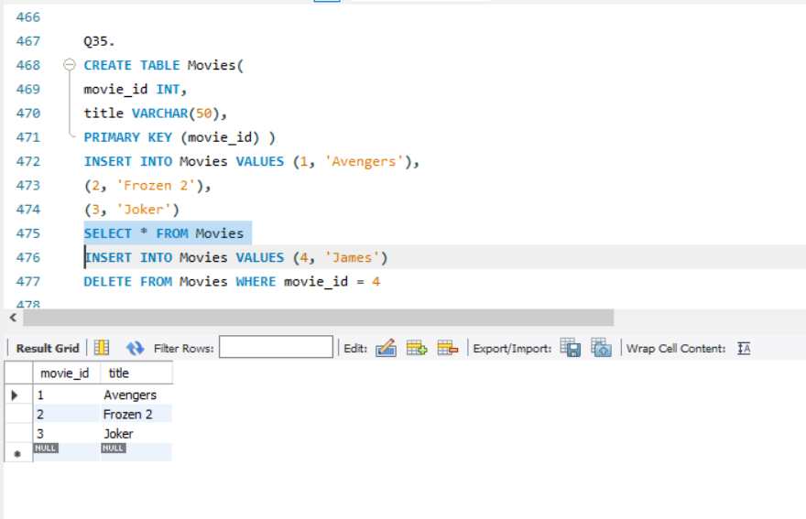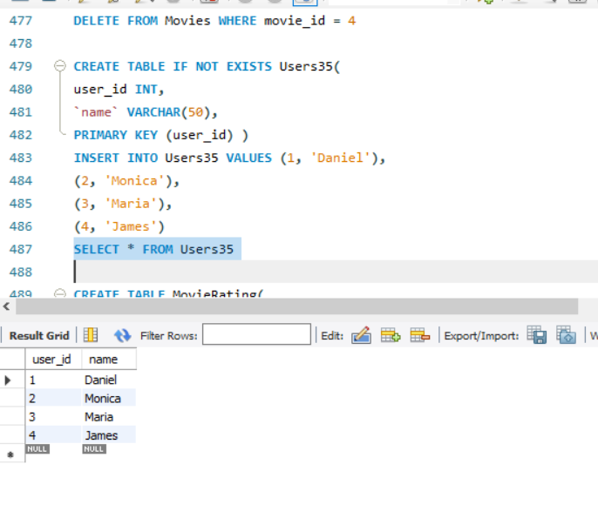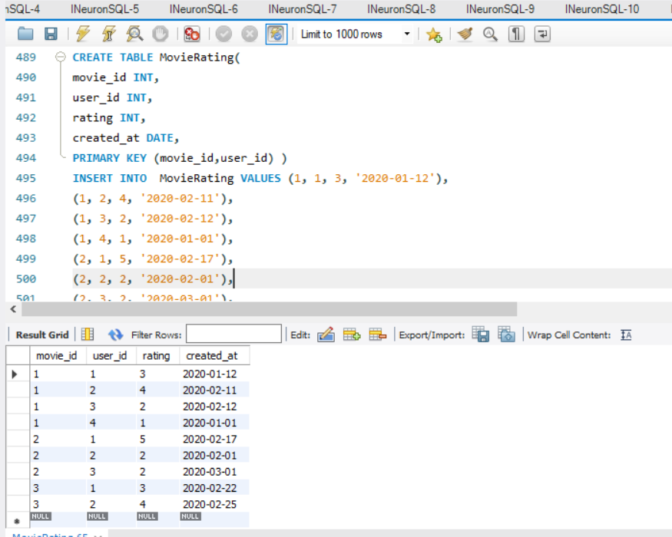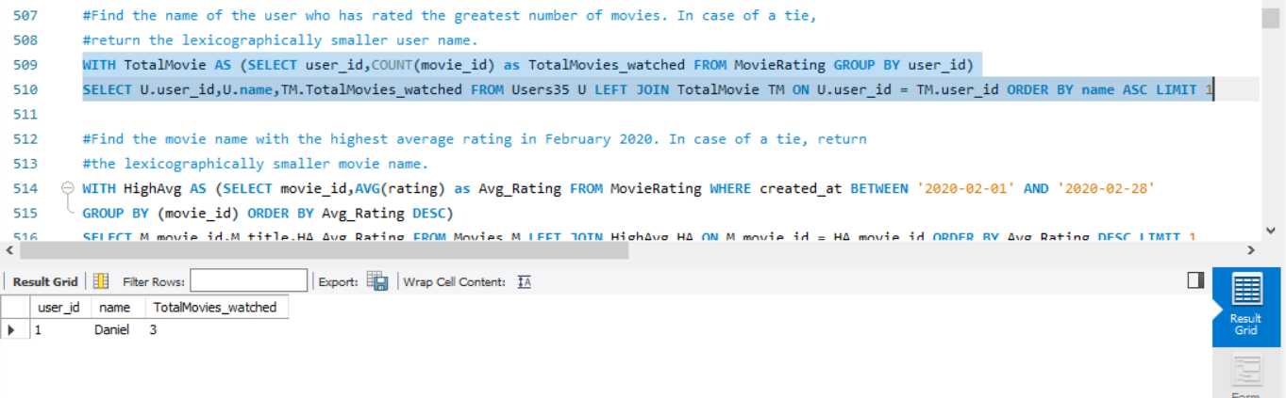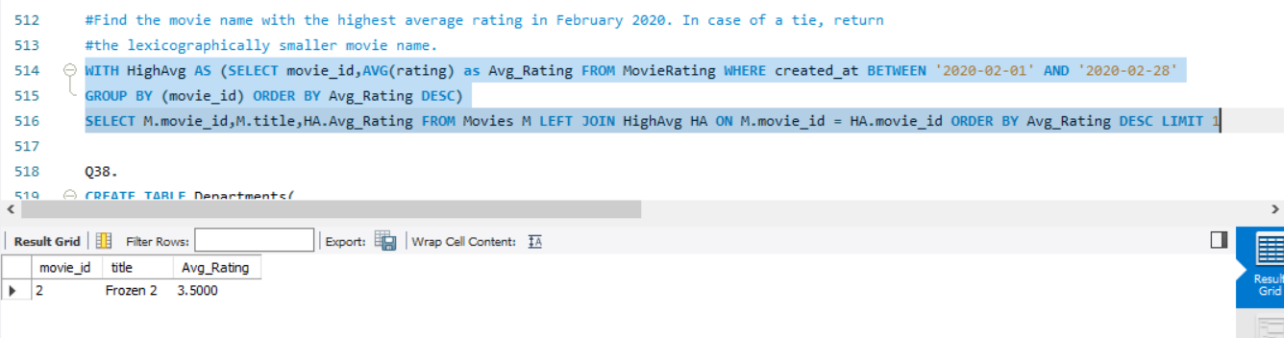

**Q38.** Write an SQL query to find the id and the name of all students who are enrolled in departments that no longer exist.

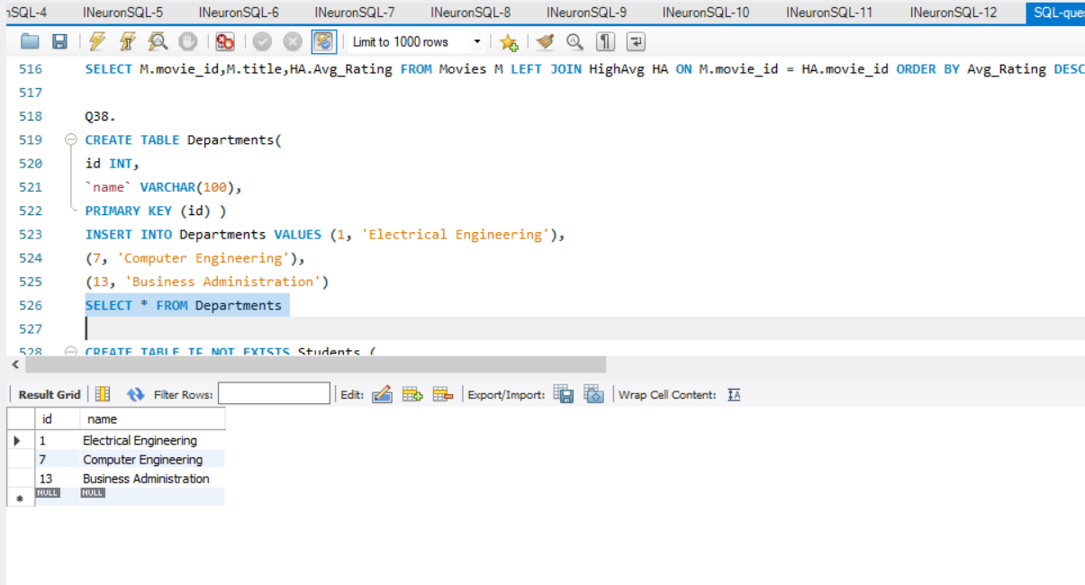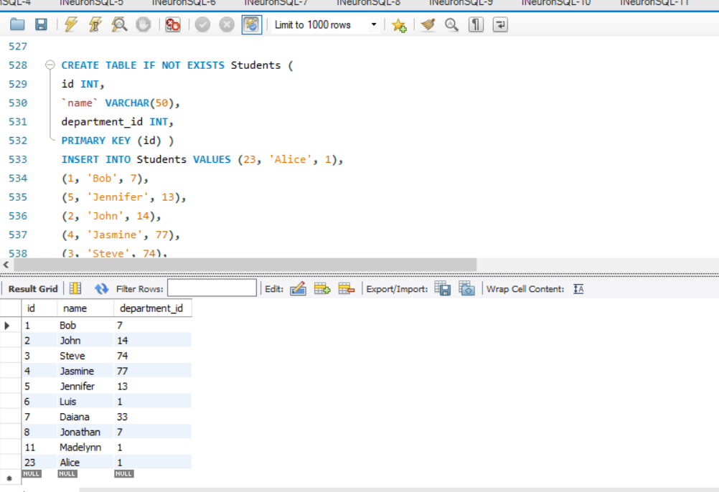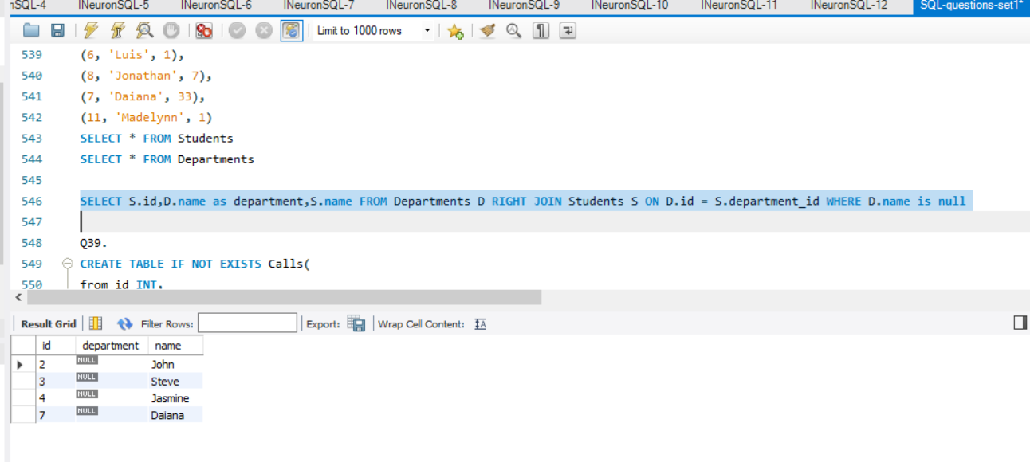

**Q39.** Write an SQL query to report the number of calls and the total call duration between each pair of distinct persons (person1, person2) where person1 < person2.

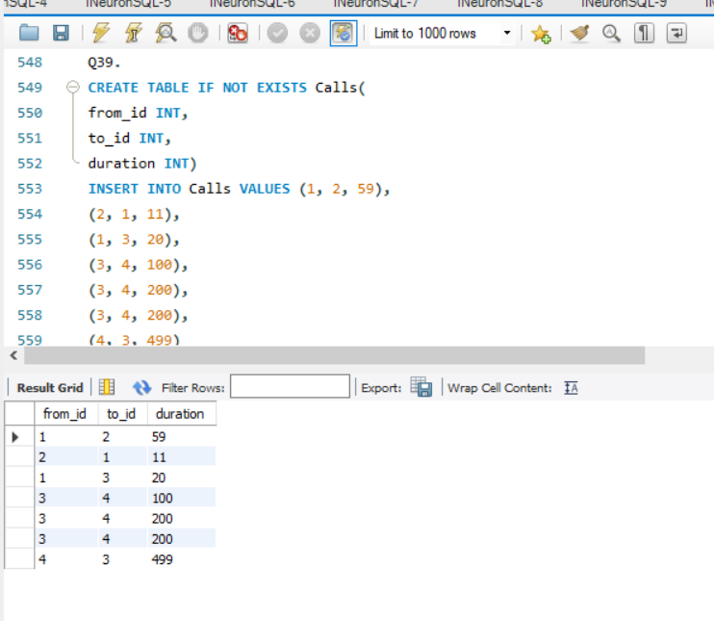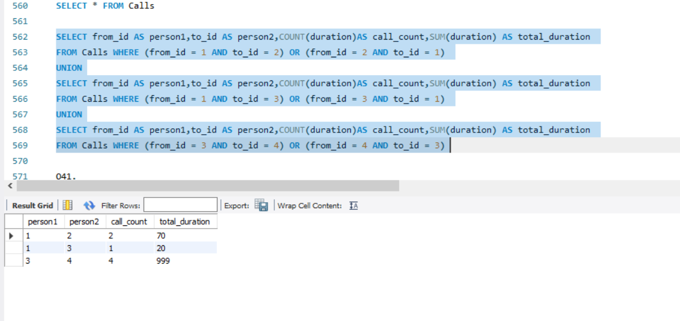

**Q41.** Write an SQL query to report the number of cubic feet of volume the inventory occupies in each warehouse.

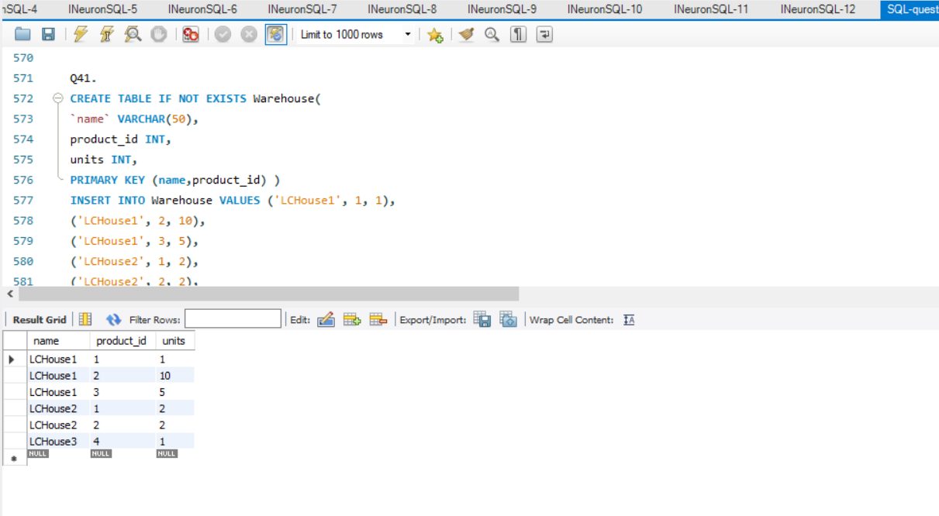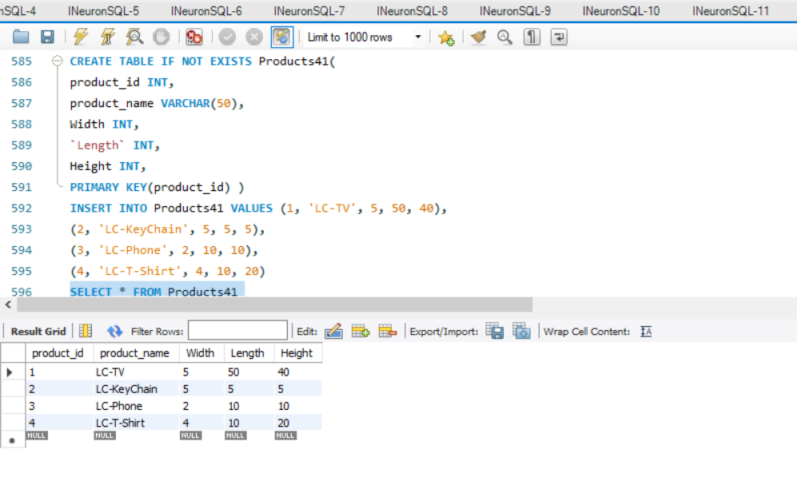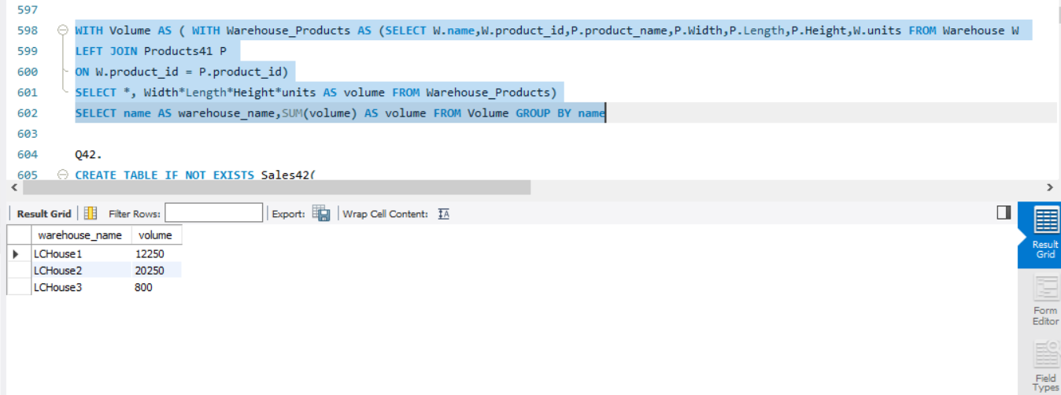

**Q42.** Write an SQL query to report the difference between the number of apples and oranges sold each day. Return the result table ordered by sale_date.

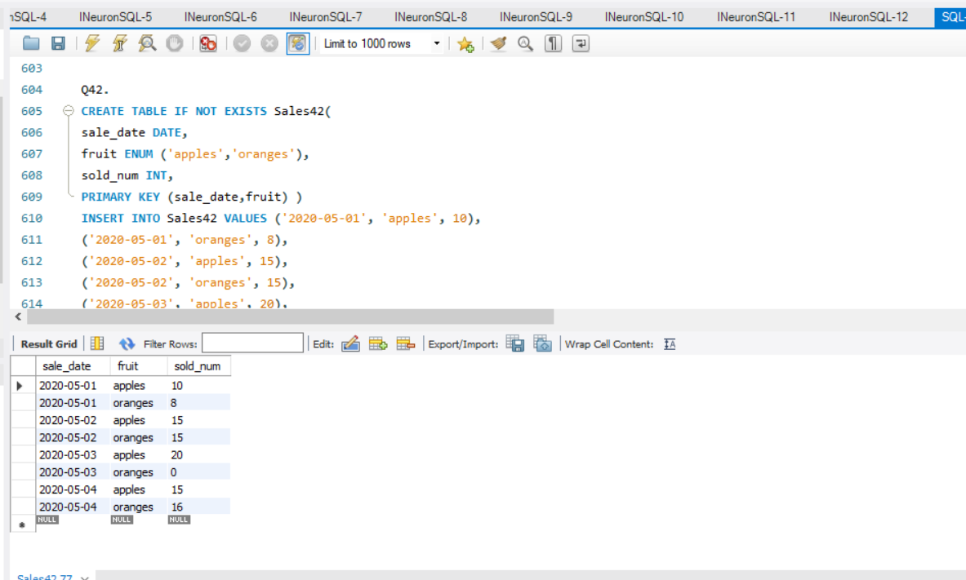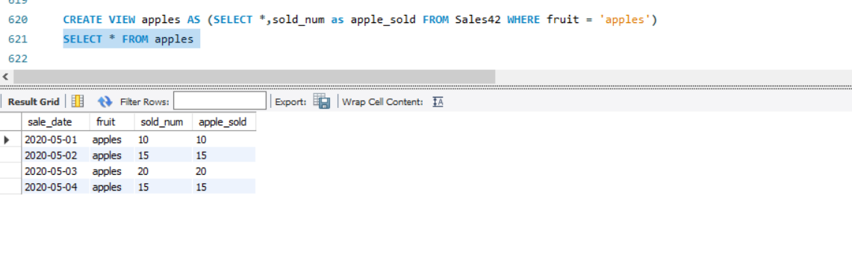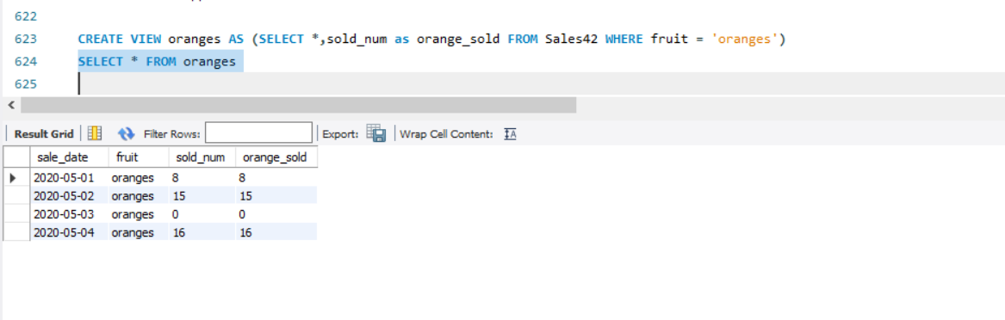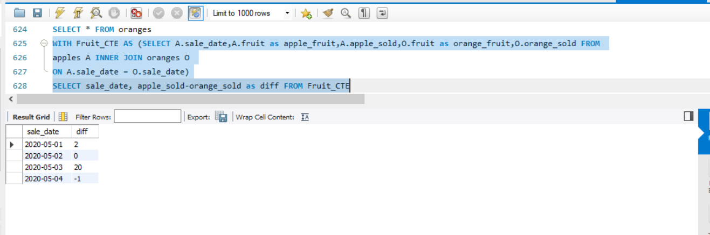

**Q43.** Write an SQL query to report the fraction of players that logged in again on the day after the day they first logged in, rounded to 2 decimal places. In other words, you need to count the number of players that logged in for at least two consecutive days starting from their first login date, then divide that number by the total number of players.

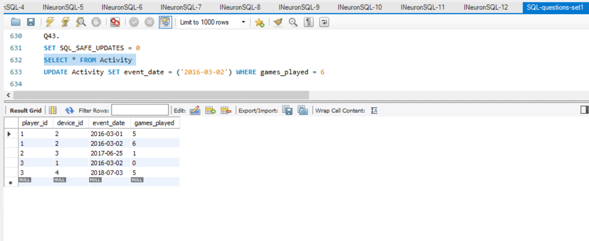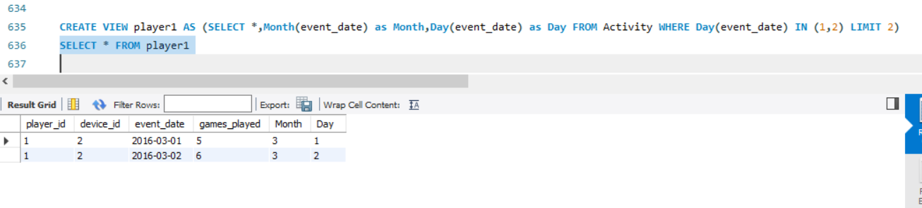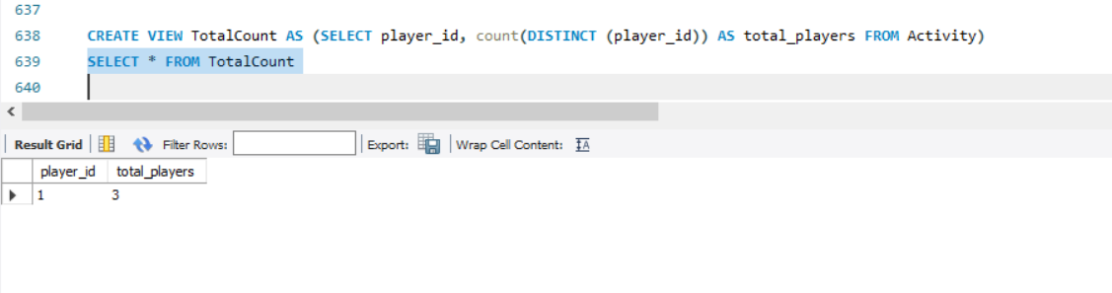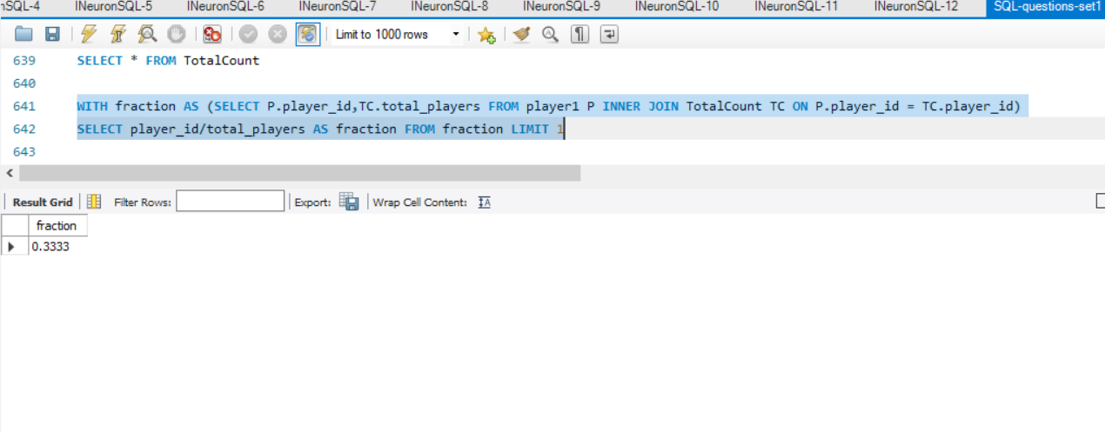

**Q44.** Write an SQL query to report the managers with at least five direct reports.Return the result table in any order.

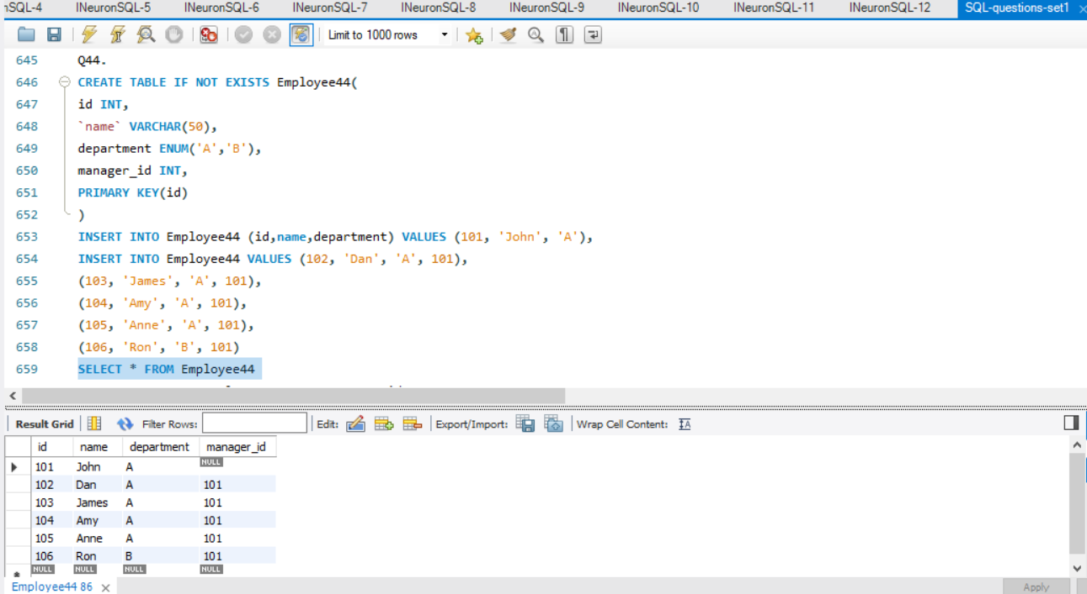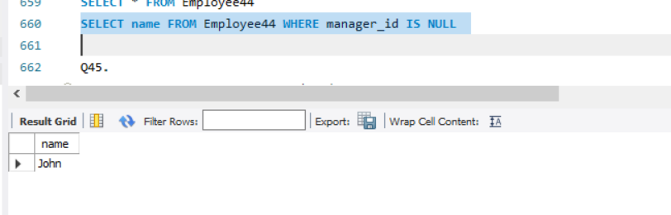

**Q45.** Write an SQL query to report the respective department name and number of students majoring in each department for all departments in the Department table (even ones with no current students).Return the result table ordered by student_number in descending order. In case of a tie, order them by dept_name alphabetically.

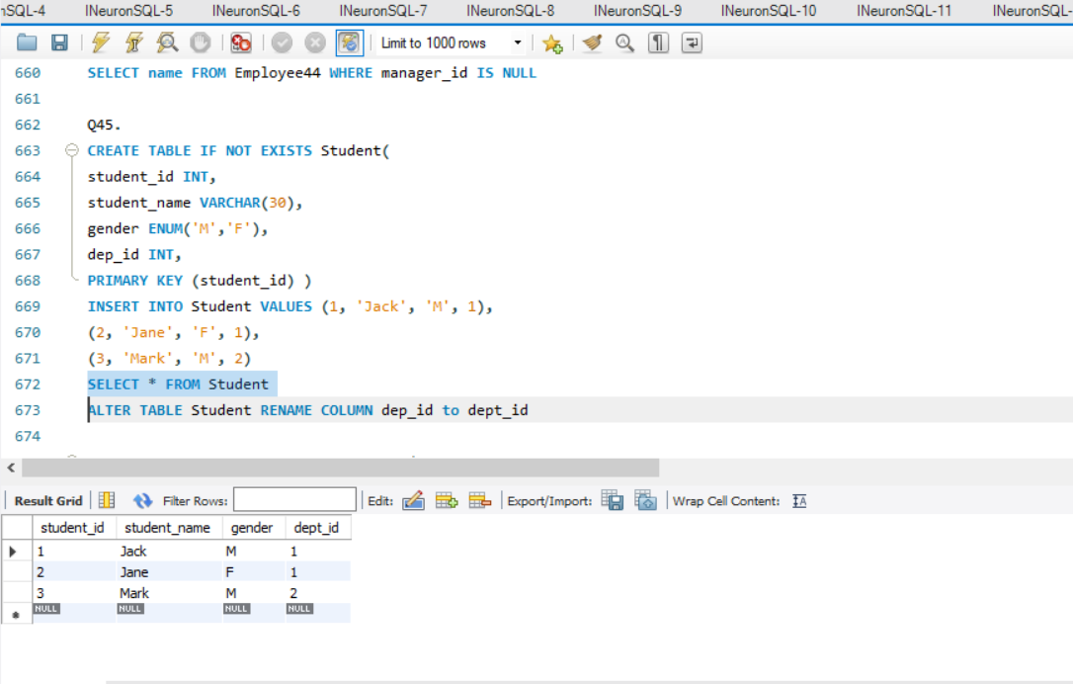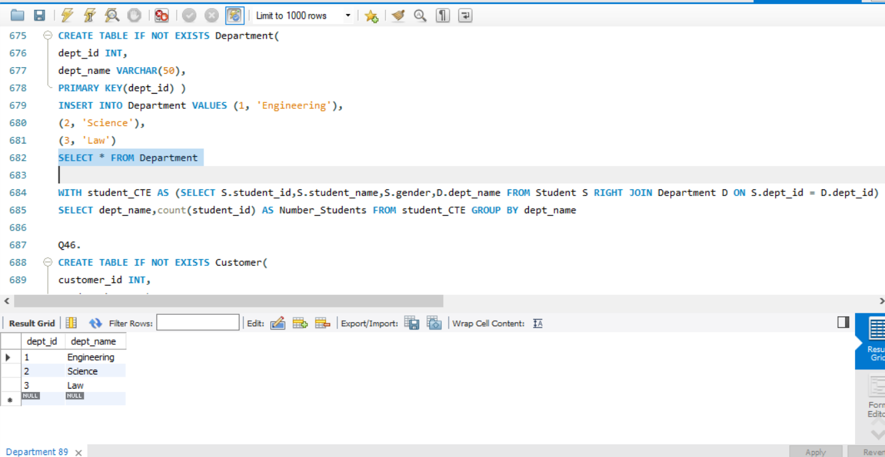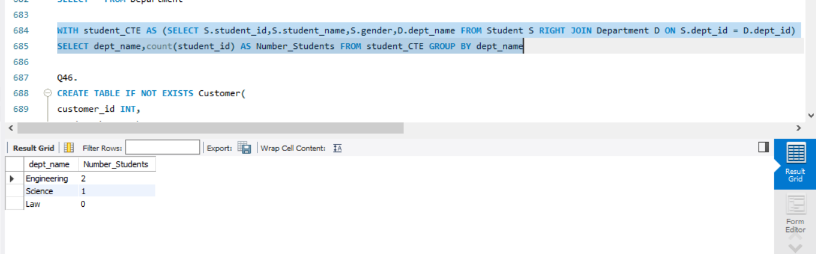

**Q46.** Write an SQL query to report the customer ids from the Customer table that bought all the products in the Product table.

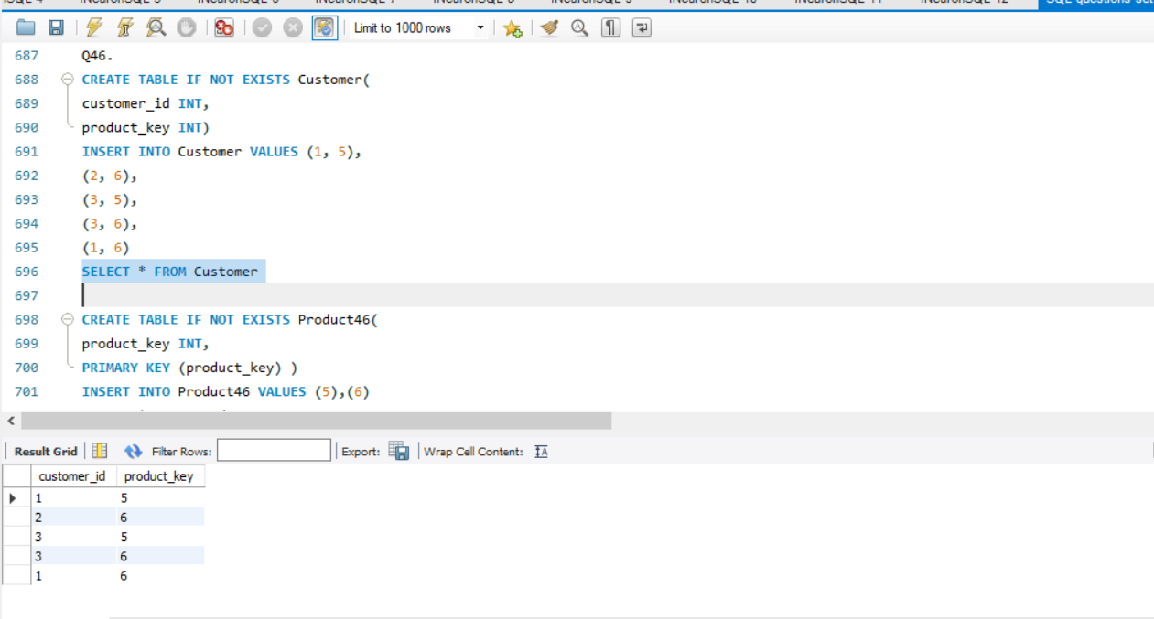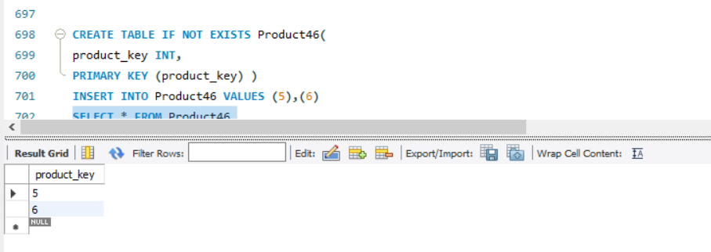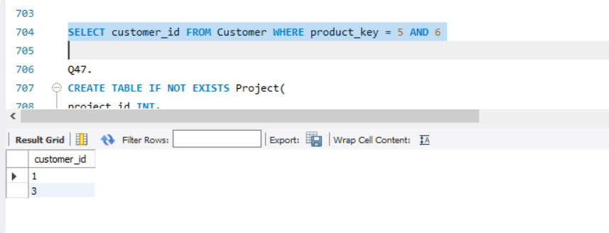

**Q47.** Write an SQL query that reports the most experienced employees in each project. In case of a tie,report all employees with the maximum number of experience years.

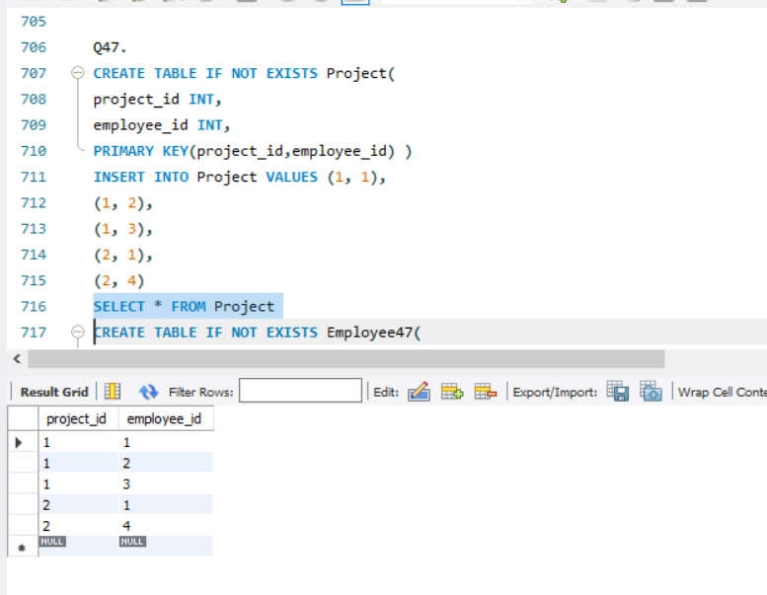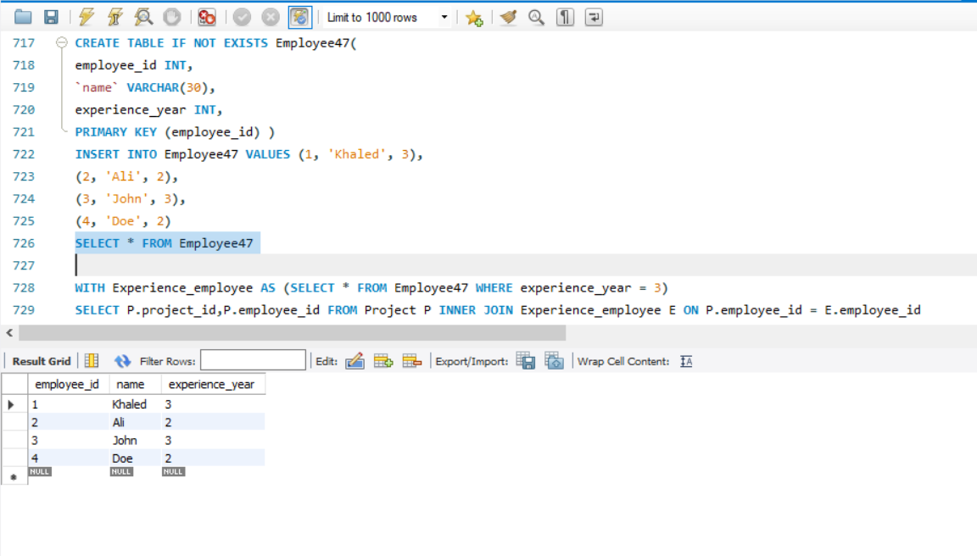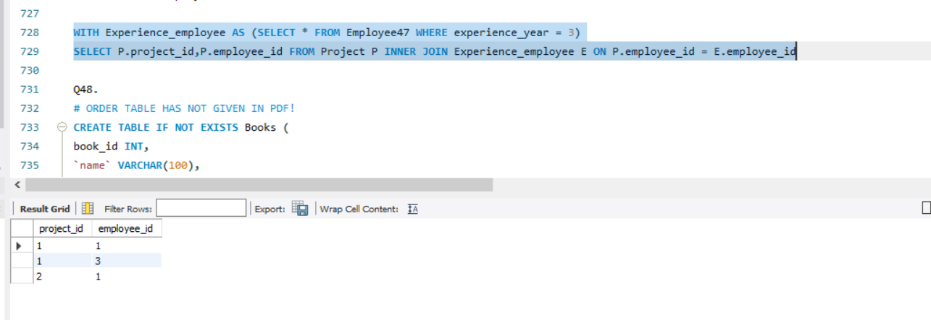

**Q49.** Write a SQL query to find the highest grade with its corresponding course for each student. In case of a tie, you should find the course with the smallest course_id.

Return the result table ordered by student_id in ascending order.

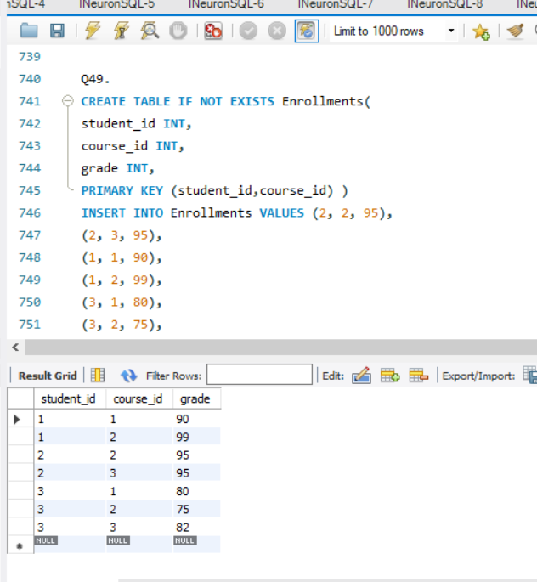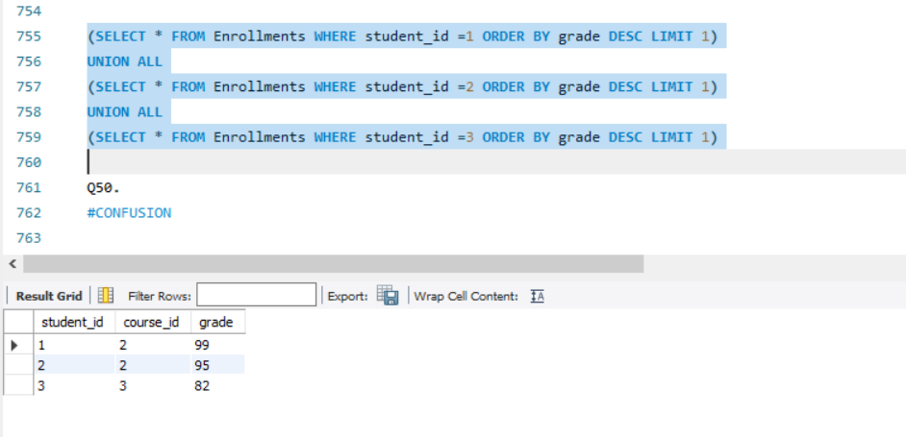

**Q51.** Write an SQL query to report the name, population, and area of the big countries. Return the result table in any order.

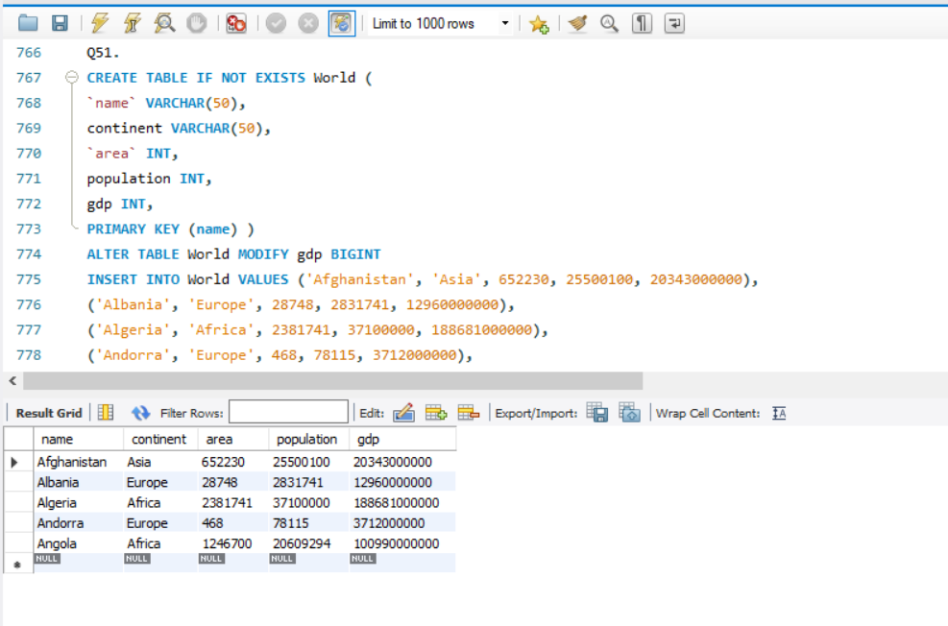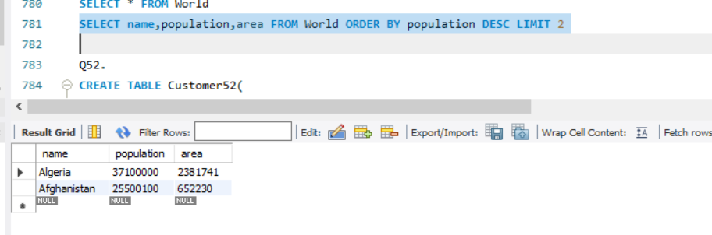

**Q52.** Write an SQL query to report the names of the customer that are not referred by the customer with id = 2.

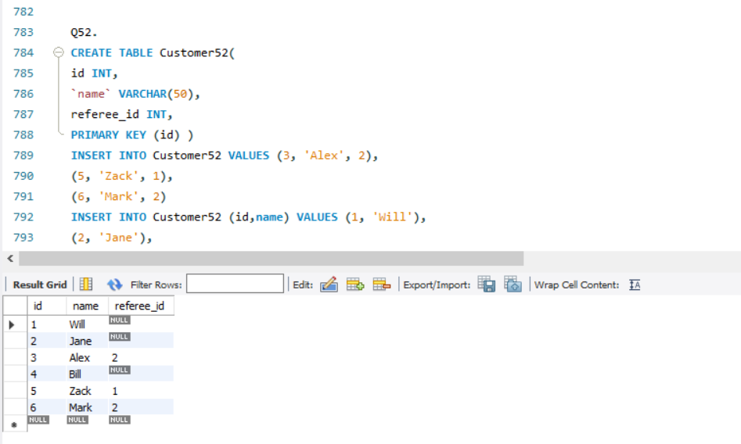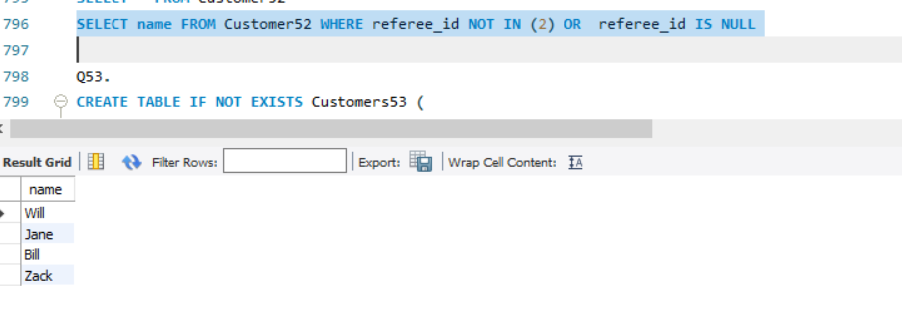

**Q53.** Write an SQL query to report all customers who never order anything.

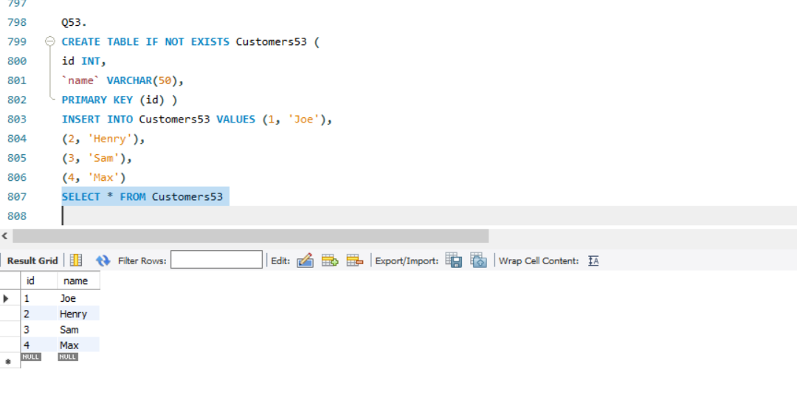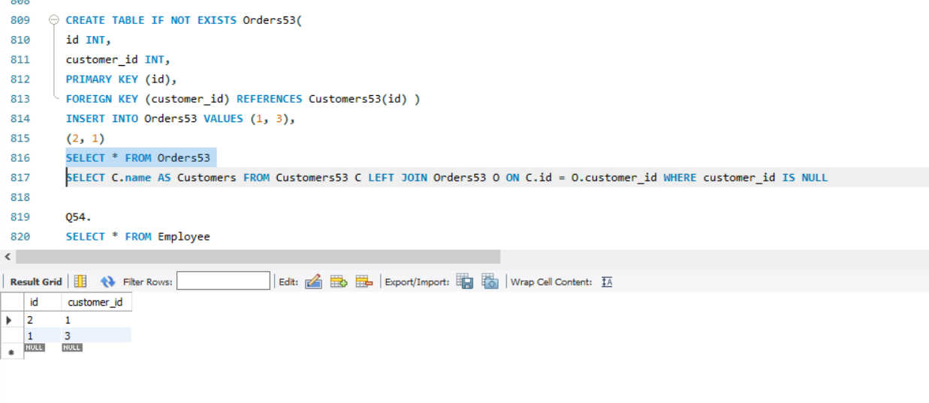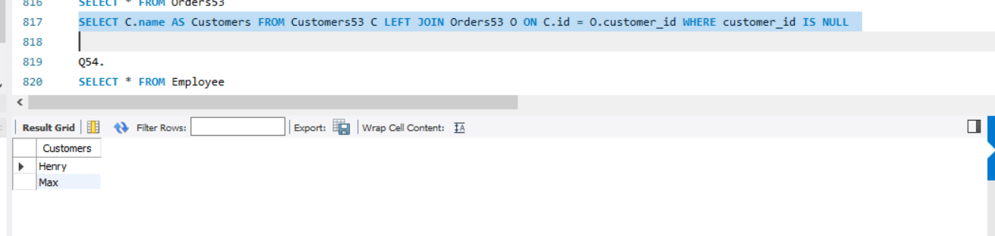

**Q54.** Write an SQL query to find the team size of each of the employees.

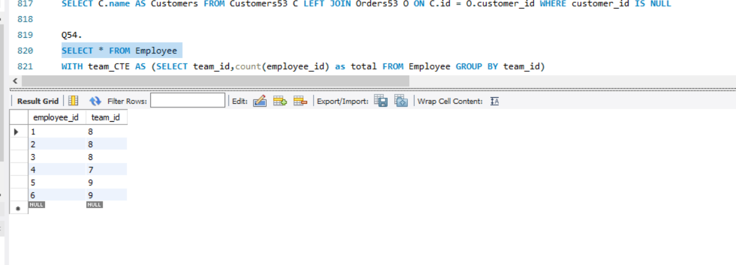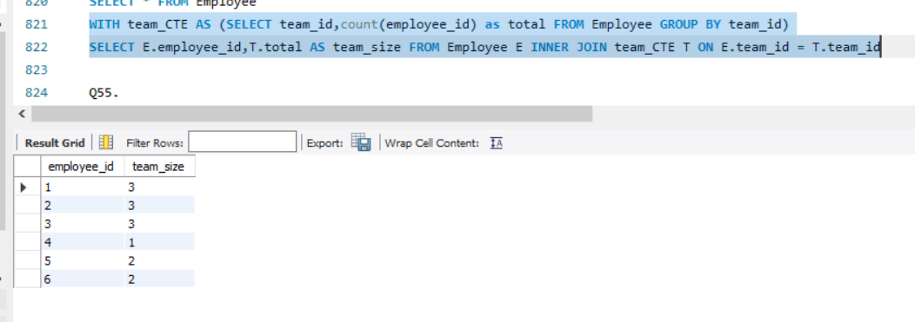

**Q55.**Write an SQL query to find the countries where this company can invest.

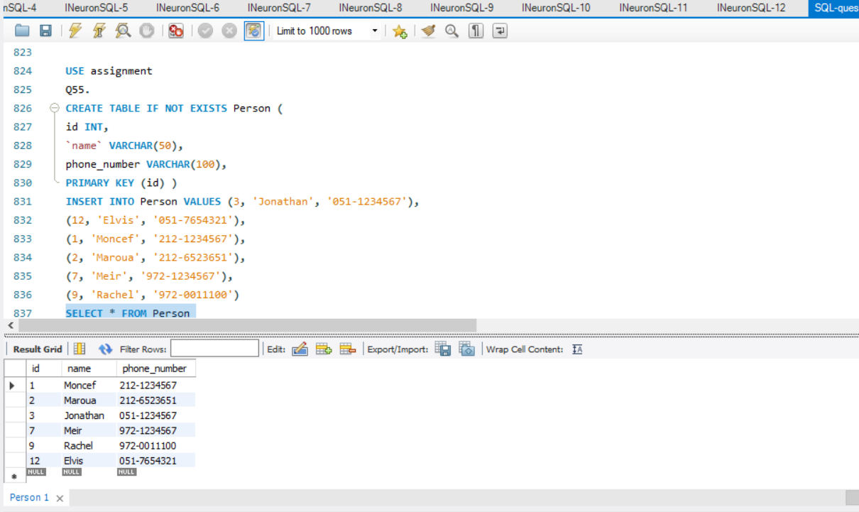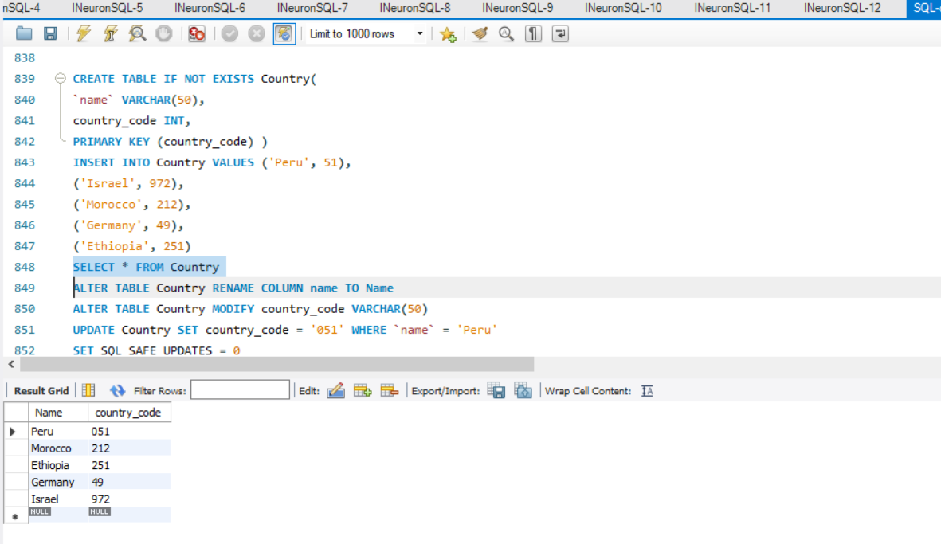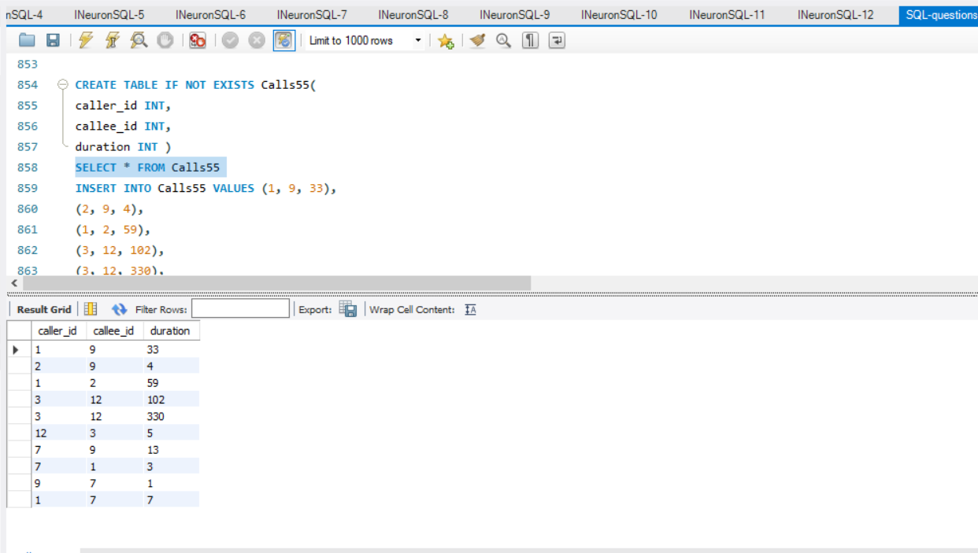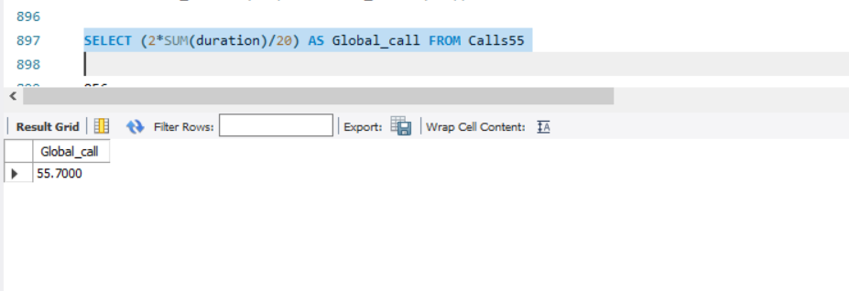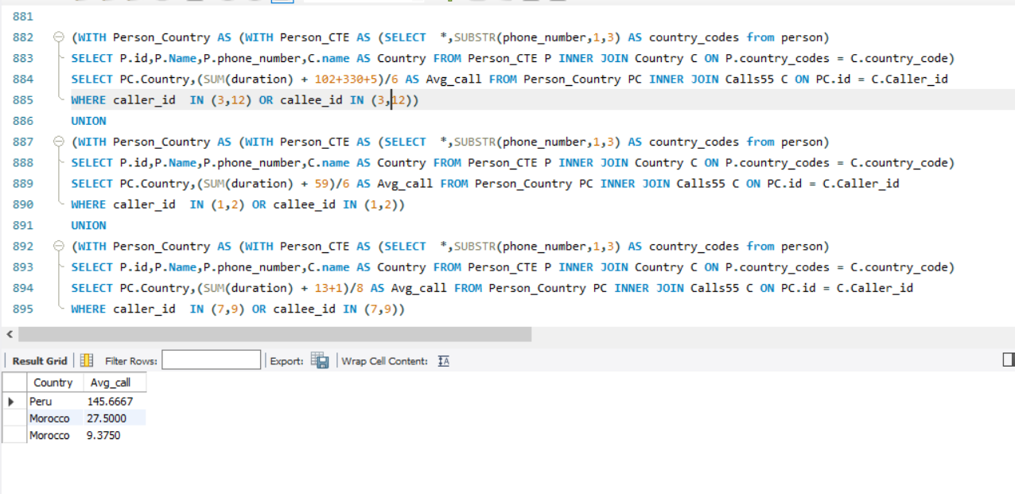

**Q56.** Write an SQL query to report the device that is first logged in for each player.

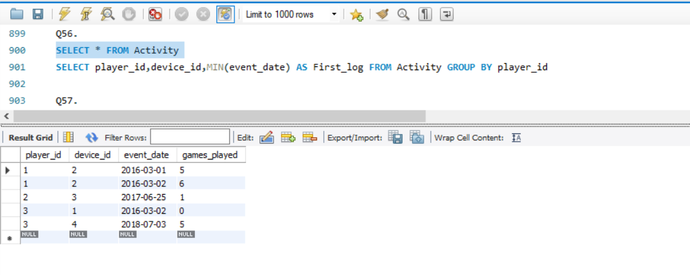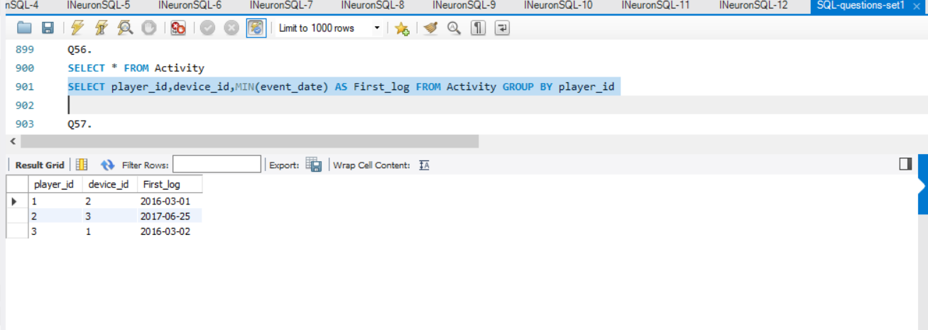

**Q57.** Write an SQL query to find the customer_number for the customer who has placed the largest number of orders.

The test cases are generated so that exactly one customer will have placed more orders than any other customer.

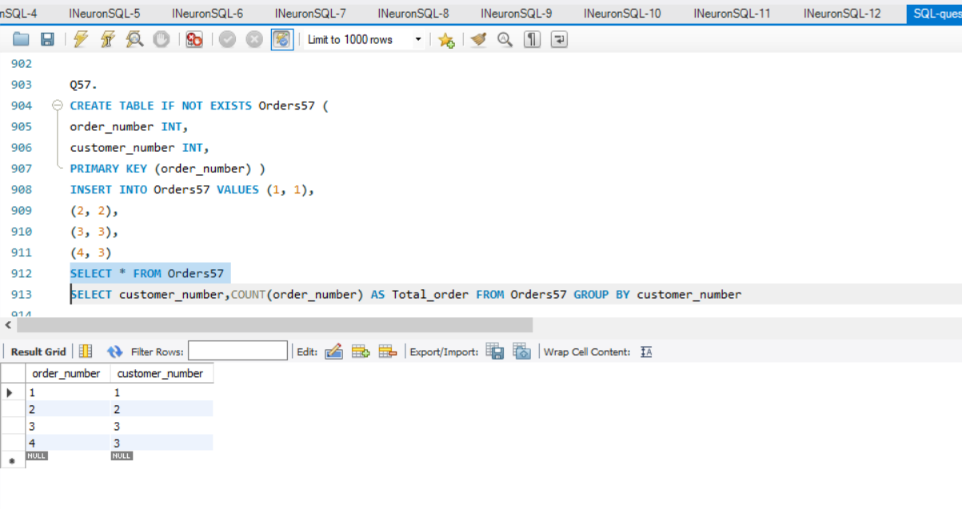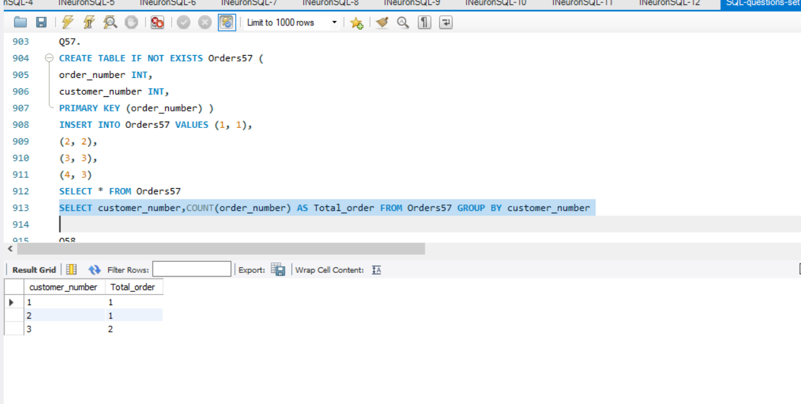

**Q58.** Write an SQL query to report all the consecutive available seats in the cinema.Return the result table ordered by seat_id in ascending order.The test cases are generated so that more than two seats are consecutively available.

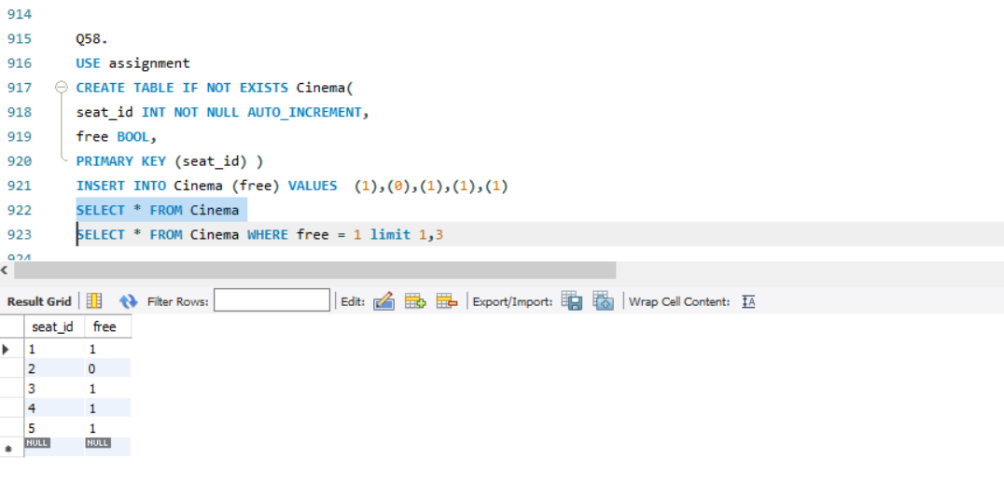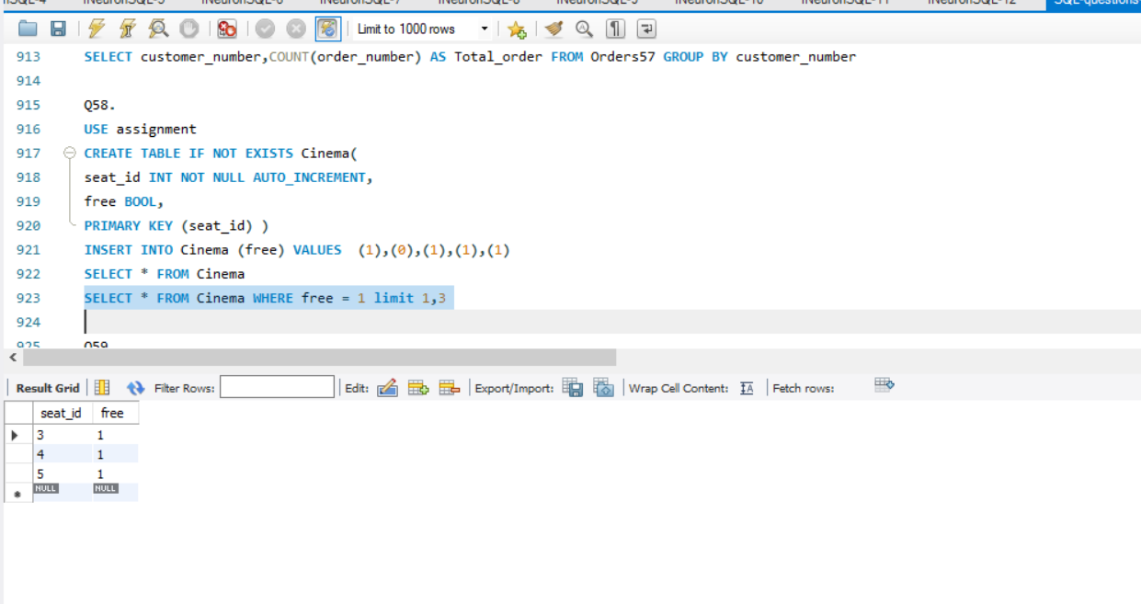

**Q59.** Write an SQL query to report the names of all the salespersons who did not have any orders related to the company with the name "RED".

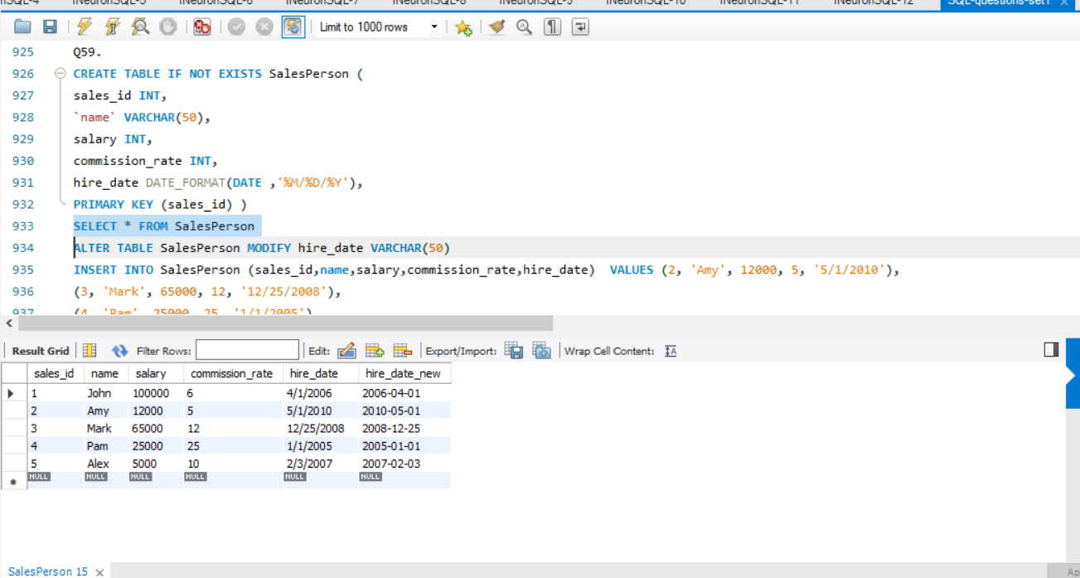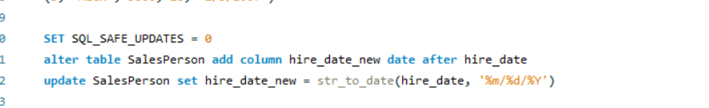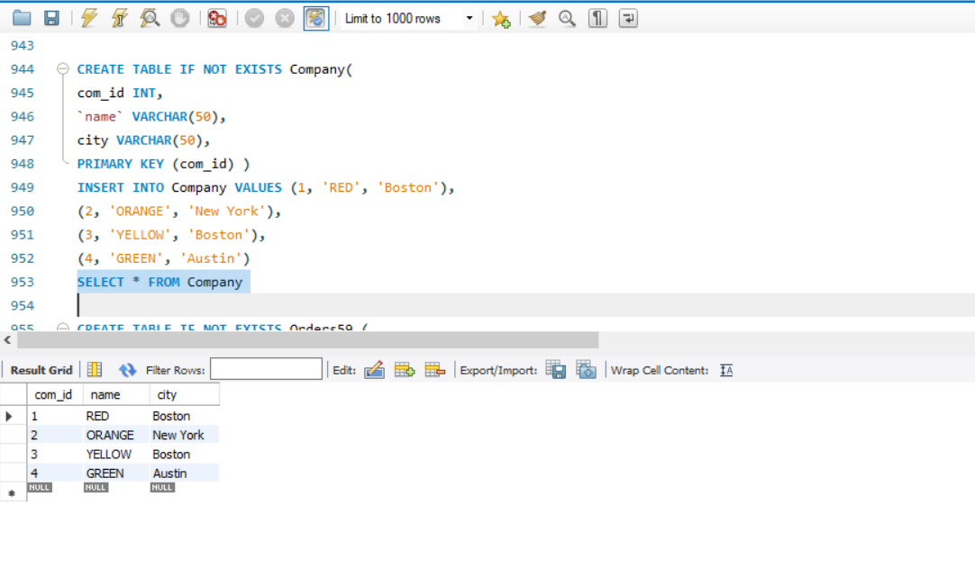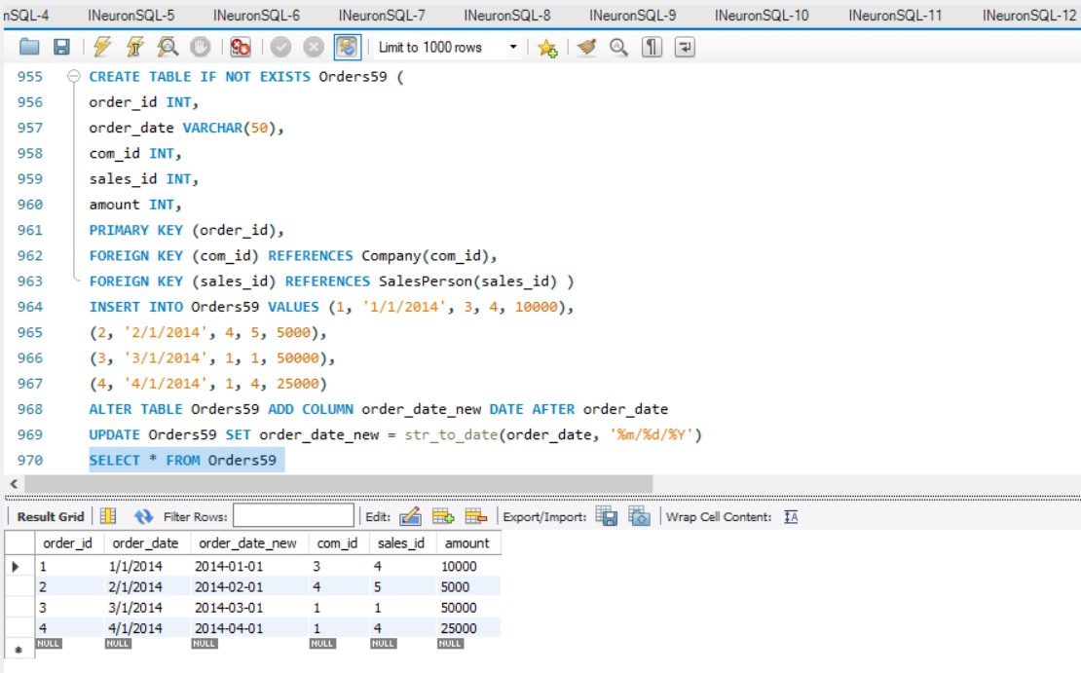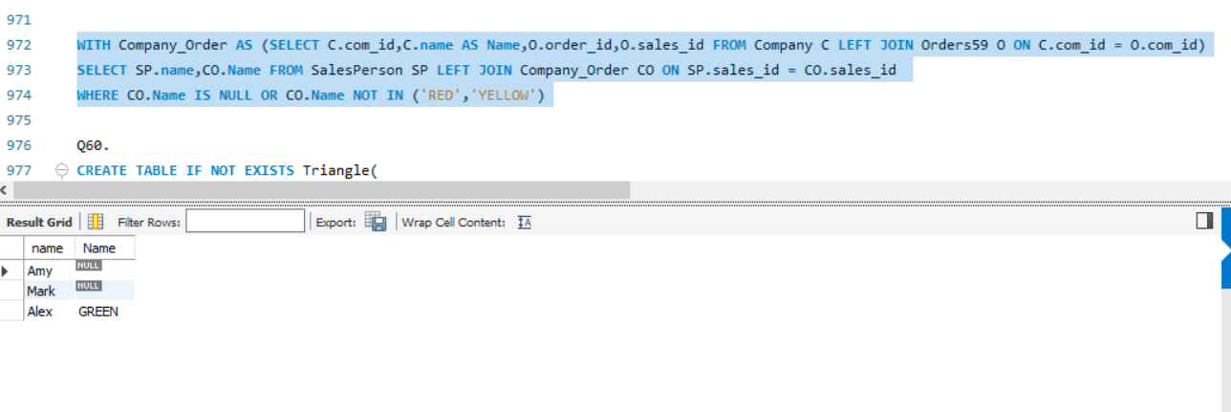

**Q60.** Write an SQL query to report for every three line segments whether they can form a triangle.

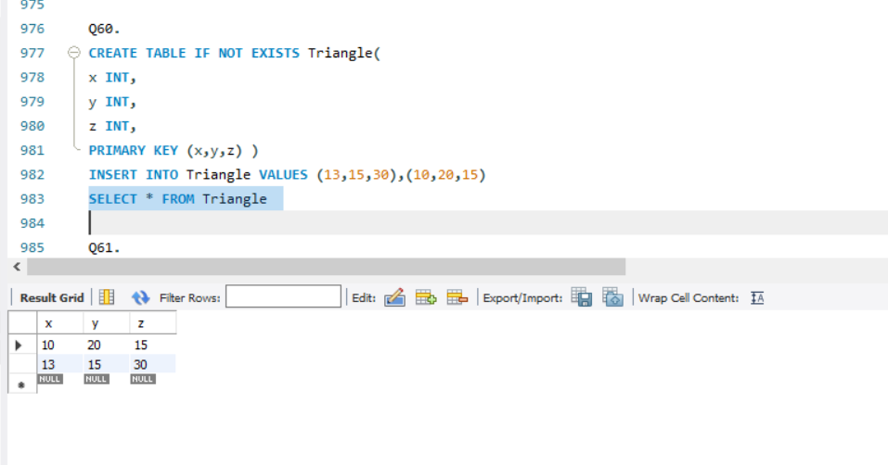

**Q62.** Write a SQL query for a report that provides the pairs (actor_id, director_id) where the actor has cooperated with the director at least three times.

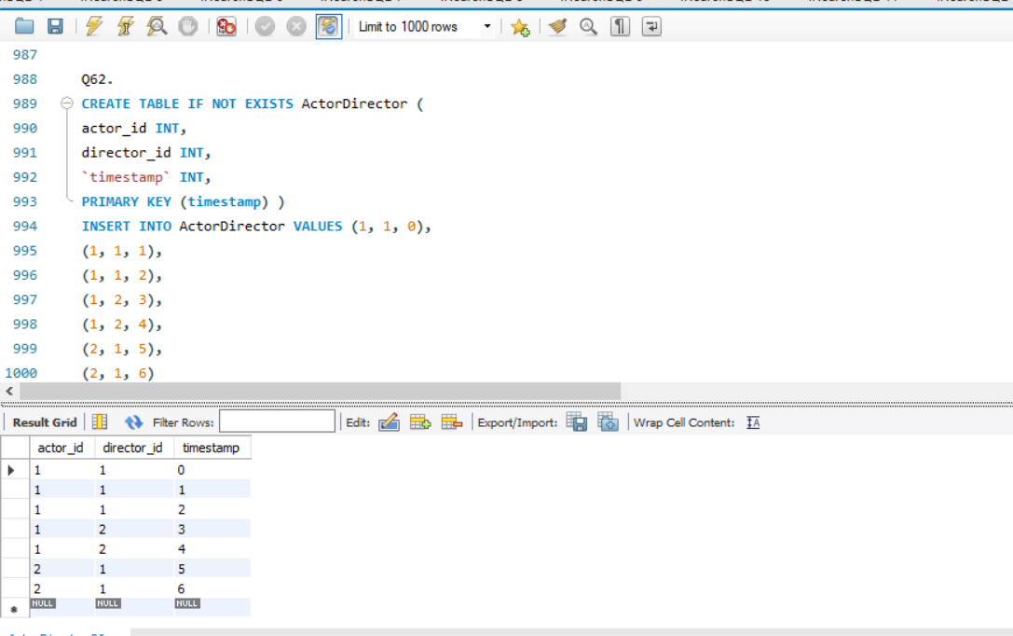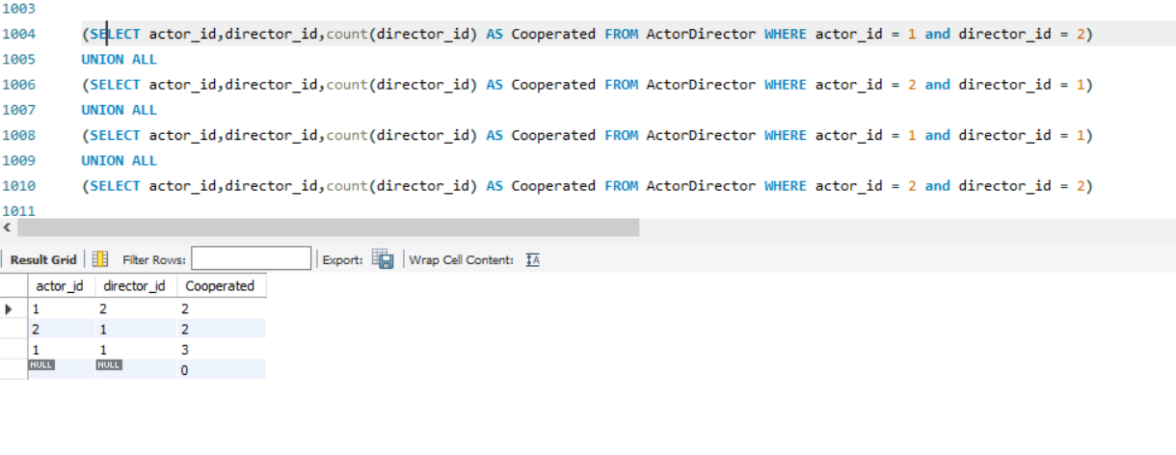

**Q63.** Write an SQL query that reports the product_name, year, and price for each sale_id in the Sales table.

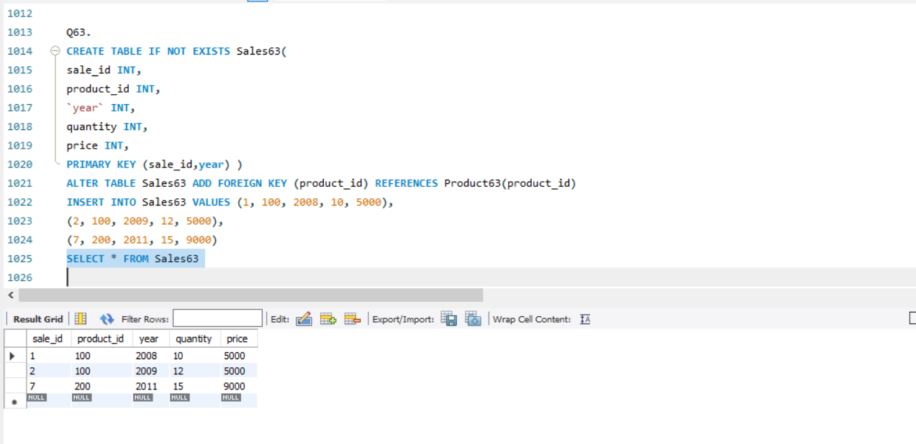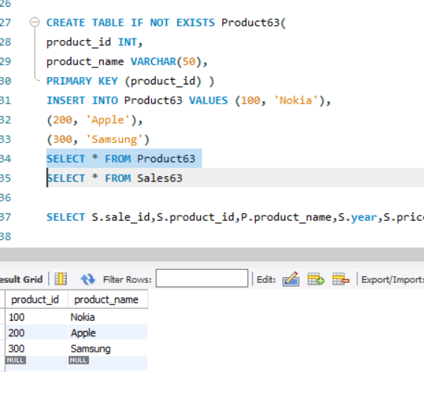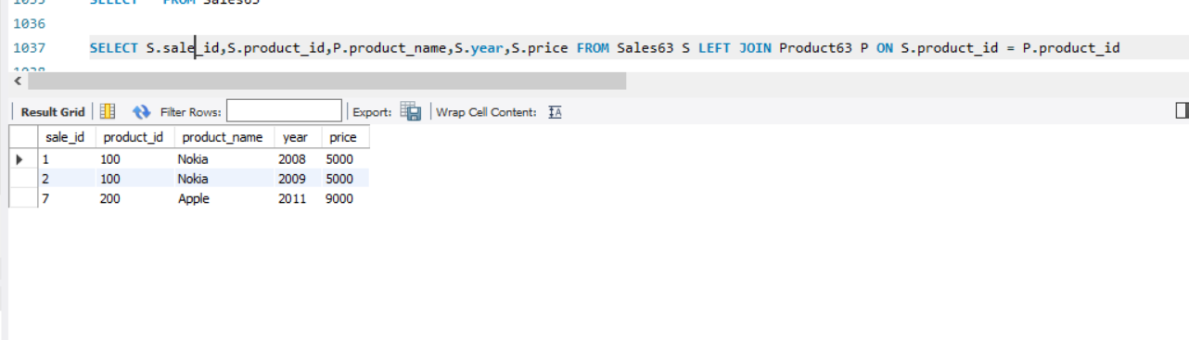

**Q64.** Write an SQL query that reports the average experience years of all the employees for each project, rounded to 2 digits.

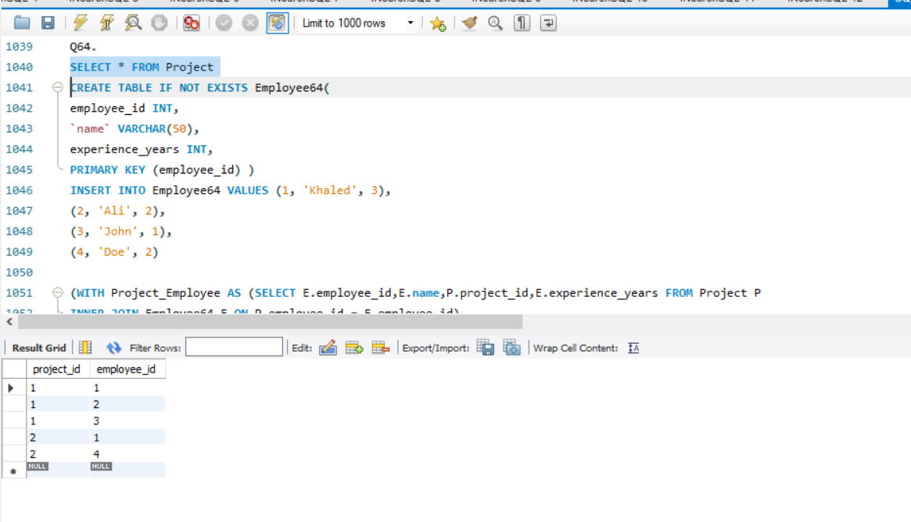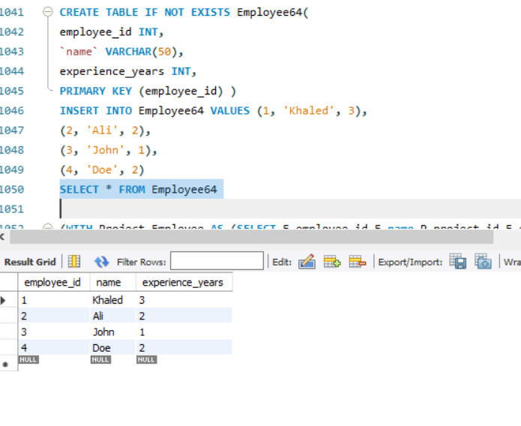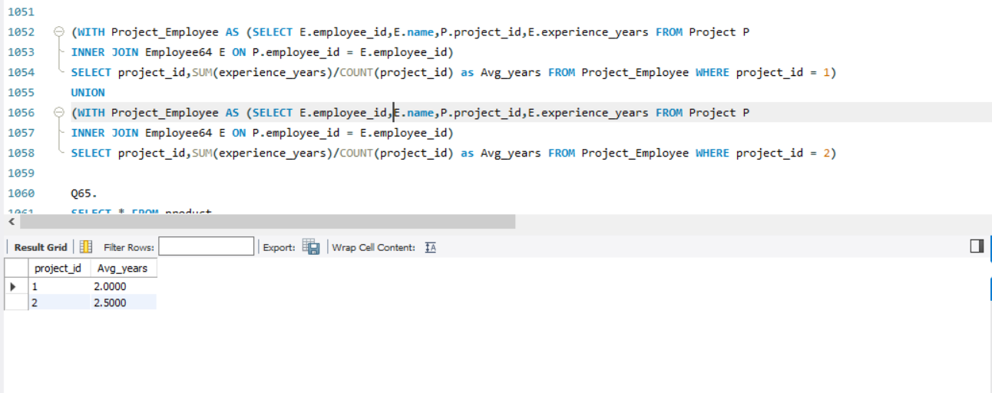

**Q65.** Write an SQL query that reports the best seller by total sales price, If there is a tie, report them all.

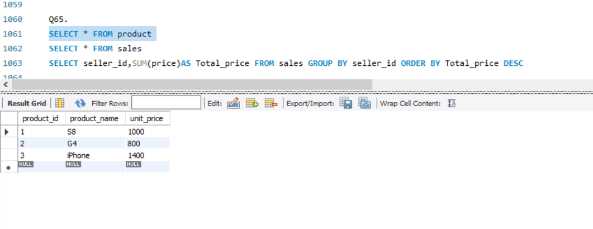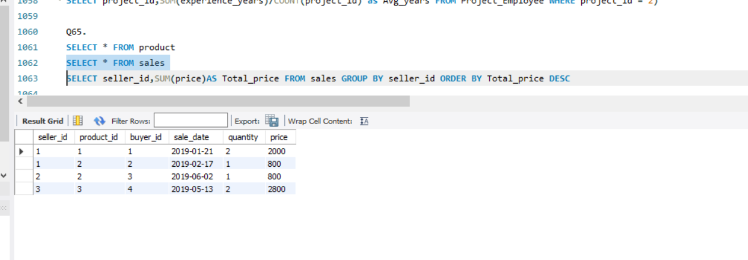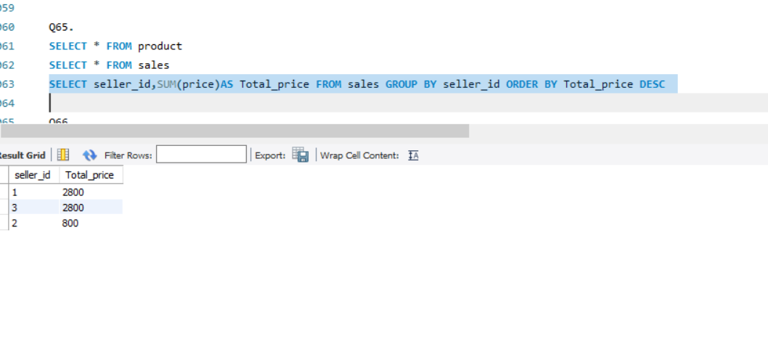

**Q66.** Write an SQL query that reports the buyers who have bought S8 but not iPhone. Note that S8 and iPhone are products present in the Product table.

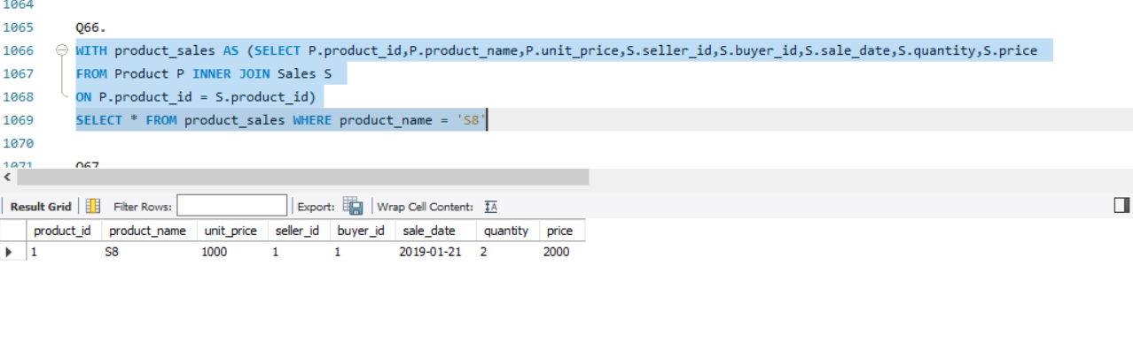

**Q67.** Write an SQL query to compute the moving average of how much the customer paid in a seven days window (i.e., current day + 6 days before). average_amount should be rounded to two decimal places.

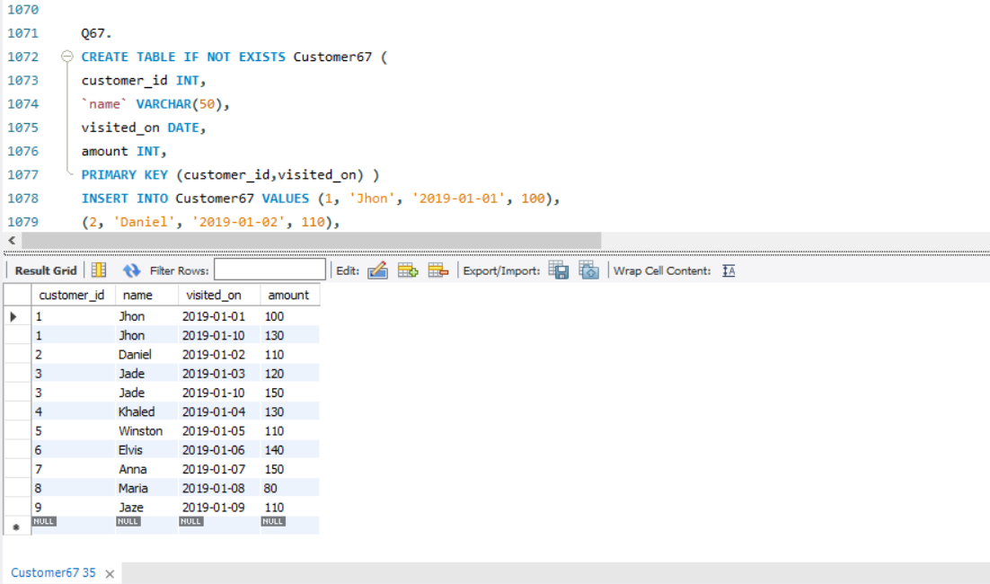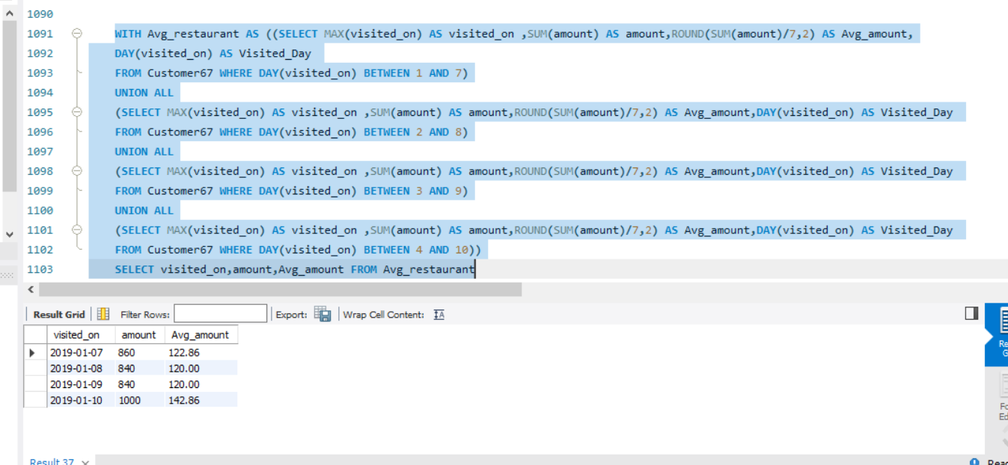

**Q68.** Write an SQL query to find the total score for each gender on each day.

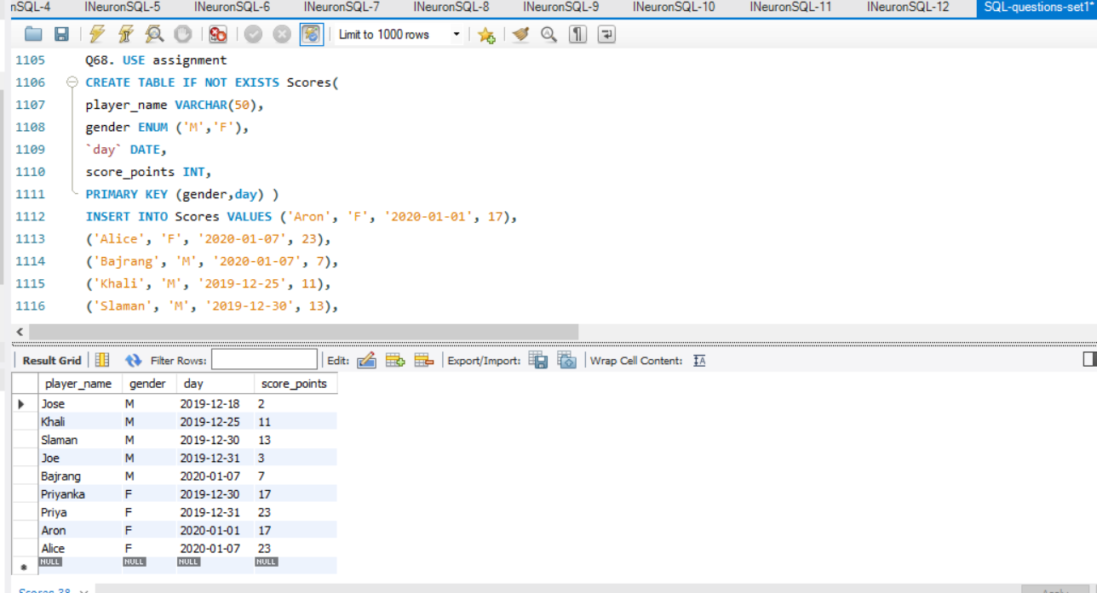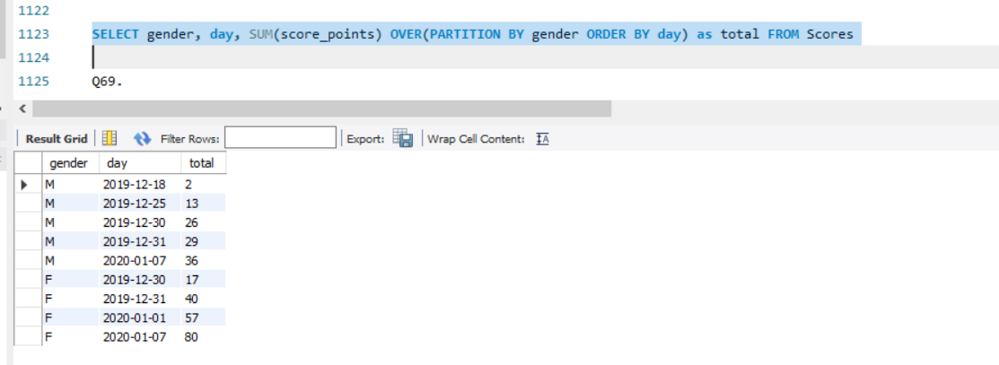

**Q70.** Write an SQL query to find the number of times each student attended each exam.

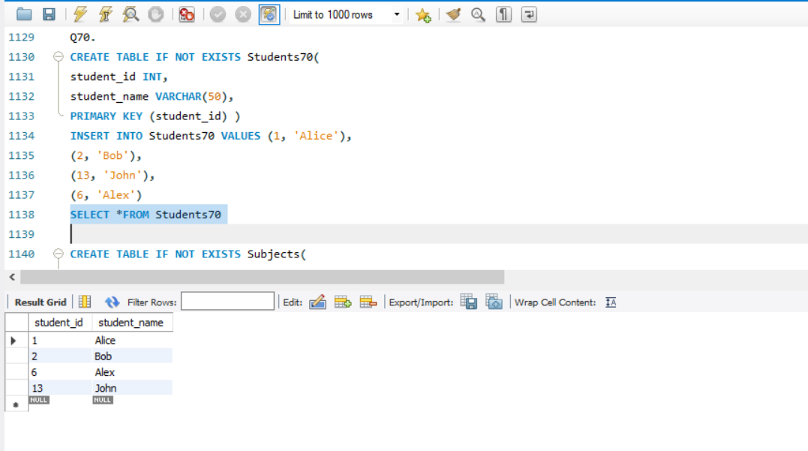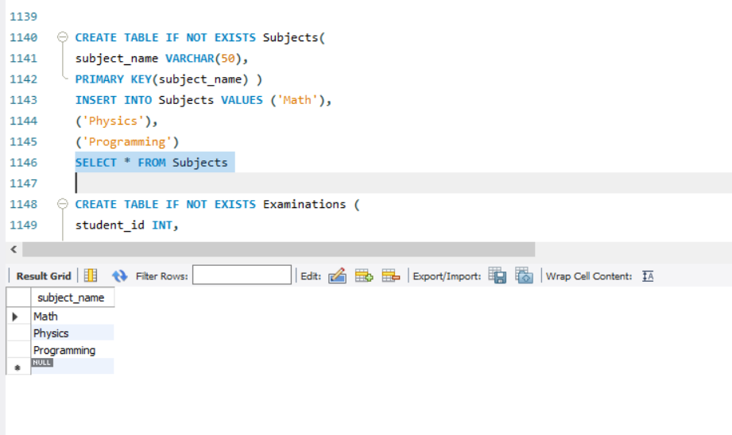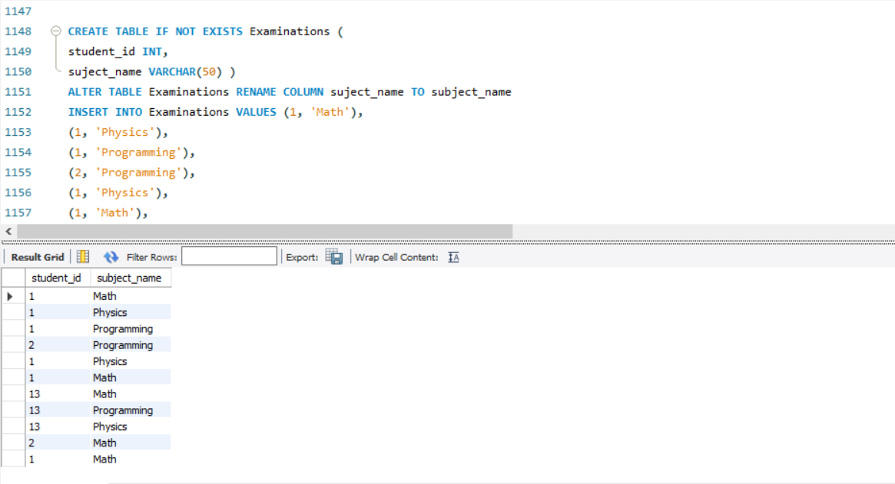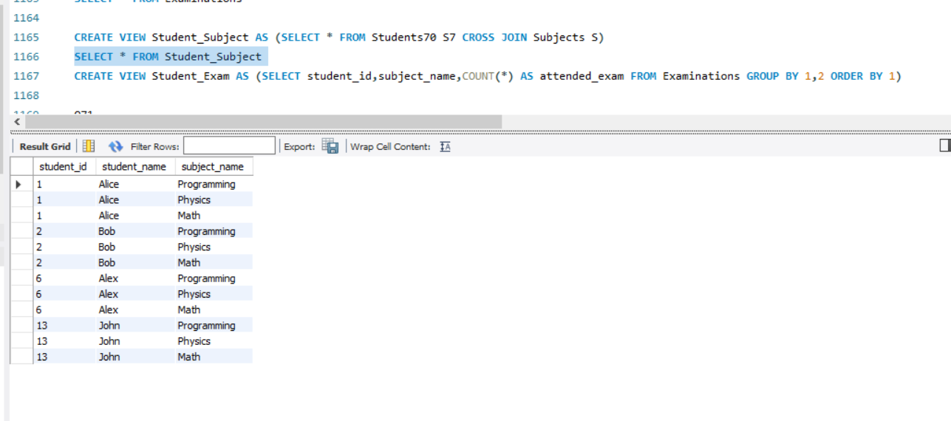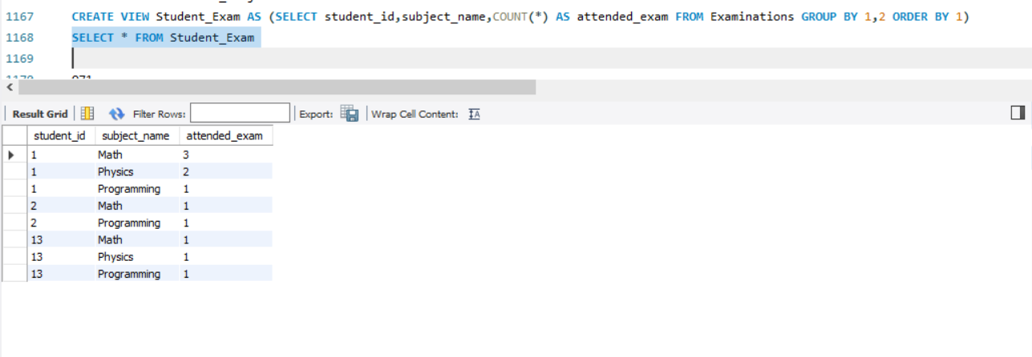

**Q71.** Write an SQL query to find employee_id of all employees that directly or indirectly report their work to the head of the company.

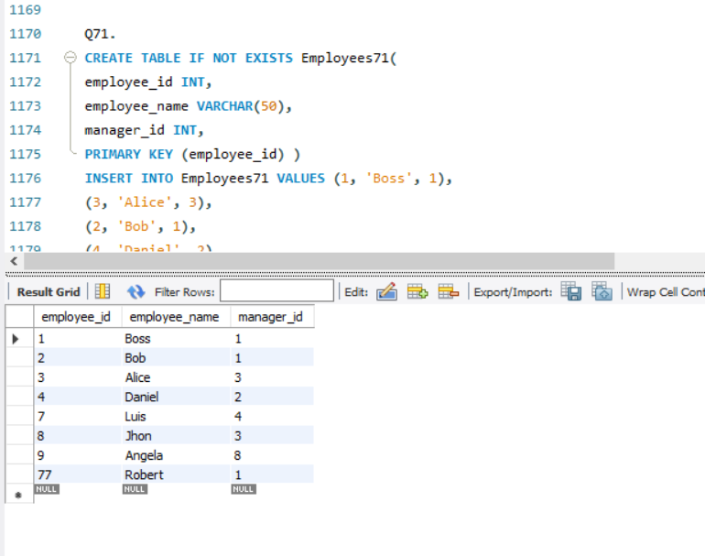

**Q72.** Write an SQL query to find for each month and country, the number of transactions and their total amount, the number of approved transactions and their total amount.

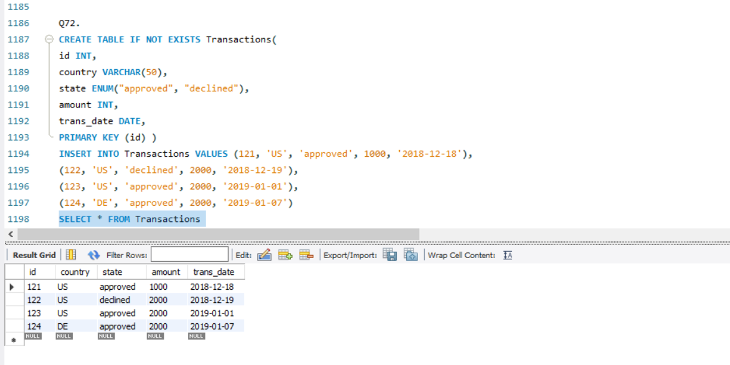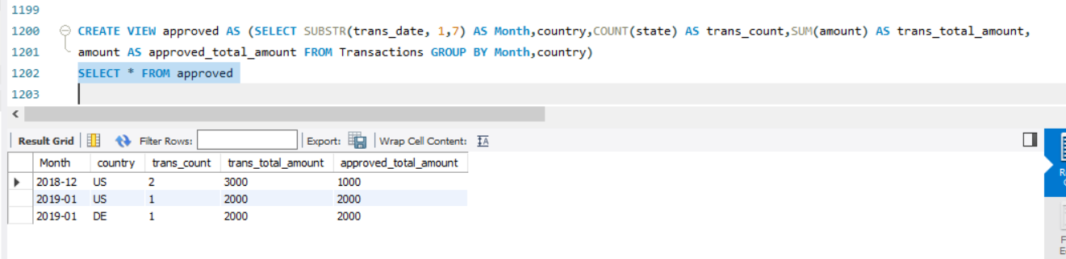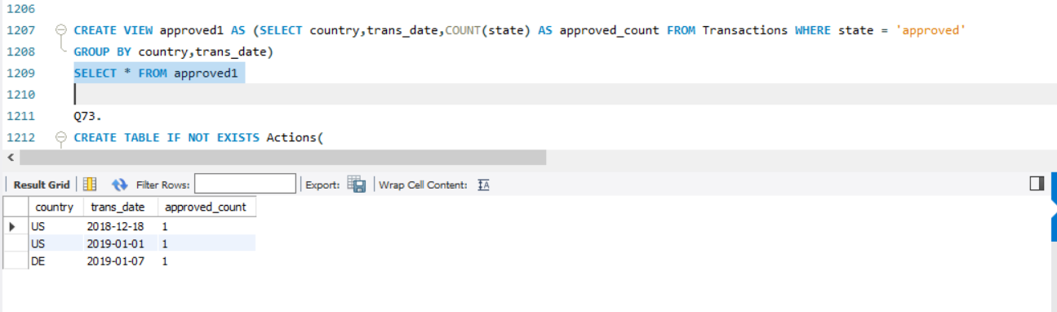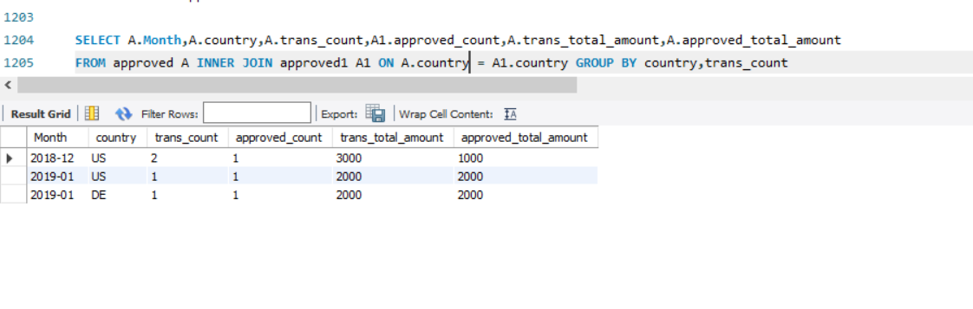

**Q73.** Write an SQL query to find the average daily percentage of posts that got removed after being reported as spam, rounded to 2 decimal places.

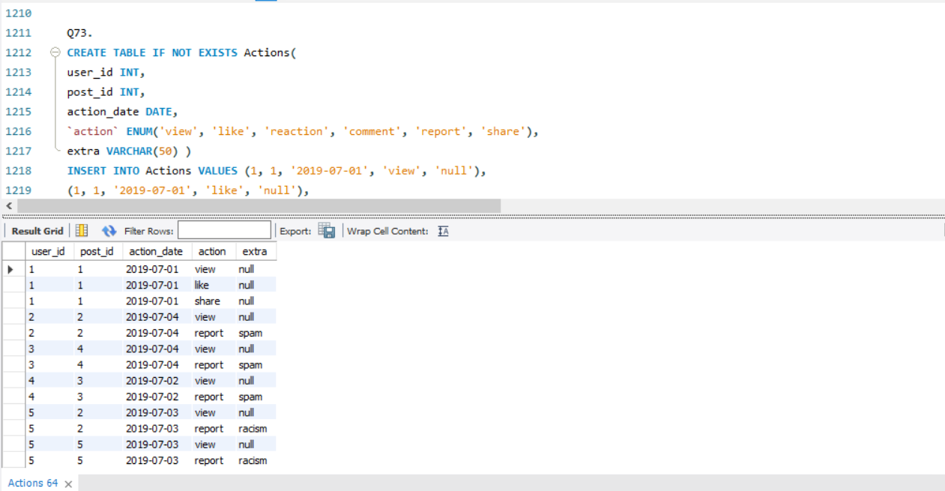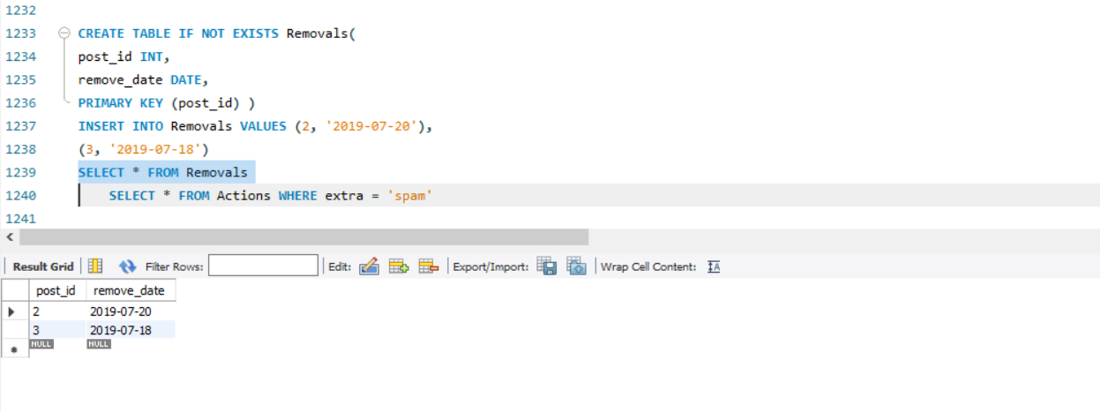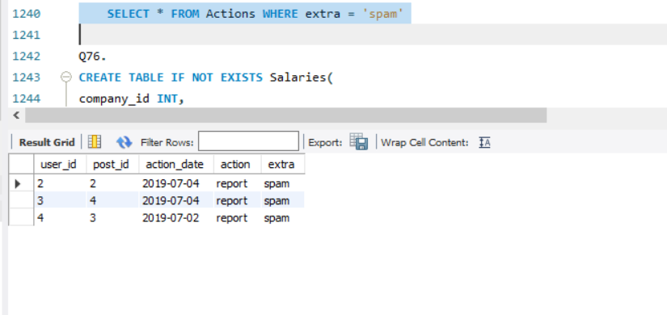

**Q76.** Write an SQL query to find the salaries of the employees after applying taxes. Round the salary to the nearest integer.

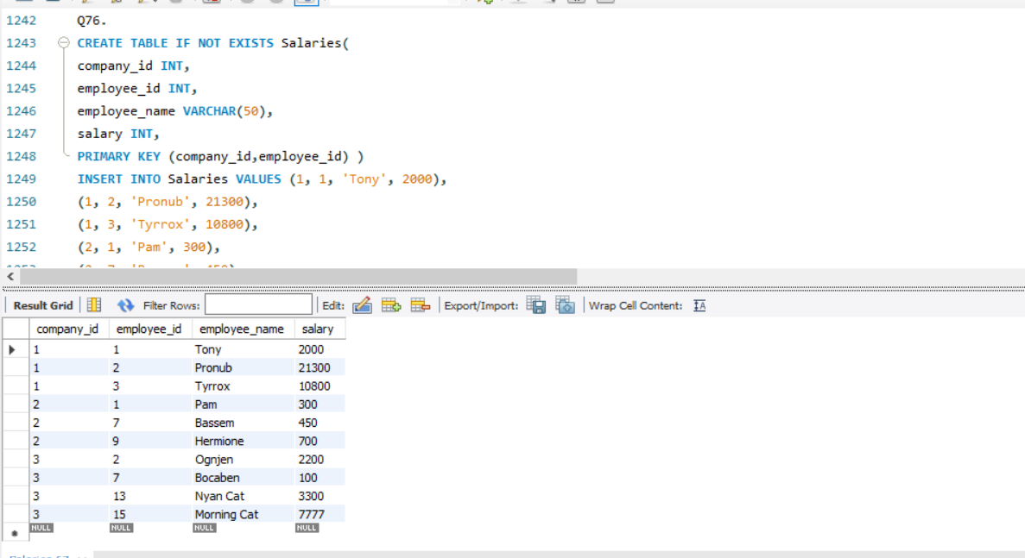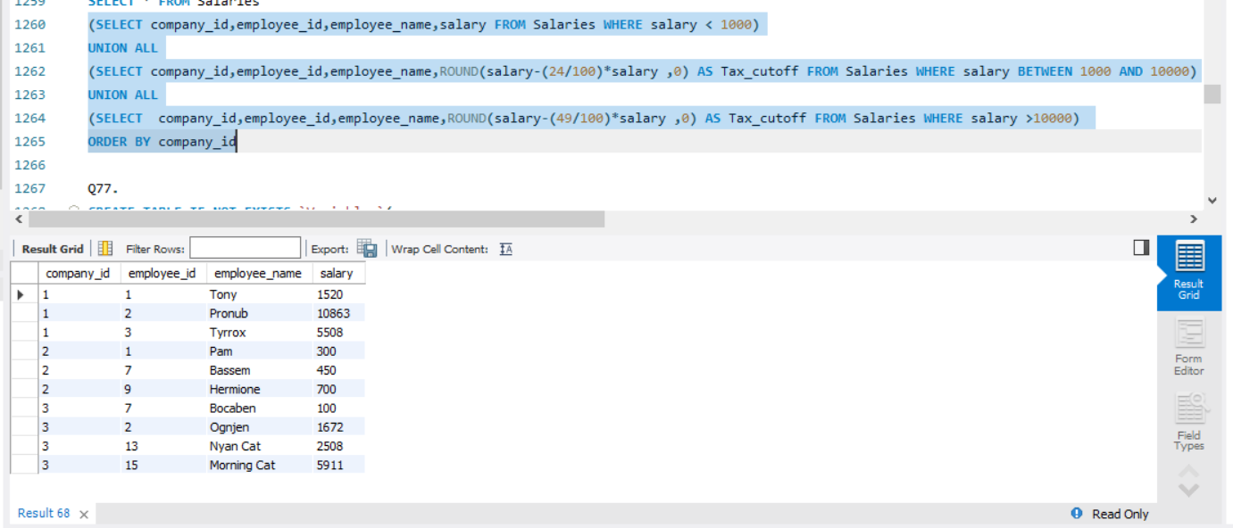

**Q77.** Write an SQL query to evaluate the boolean expressions in Expressions table.

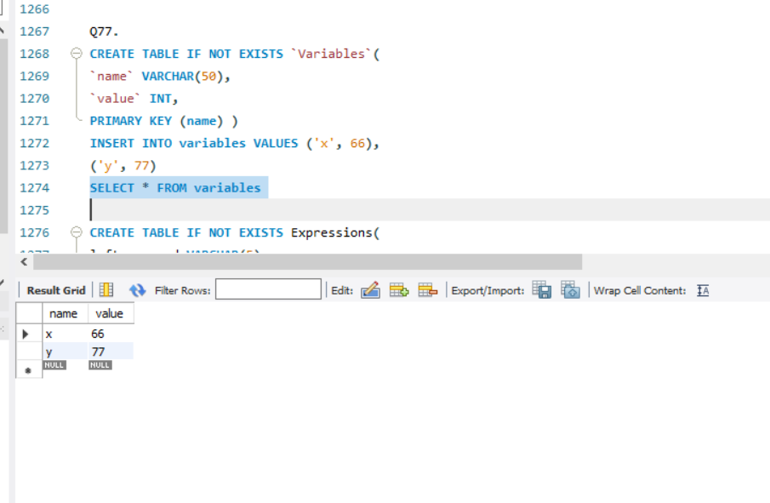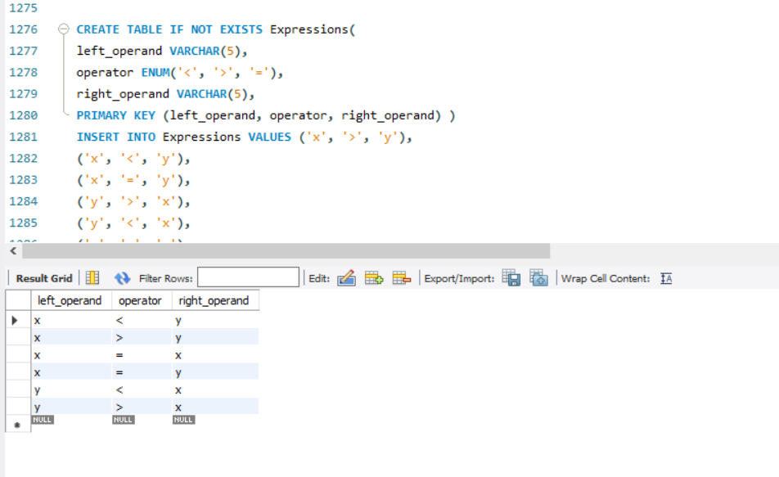

**Q79**. Write a query that prints a list of employee names (i.e.: the name attribute) from the Employee table in alphabetical order.

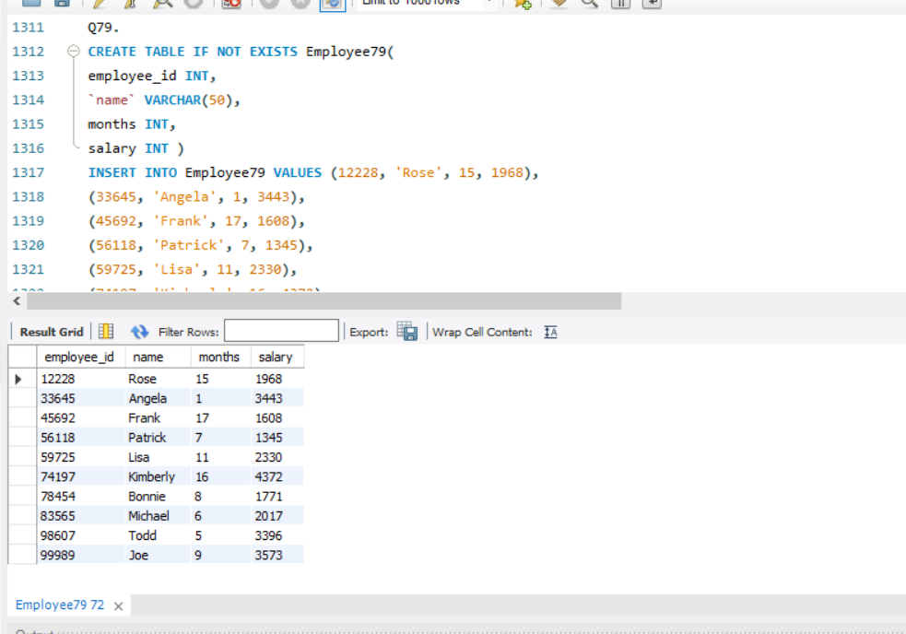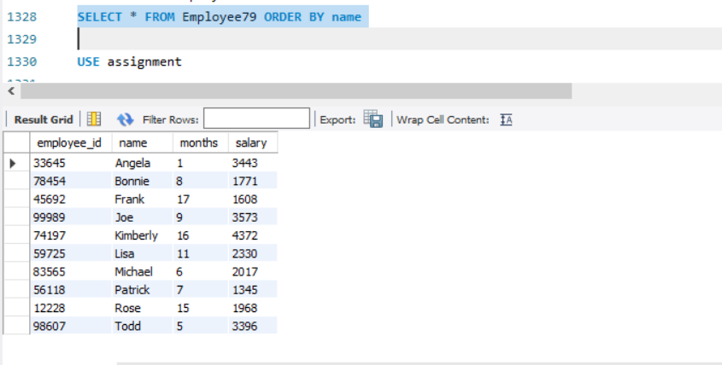

**Q80.** Write a query to obtain the year-on-year growth rate for the total spend of each product for each year.

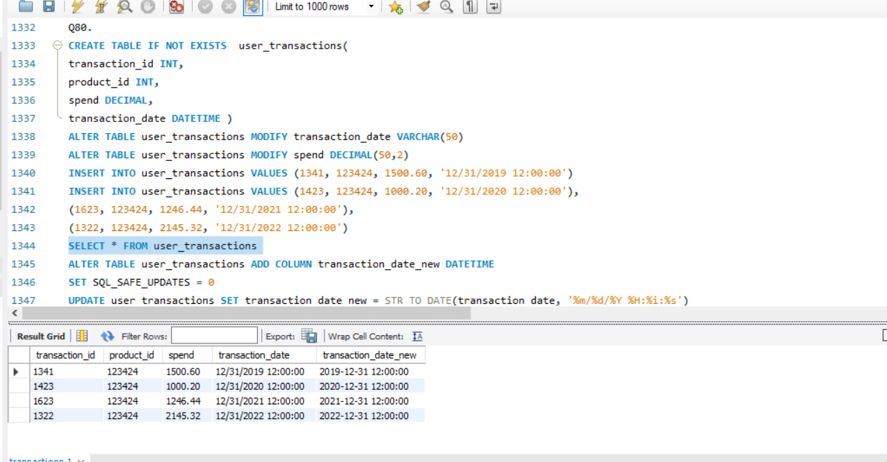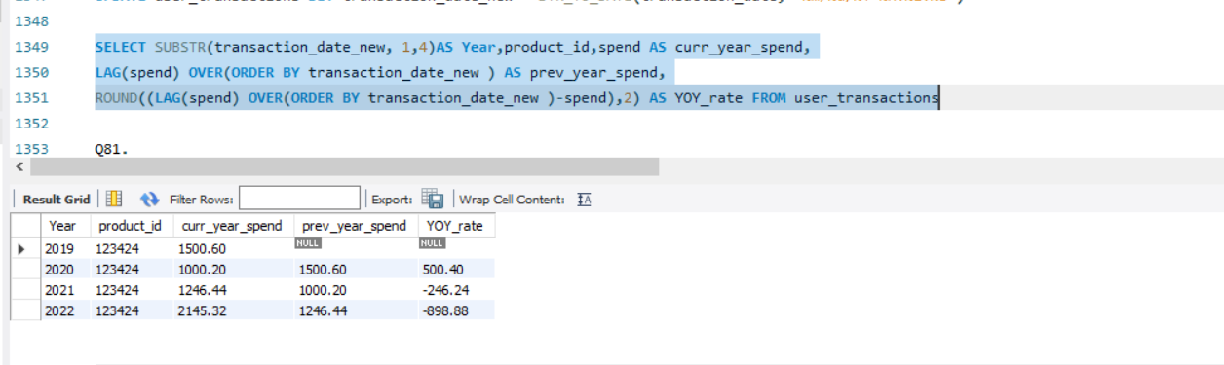

**Q81.** Write a SQL query to find the number of prime and non-prime items that can be stored in the 500,000 square feet warehouse. Output the item type and number of items

to be stocked.

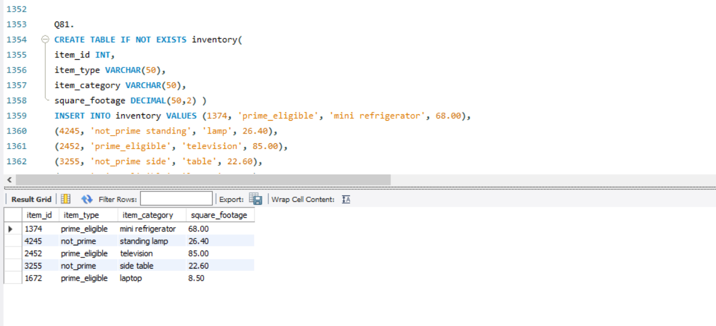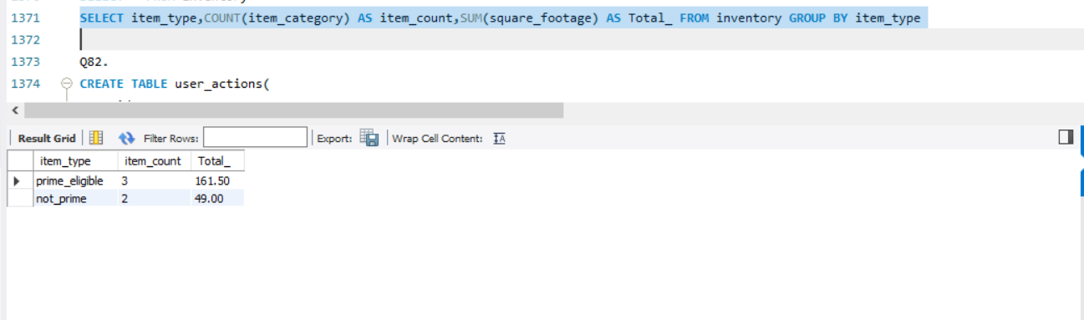

**Q82.** Write a query to obtain the active user retention in July 2022. Output the month (in numerical format 1, 2, 3) and the number of monthly active users (MAUs).

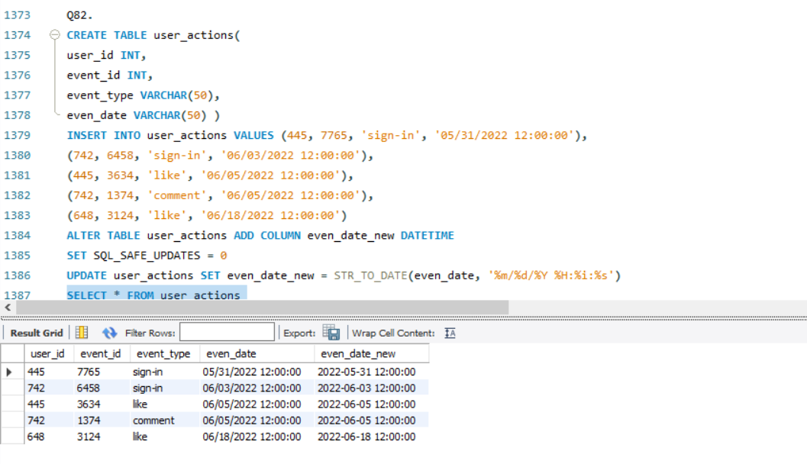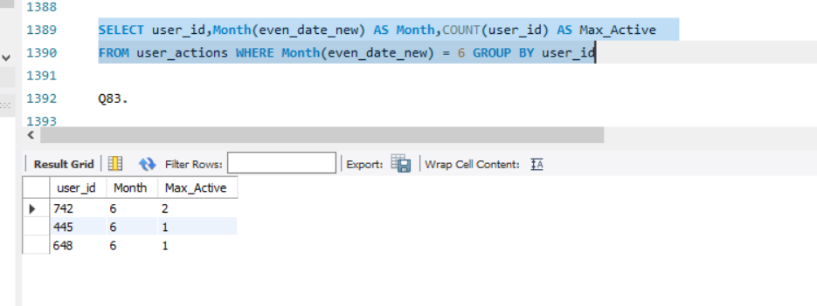

**Q83.** Write a query to report the median of searches made by a user. Round the median to one decimal point.

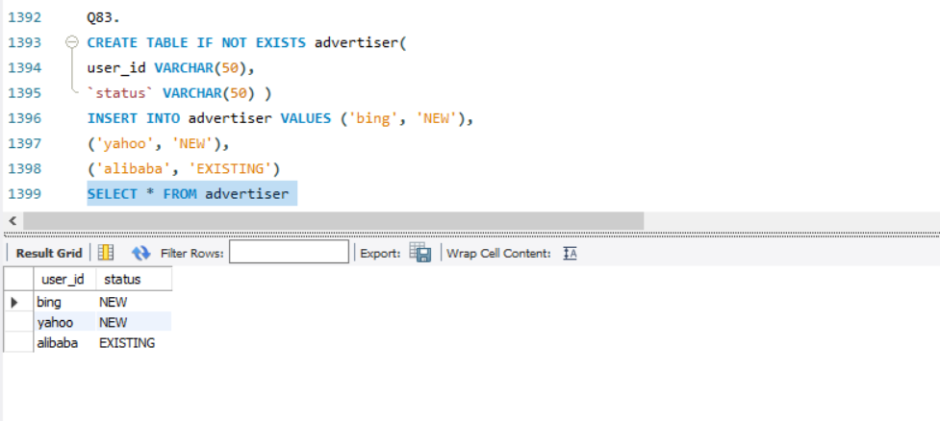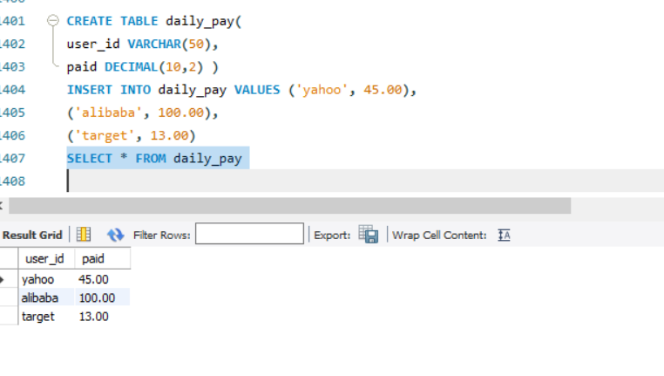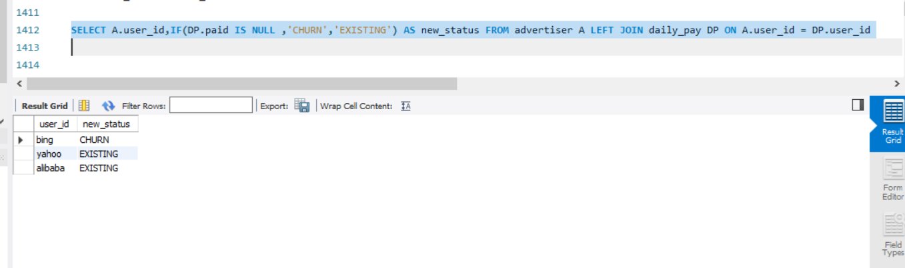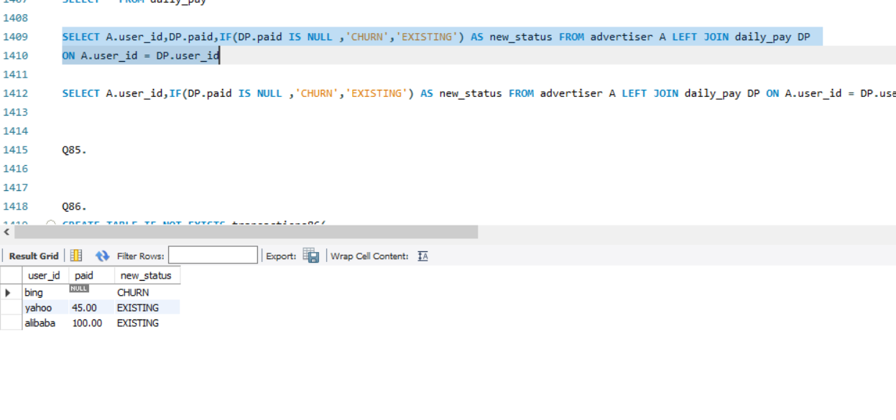

**Q86.**

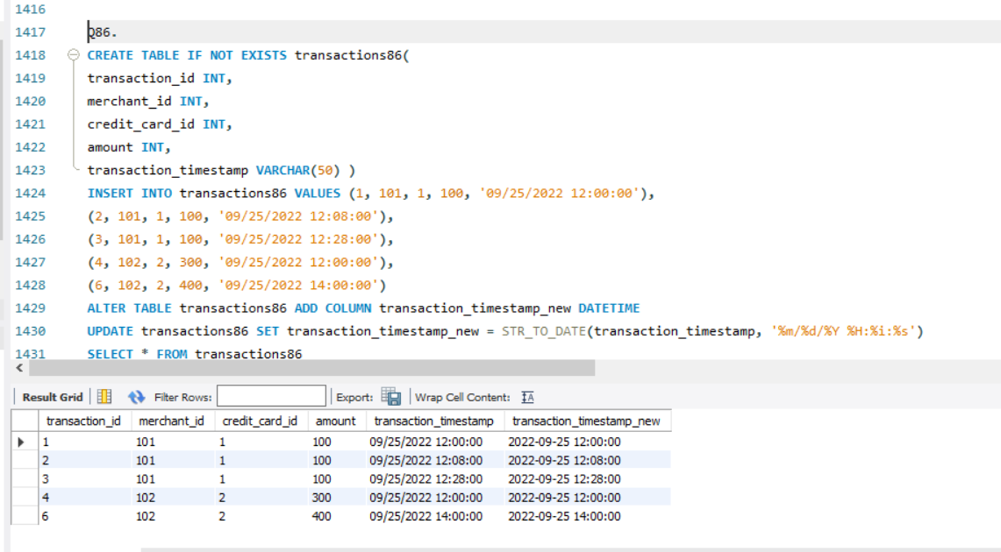

**Q87.** Write a query to find the bad experience rate in the first 14 days for new users who signed up in June 2022. Output the percentage of bad experience rounded to 2 decimal places

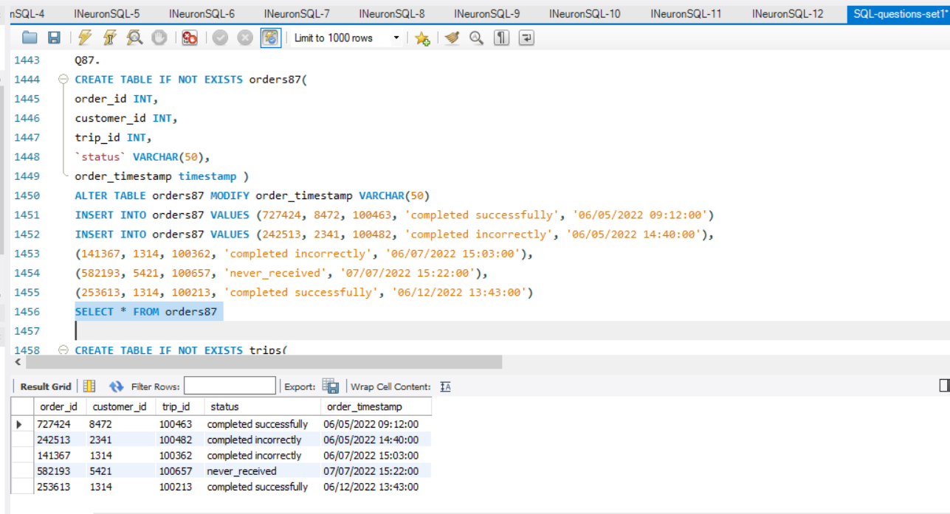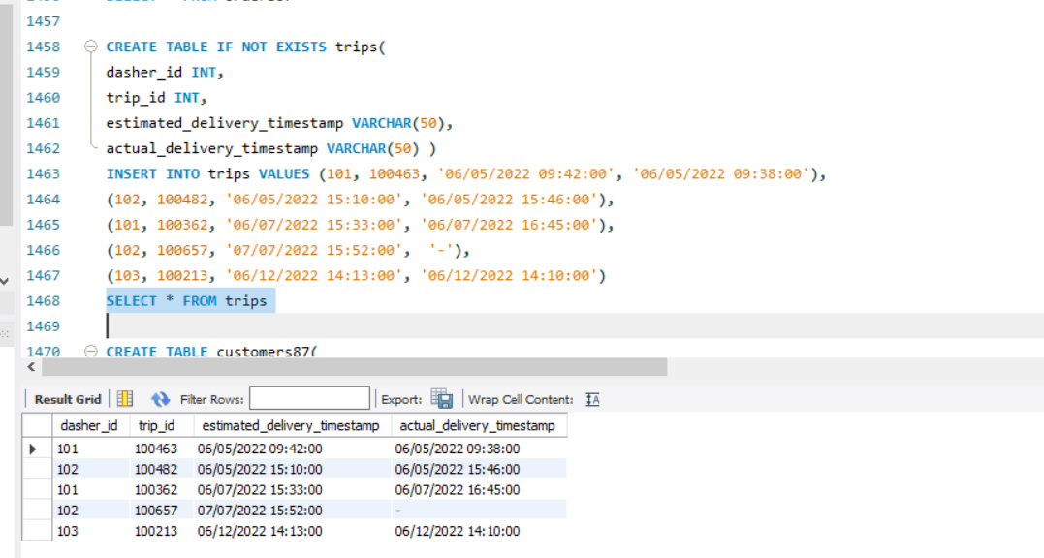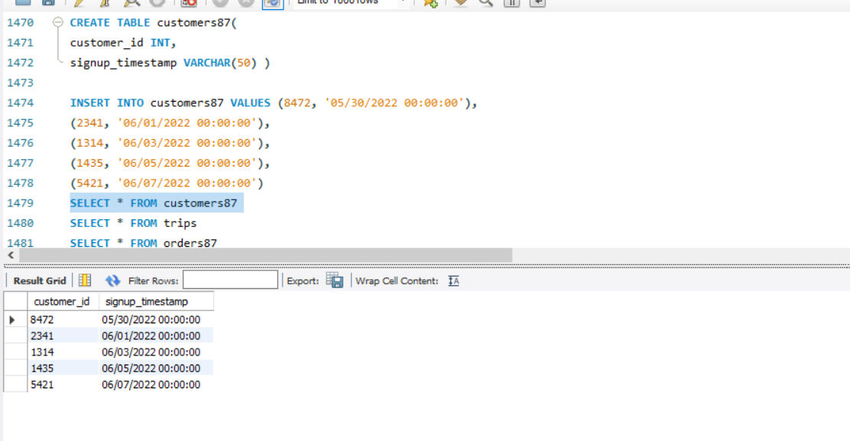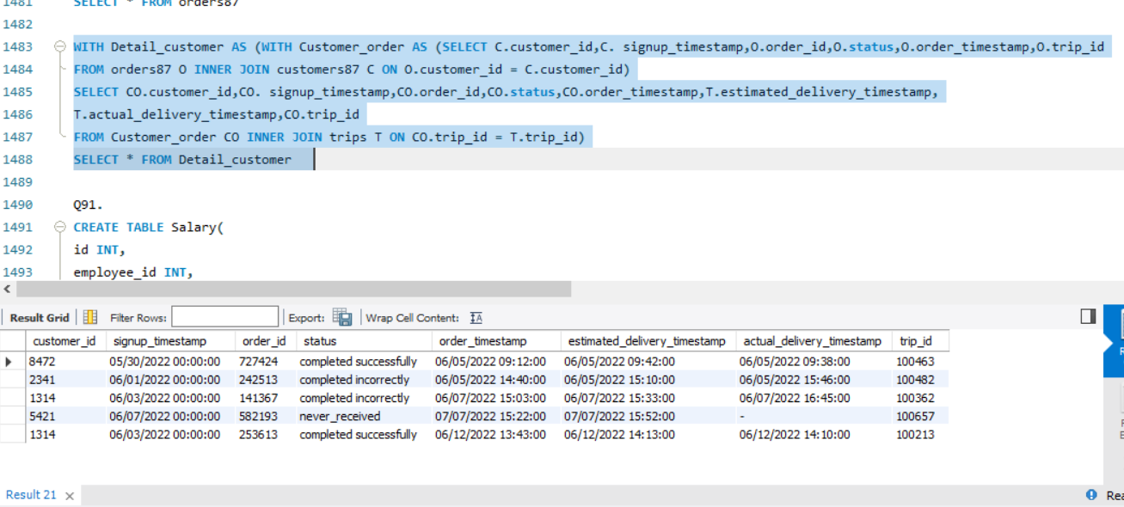

**Q91.** Write an SQL query to report the comparison result (higher/lower/same) of the average salary of employees in a department to the company's average salary.

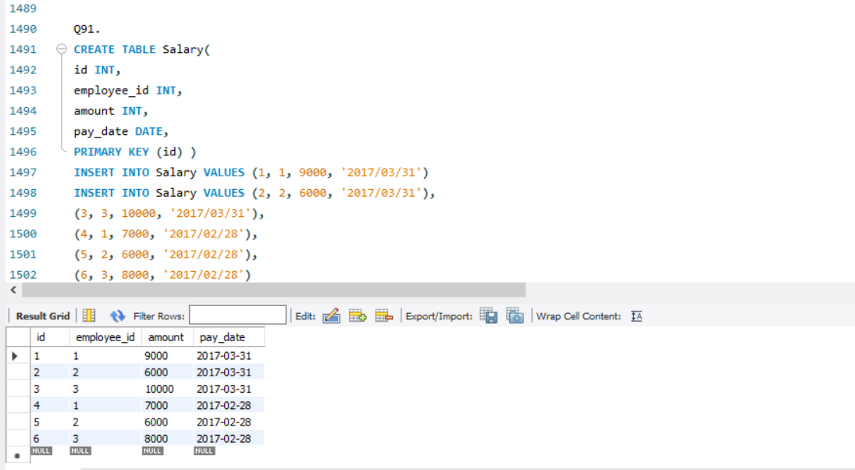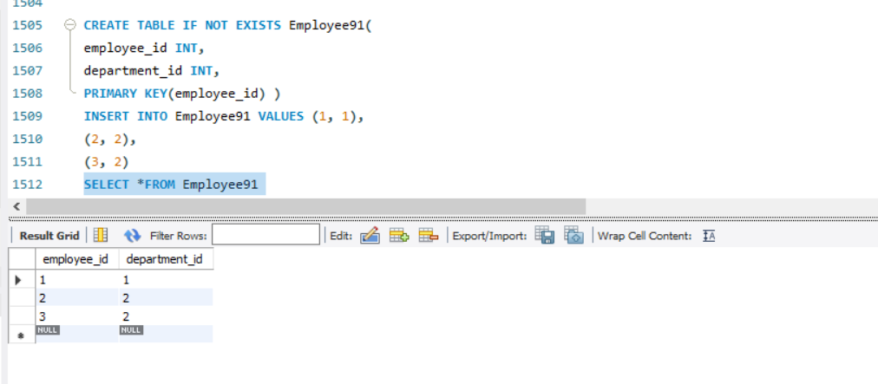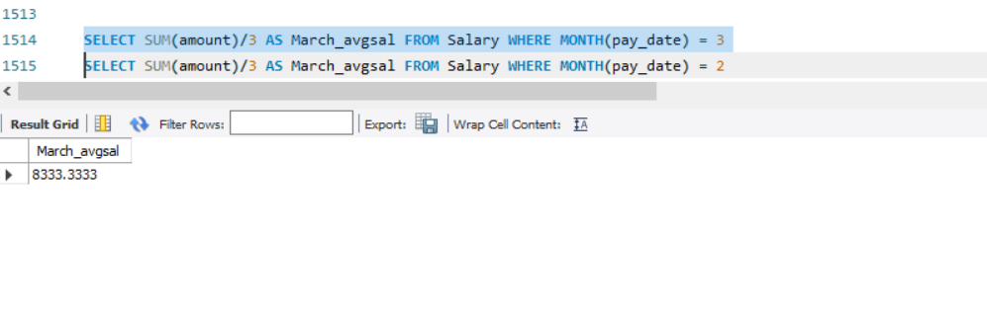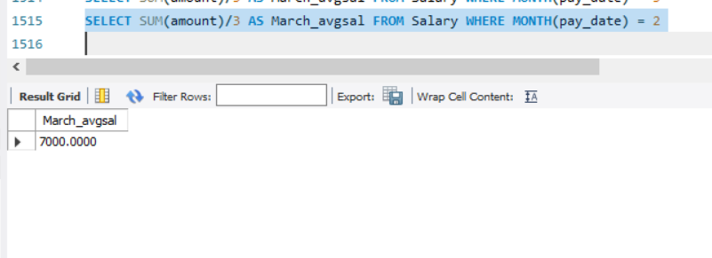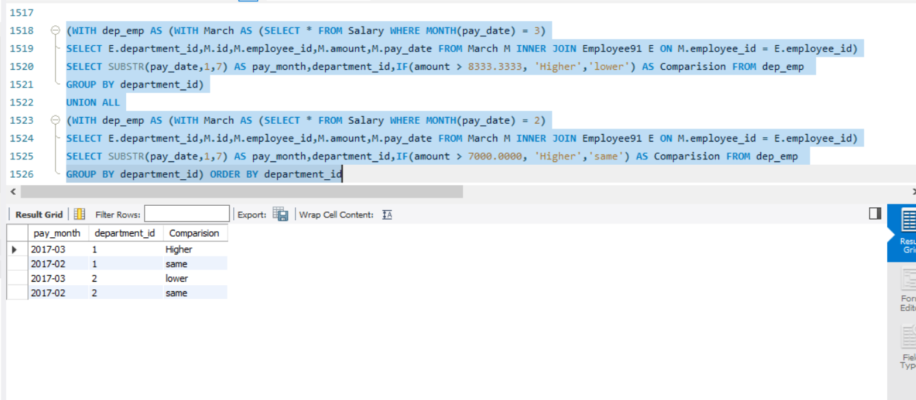

**Q92.** Write an SQL query to report for each install date, the number of players that installed the game on that day, and the day one retention.

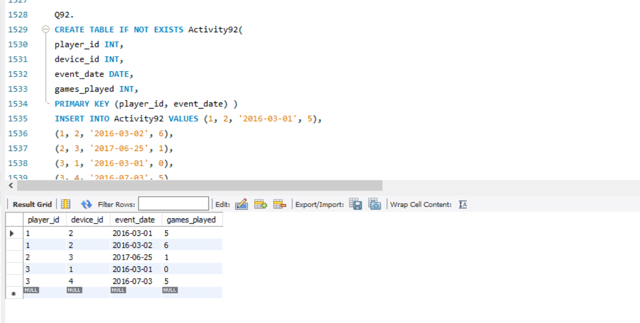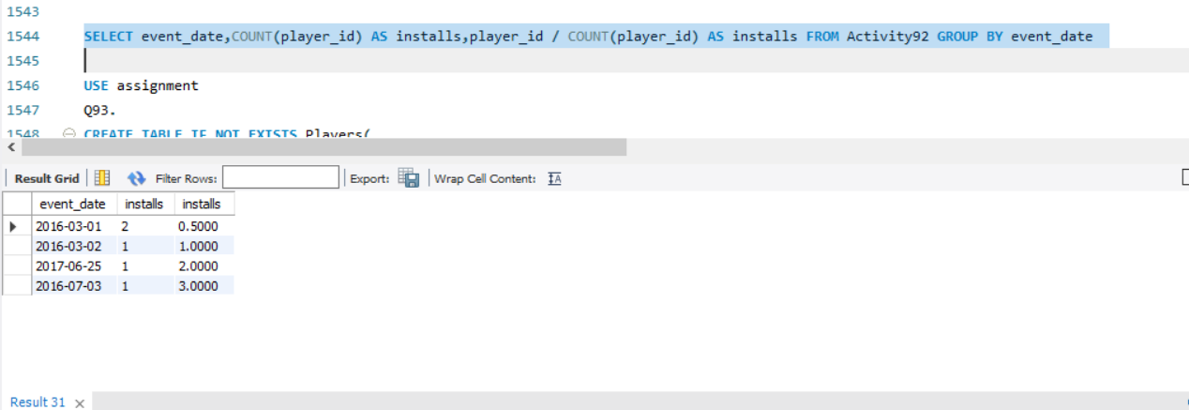

**Q93.** Write an SQL query to find the winner in each group.

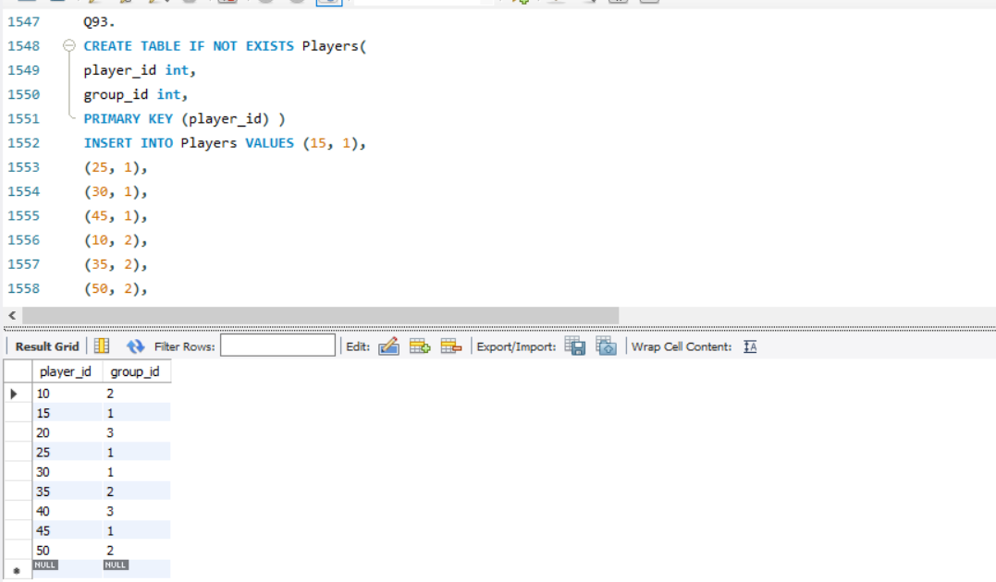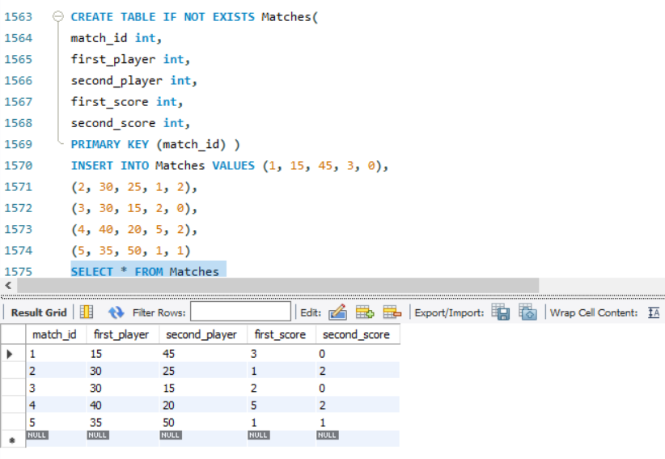

**Q94.** Write an SQL query to report the students (student_id, student_name) being quiet in all exams. Do not return the student who has never taken any exam.

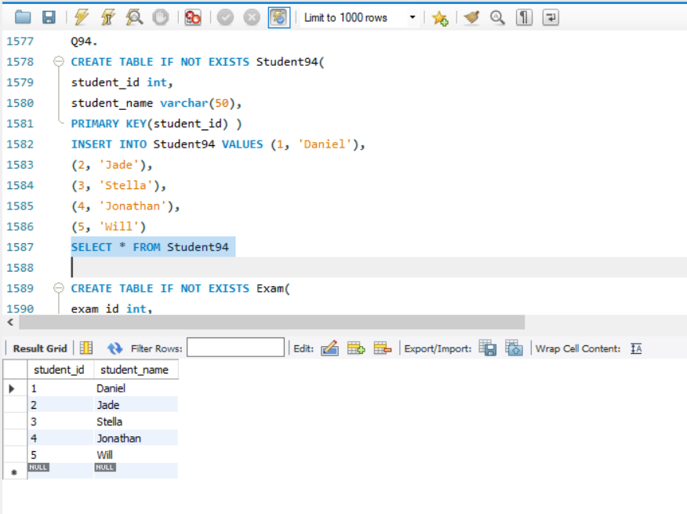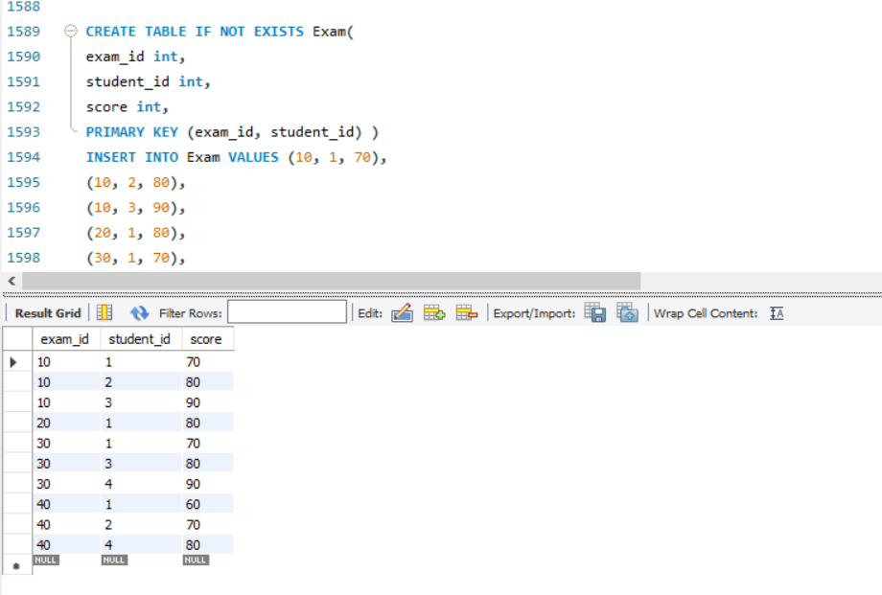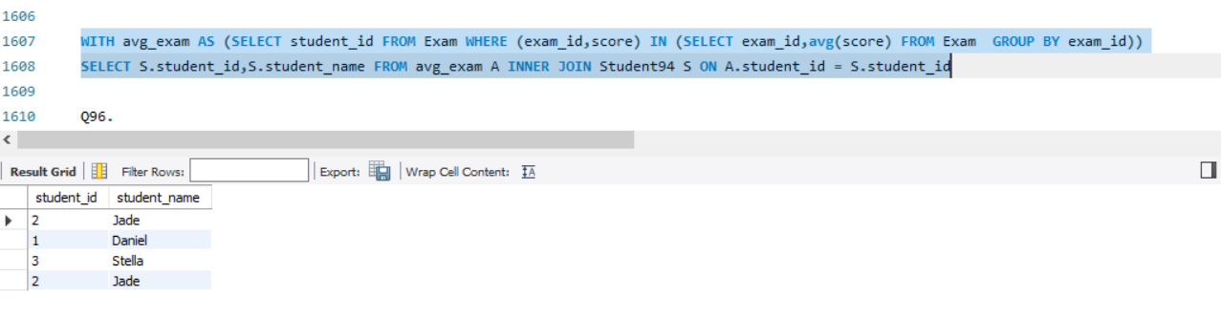

**Q97.** Write a query to find the confirmation rate of users who confirmed their signups with text messages. Round the result to 2 decimal places.

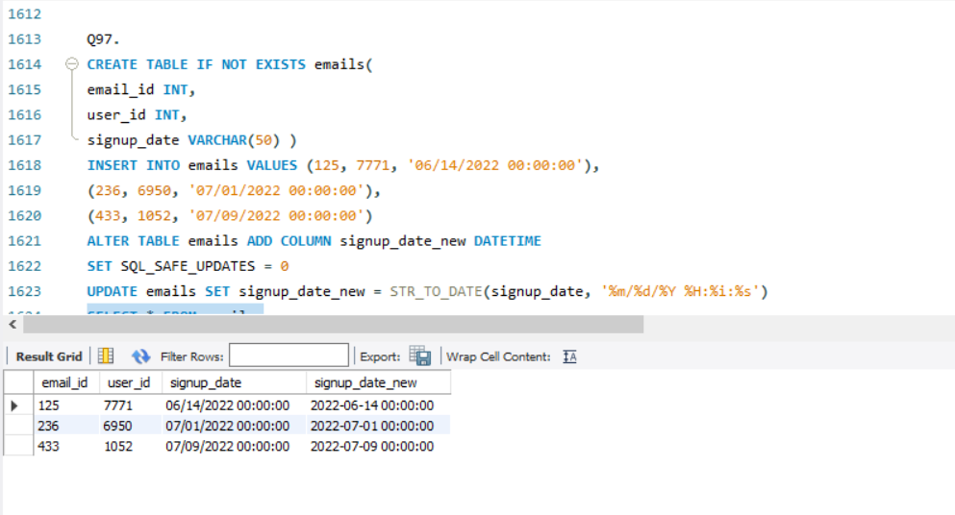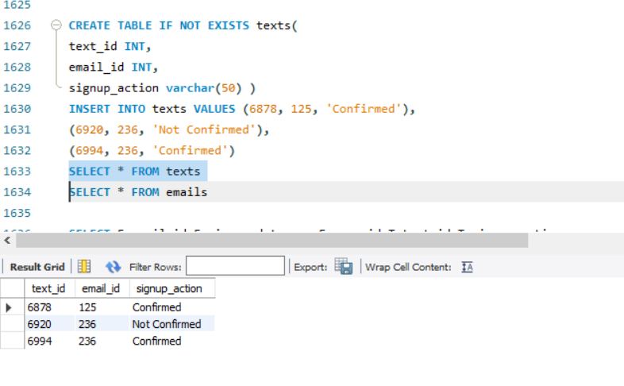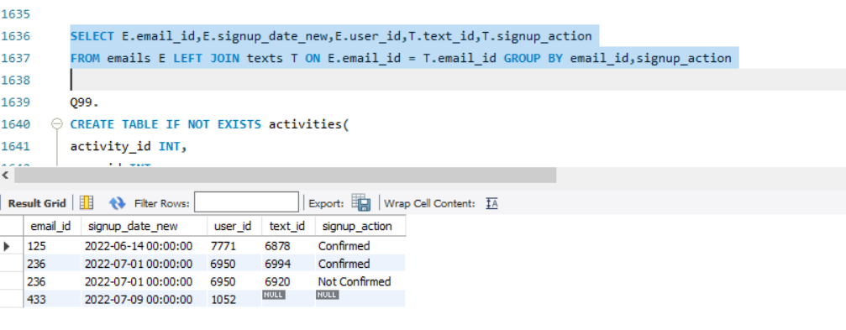

**Q99.** Write a query to obtain a breakdown of the time spent sending vs. opening snaps (as a percentage of total time spent on these activities) for each age group.

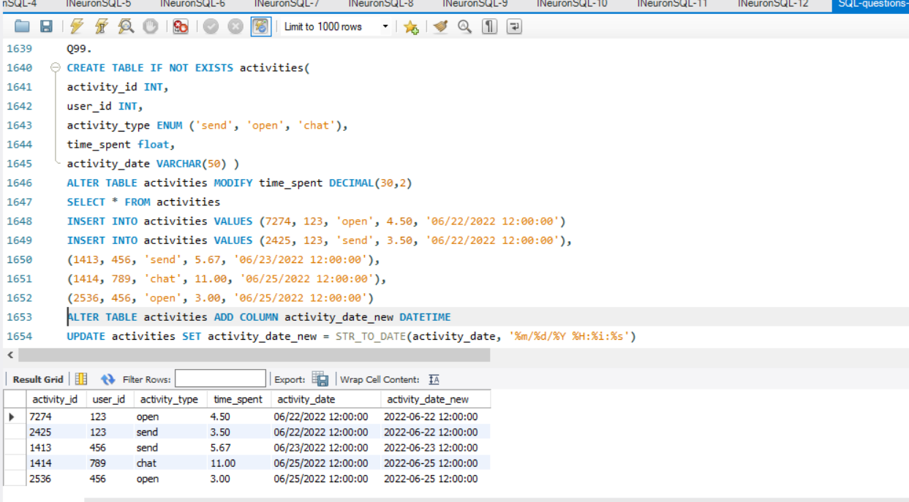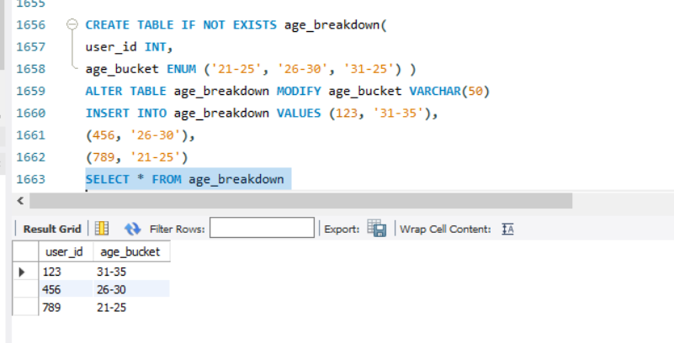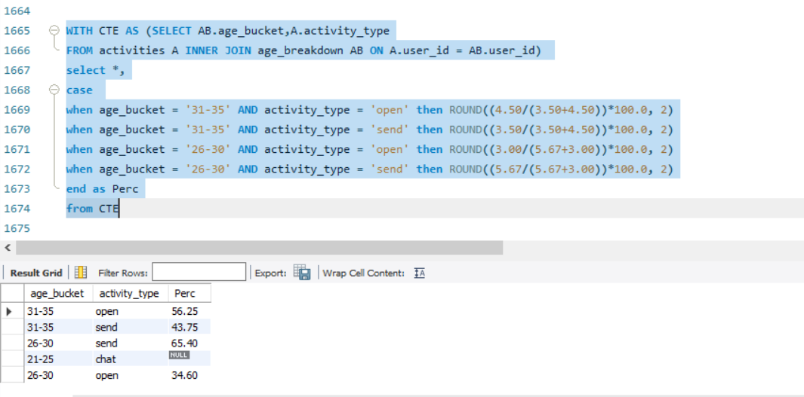

**Q100 .** Write a query to return the IDs of these LinkedIn power creators in ascending order.

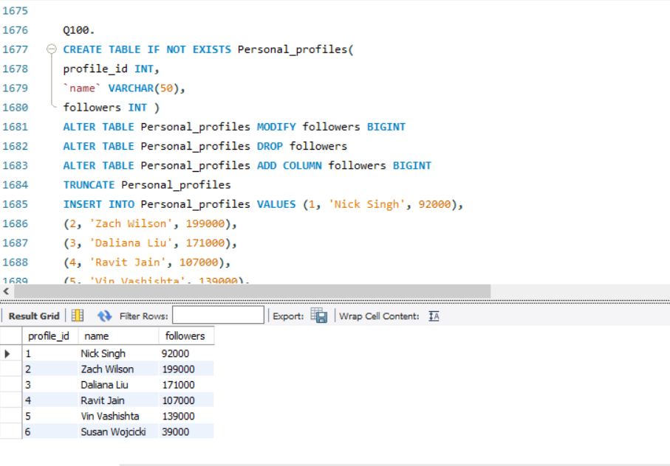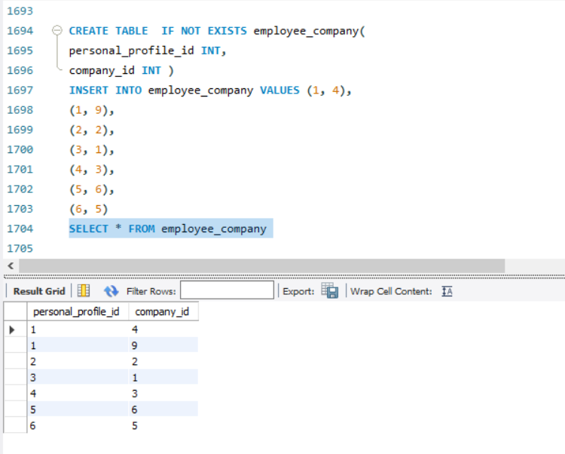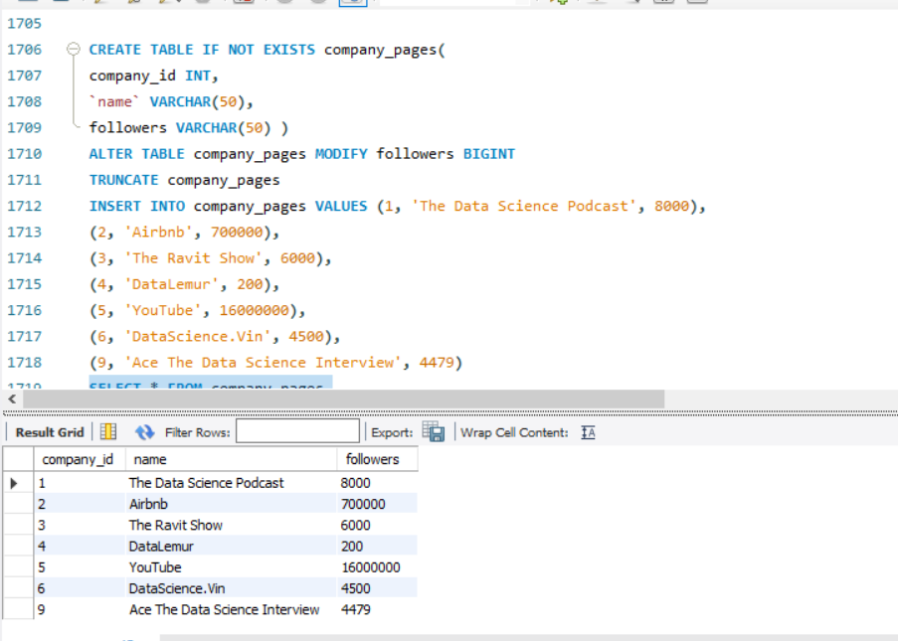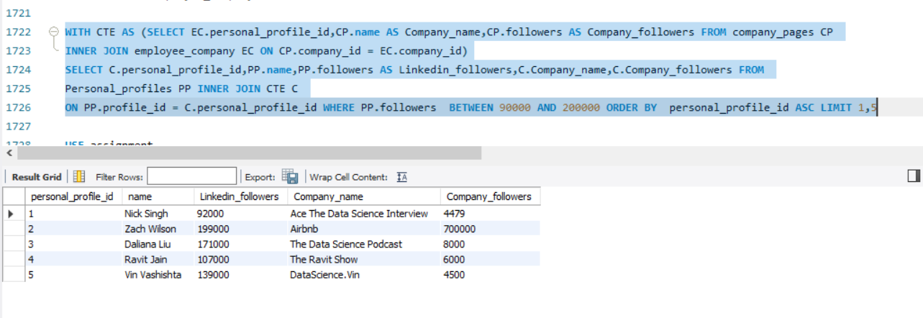

**Q 101.** Write an SQL query to show the second most recent activity of each user. If the user only has one activity, return that one. A user cannot perform more than one activity at the same time.

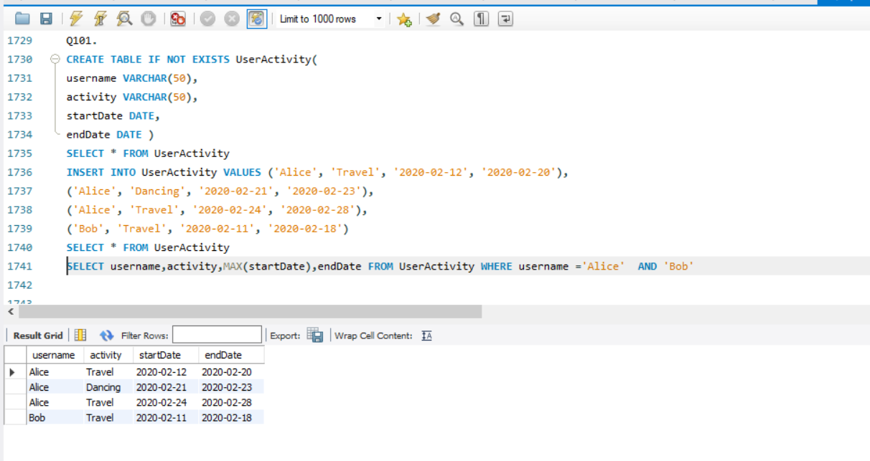

**Q103.** Query the Name of any student in STUDENTS who scored higher than 75 Marks. Order your output bythe last three characters of each name. If two or more students both have names ending in the samelast three characters (i.e.: Bobby, Robby, etc.), secondary sort them by ascending ID.

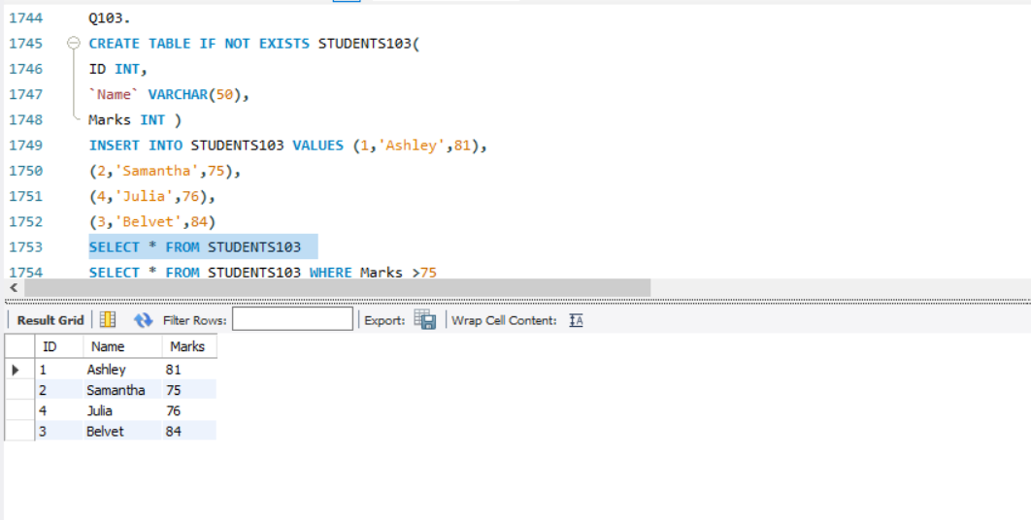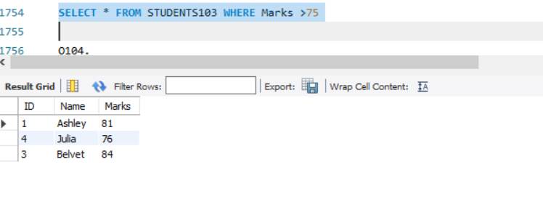

**Q104.** Write a query that prints a list of employee names (i.e.: the name attribute) for employees in Employee having a salary greater than $2000 per month who have been employees for less than 10 months. Sort your result by ascending employee_id.

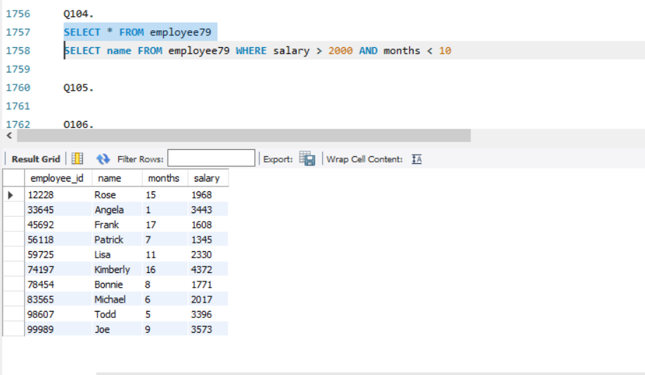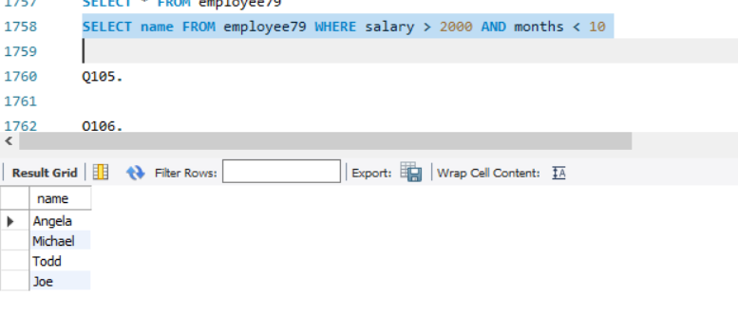

**Q106.**

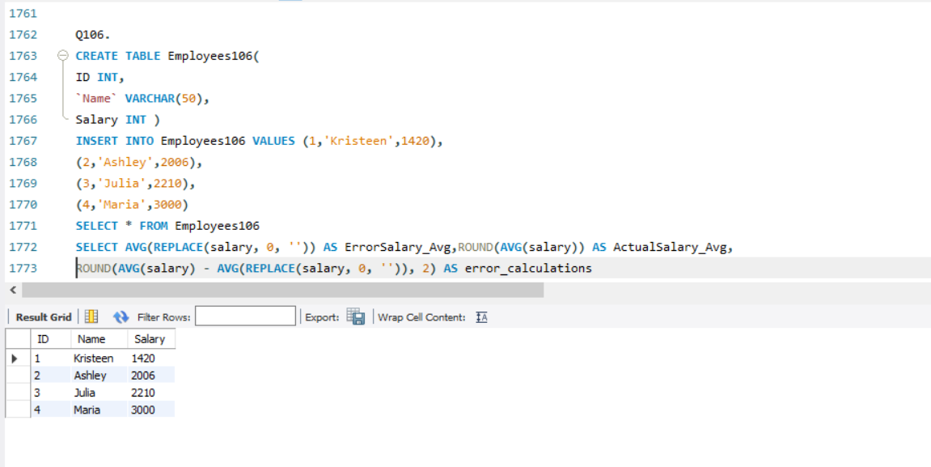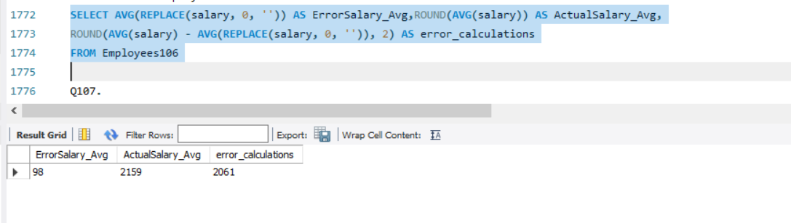

**Q107.** Write a query to find the maximum total earnings for all employees as well as the total number of employees who have maximum total earnings. Then print these values as 2 space-separated integers.

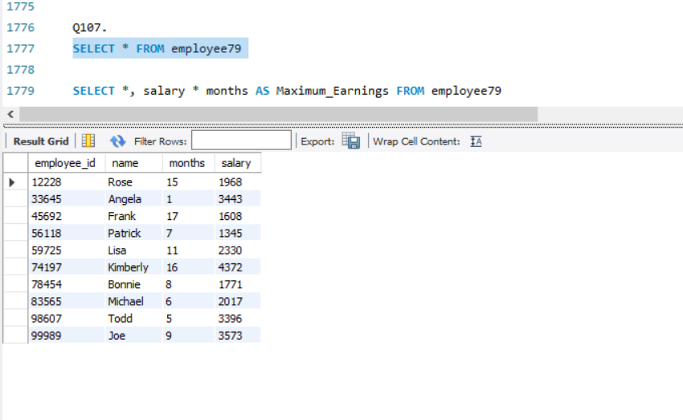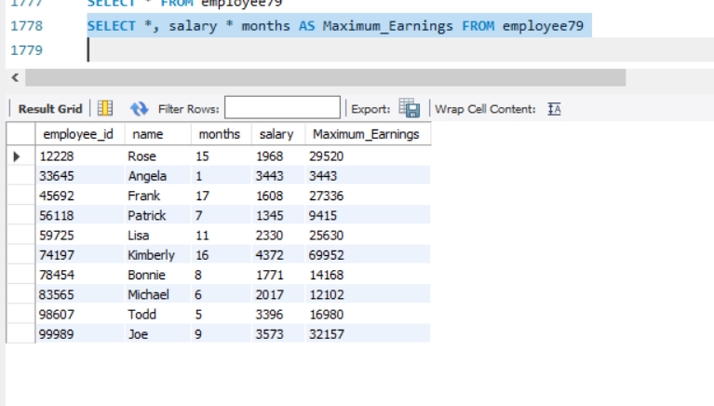

**Q108.**

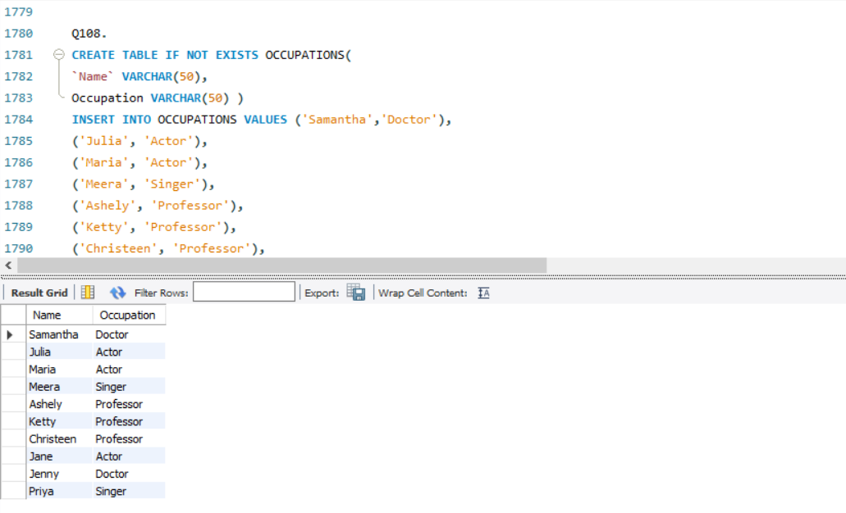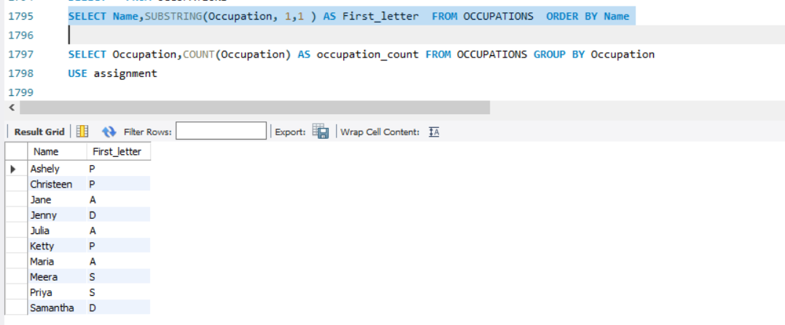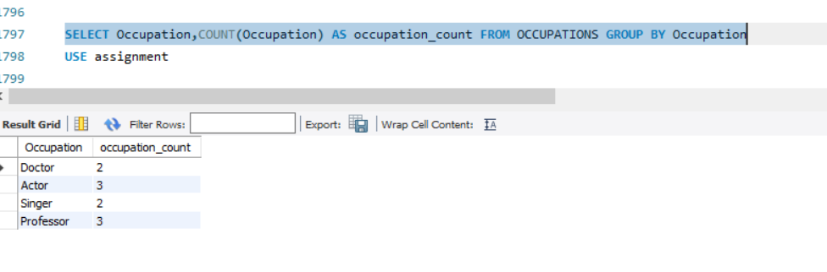

**Q144 .** Write a query to output the names of those students whose best friends got offered a higher salary than them. Names must be ordered by the salary amount offered to the best friends. It is guaranteed that no two students get the same salary offer.

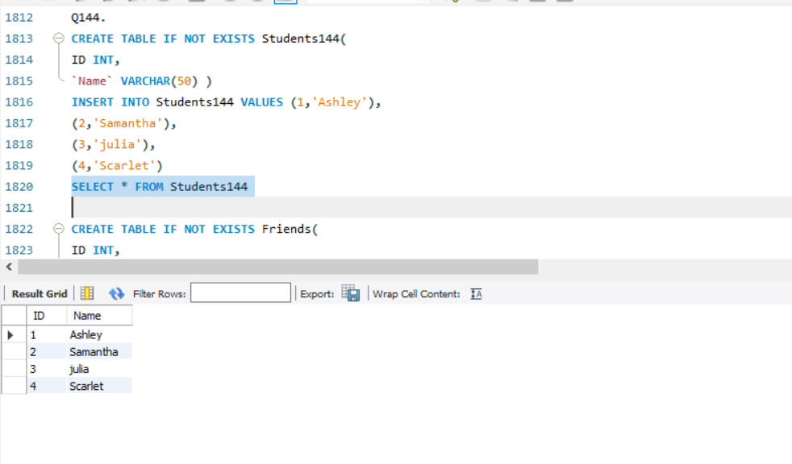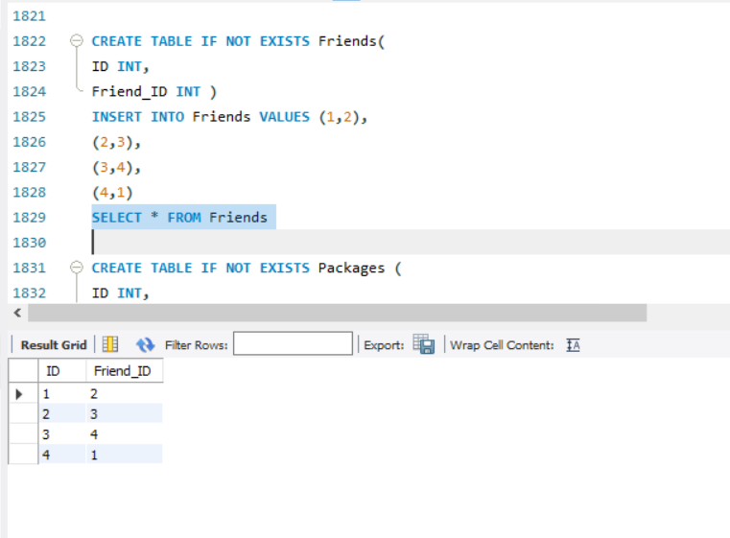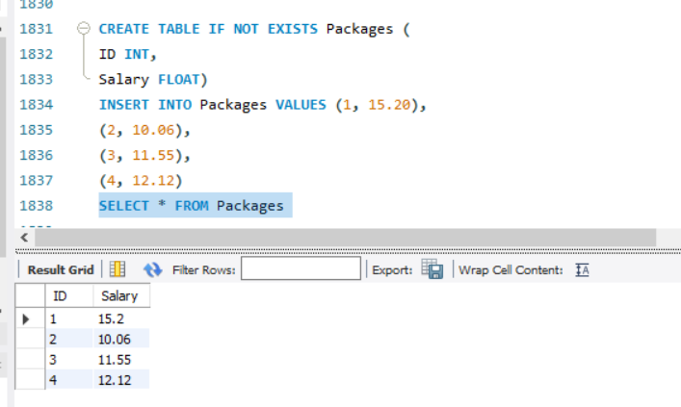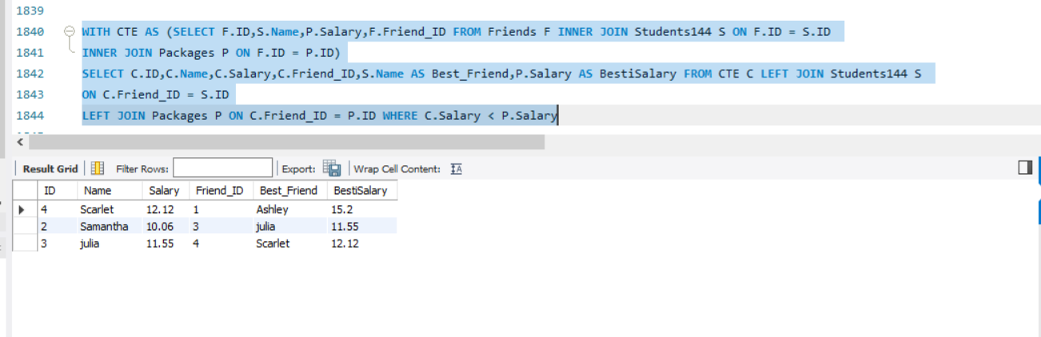

**Q145.**

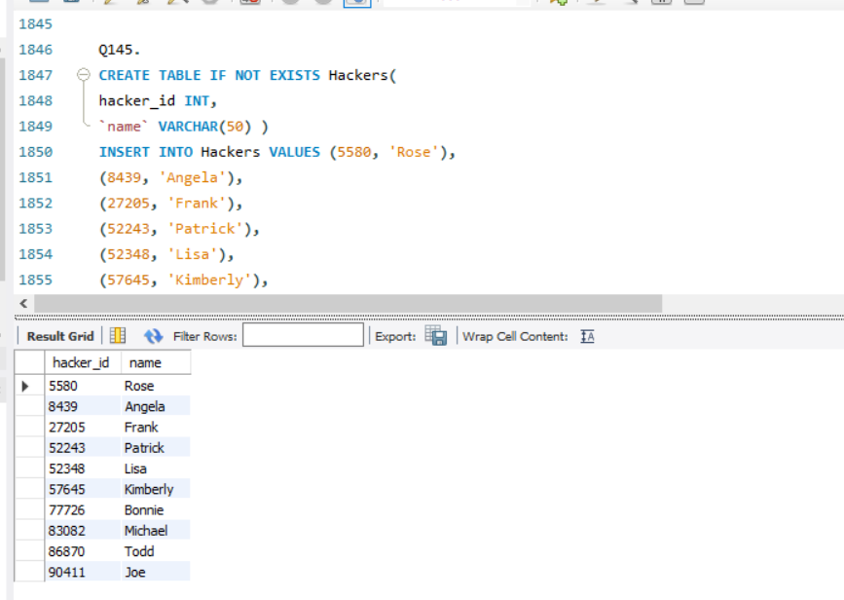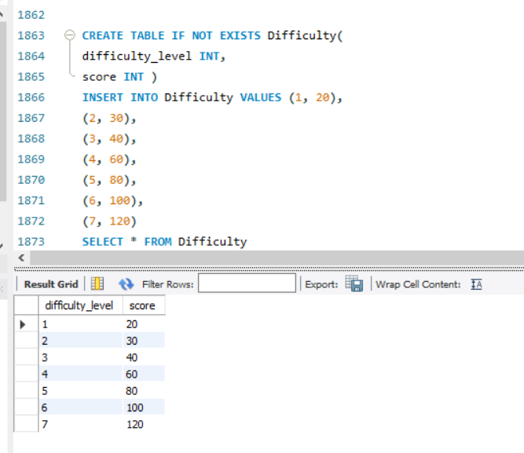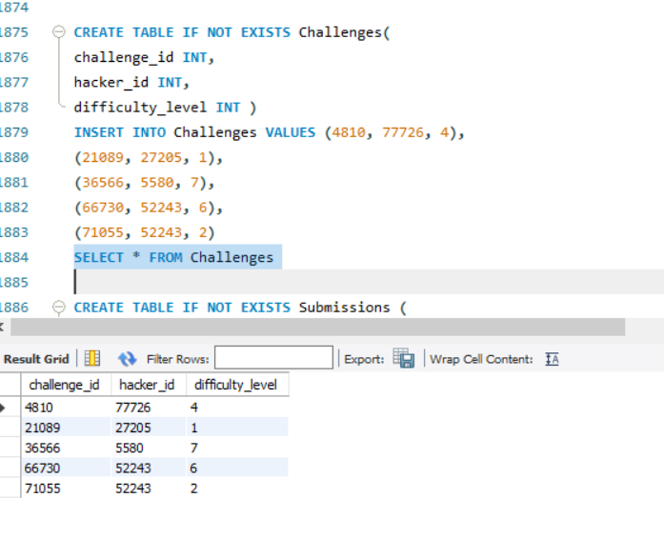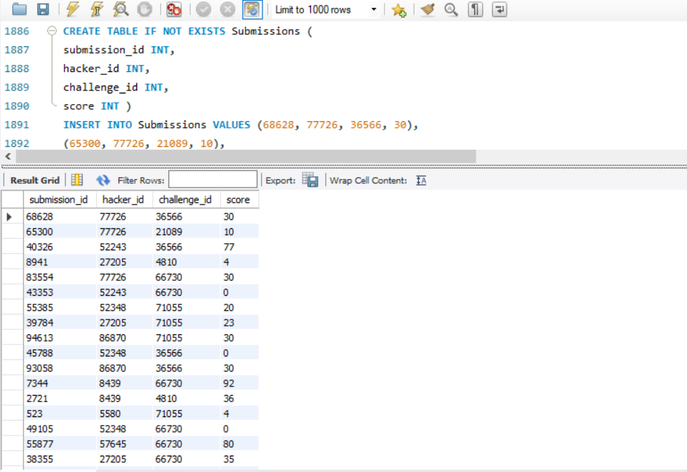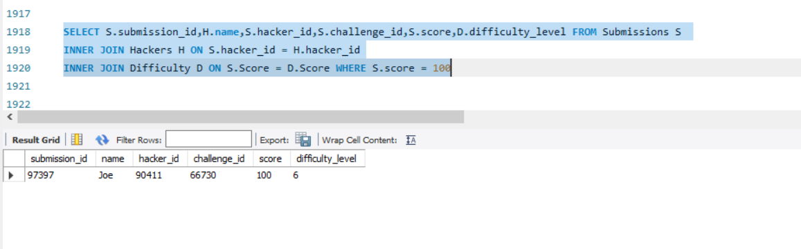

**Q146.**

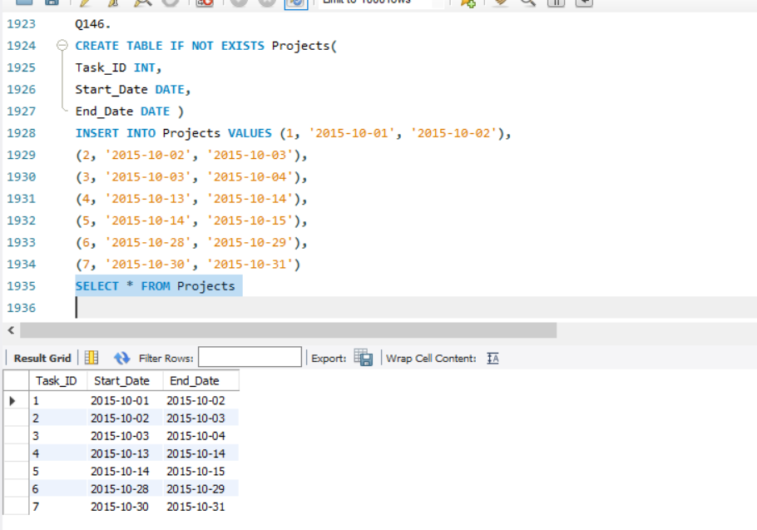

**Q148 .**

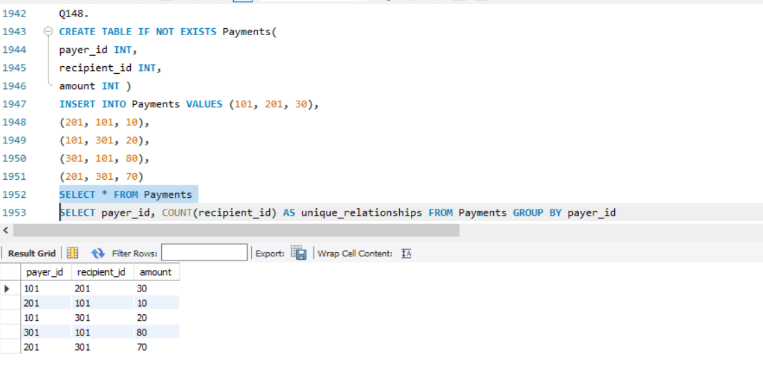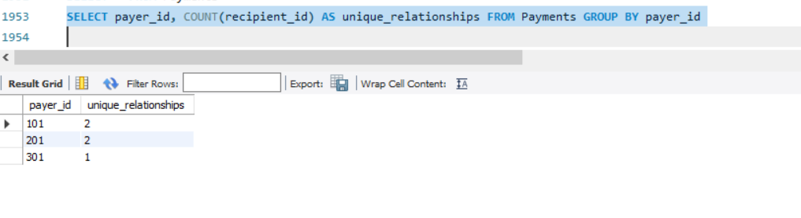

**Q149.**

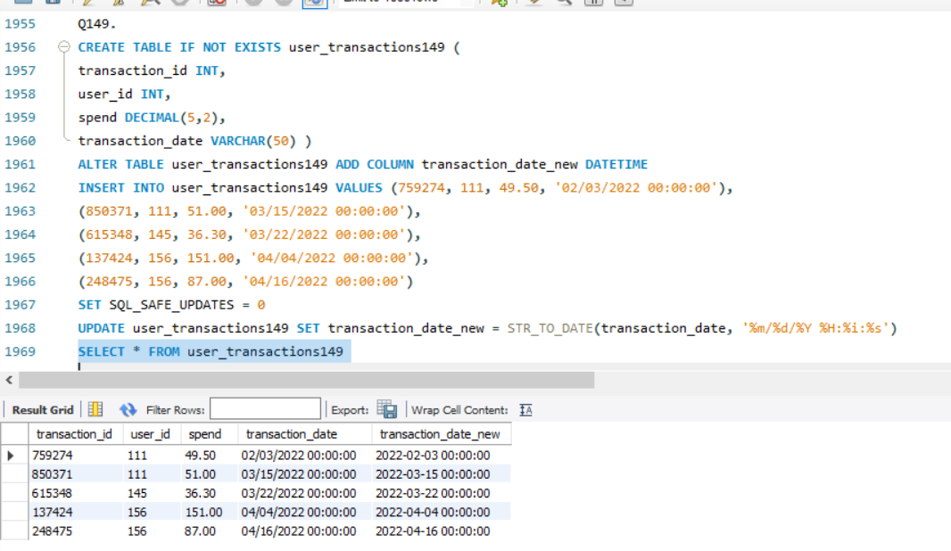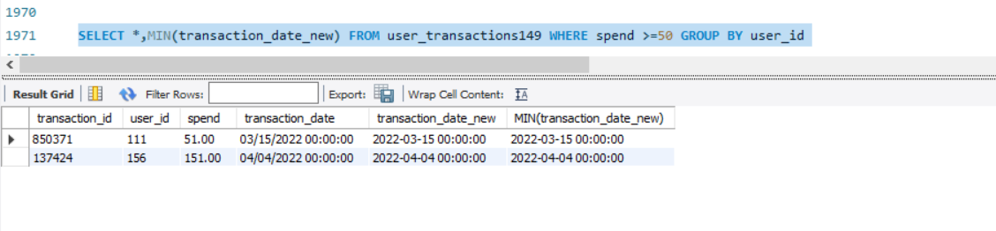

**Q150.**

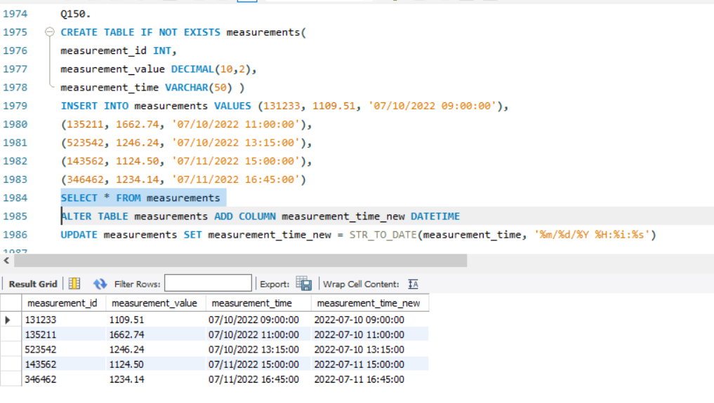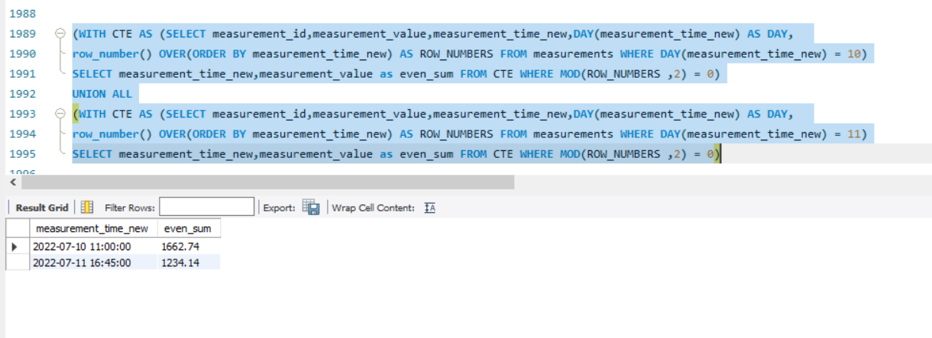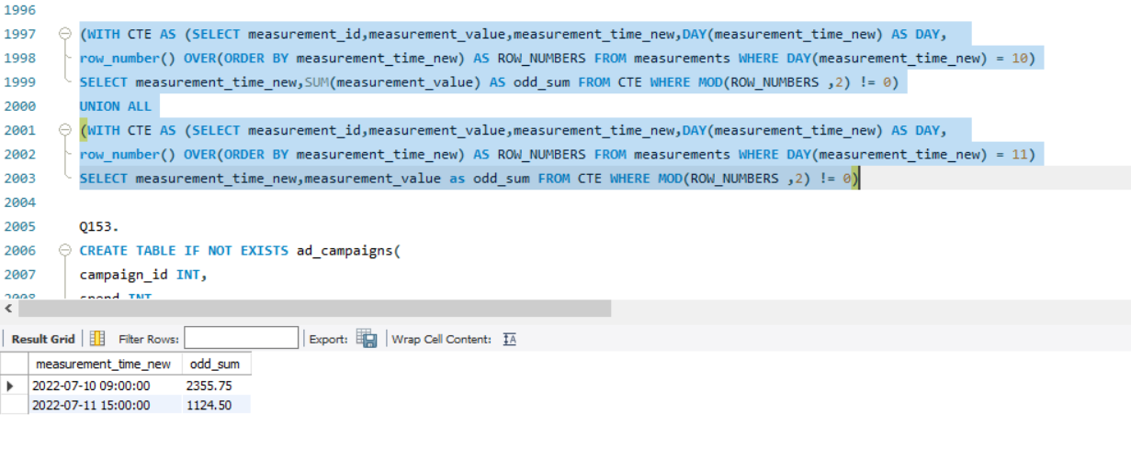

**Q153.**

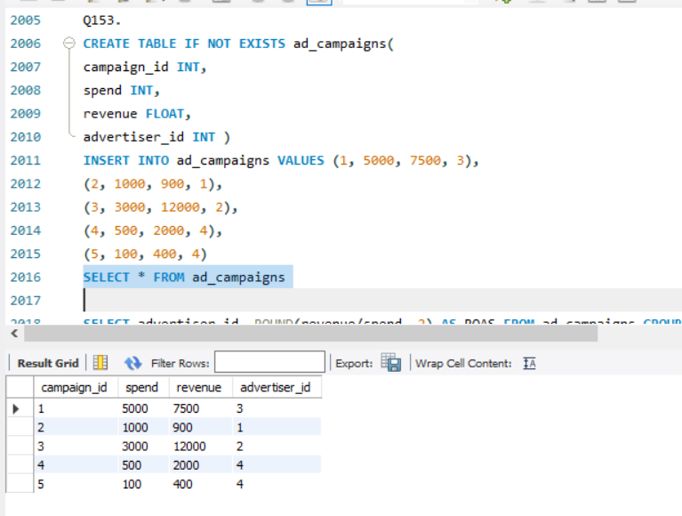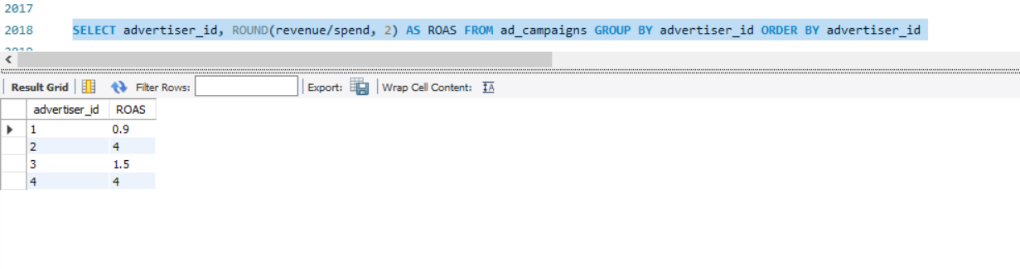

**Q154.**

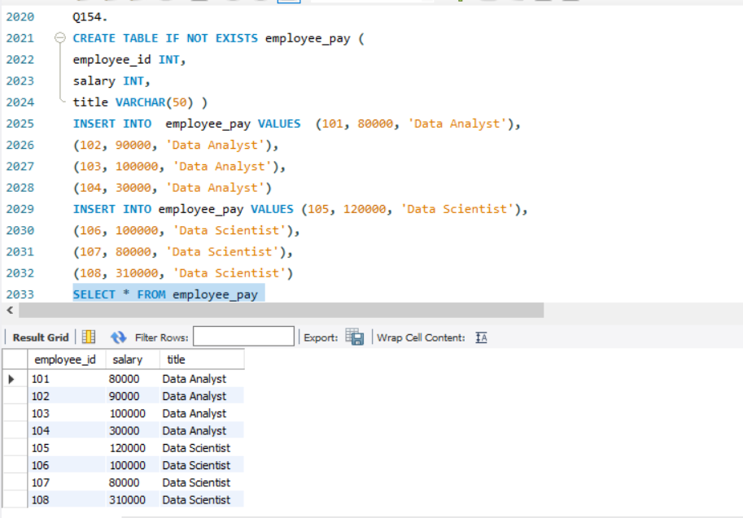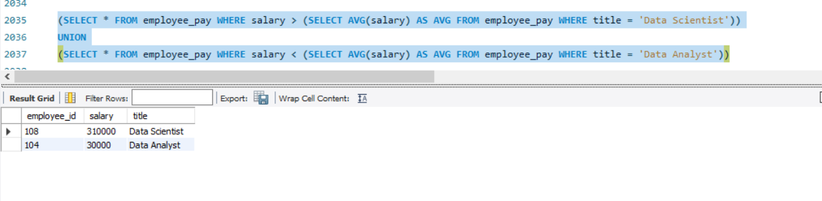

**Q156.**

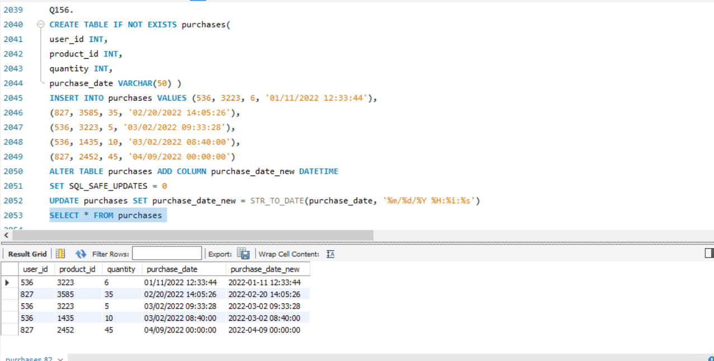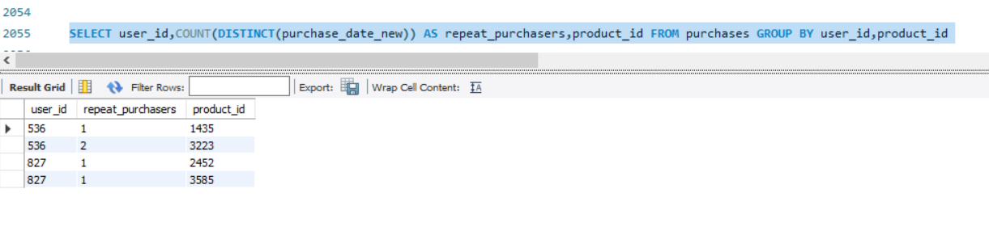

**Q157.**

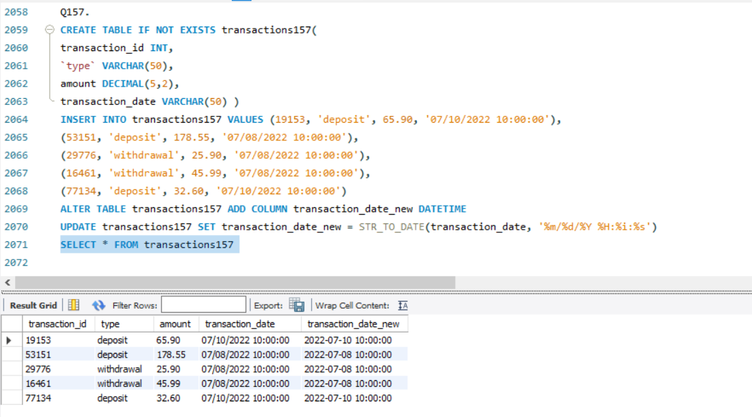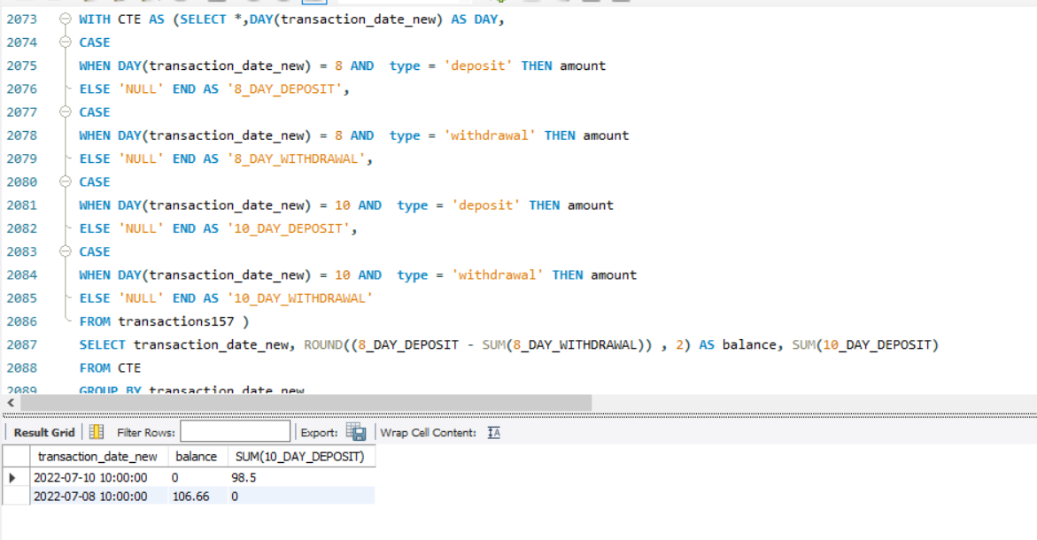

**Q158.**

